



# Splunk Fundamentals 2 Instructor on Demand

**Generated for mastinder singh (mastinder.singh@jpmchase.com) (C) Splunk Inc, not for distribution**

Splunk Fundamentals 2

1

Copyright © 2018 Splunk, Inc. All rights reserved | 14 June 2018

* To be successful in this course, you should have completed:



Note

In order to receive credit for this course, you must complete all lab exercises.

* + Splunk Fundamentals Part 1
* Hands-on lab exercises reinforce information presented in the lecture modules
* To receive a completion for the course, you must complete the lab exercises
* The lab exercises must be completed sequentially
  + Later lab exercises often depend on steps completed in previous lab exercises
* Use transforming commands and visualizations



Course Goals

* Filter and format the results of a search
* Correlate events into transactions
* Create and manage Knowledge Objects
* Create & manage extracted fields, field aliases, calculated fields
* Create tags and event types
* Create and use macros and workflow objects
* Create and manage data models
* Use the Splunk Common Information Model (CIM)

Module 1: Course Introduction



Course Outline

Module 2: Beyond Search Fundamentals Module 3: Commands for Visualizations Module 4: Advanced Visualizations Module 5: Filtering and Formatting Data Module 6: Correlating Events

Module 7: Introduction to Knowledge Objects

Module 8: Creating and Managing Fields

Module 9: Creating Field Aliases and Calculated Fields Module 10: Creating Tags and Event Types

Module 11: Creating and Using Macros

Module 12: Creating and Using Workflow Actions Module 13: Creating Data Models

Module 14: Using the Common Information Model (CIM) Add-On

* Use cases in this course are based on Buttercup Games, a gaming company
* Searches and reports are based on:
  + Business analytics from the web access logs and lookups
  + Internal operations information from mail and internal network data
  + Security operations information from internal network and badge reader data
* Multinational company with HQ in San Francisco and offices in Boston and London
* Sells product mainly through its worldwide chain of third party stores, but also sells through its online store
* You are a Splunk power user with a great understanding of all your company’s data
* Your responsibilities are to provide information to users throughout the company and to create and manage Splunk knowledge objects for your stakeholders
* You implement best practices for naming conventions of all knowledge objects
* You gather data and statistics, and report on Security, IT Operations, Operational Intelligence, etc.

|  |  |  |  |
| --- | --- | --- | --- |
| Index | Description | Sourcetype | Host |
| web | Online transactions | access_combined | www1 |
|  |  |  | www2 |
|  |  |  | www3 |
| security | Badge reader data | history_access | badgesv1 |
|  | AD/DNS data | winauthentication_security | adldapsv1 |
|  | Web login data | linux_secure | www1 |
|  |  |  | www2 |
|  |  |  | www3 |
| sales | Retail sales data | vendor_sales | vendorUS1 |
|  | BI data | sales_entries | ecommsv1 |
| network | Firewall data | cisco_firewall | cisco_router1 |
|  | Email data | cisco_esa |  |
|  | Web appliance data | cisco_wsa_squid |  |
| games | Game logs | SimCubeBeta | sim_cube_server |

Module 2: Beyond Search Fundamentals

* Review basic search commands



Module Objectives

* Use case correctly in searches
* Describe Splunk’s search process
* **Keywords**



Basic Search Review

For example, search for a single word (e.g., error) or group of words (e.g., error password)

* **Booleans**

NOT, OR, AND; AND is implied; MUST be uppercase; can use ( )’s to force precedence

sourcetype=vendor_sales OR (sourcetype=access_combined action=purchase)

* **Phrases**

"web error" (different than web AND error)

* **Field searches**

status=404, user=admin

* **Wildcard (*)**
  + status=40* matches 40, 40a, 404, etc.
  + Starting keywords with a wildcard is very inefficient, e.g. **\*dmin**
* **Comparisons**

=, !=, <, <=, >=, > status>399, user!=admin

* table: returns table containing only specified fields in result set



Basic Search Review (cont.)

* rename: renames a field in results
* fields: includes or excludes specified fields
* dedup: removes duplicates from results
* sort: sorts results by specified field
* lookup: adds field values from external source (e.g., csv files)

|  |  |
| --- | --- |
| Case sensitive | Examples |
| Boolean operators (uppercase) | AND, OR, NOT (Boolean operators) and, or, not (literal keywords) |
| Field names | productId vs. productid  eval cs_username = "Total Access" |
| Field values from lookup (default, but configurable) | product_name="Tulip Bouquet" vs.  product_name="tulip bouquet" |
| Regular expressions | \d\d\d vs. \D\D\D |
| eval and where commands | eval action=if(action=="view",...) where action="Purchase"  stats count(eval(action="view") as… |
| Tags | tag=DMZ vs. tag=dmz |

|  |  |
| --- | --- |
| Case insensitive | Examples |
| Command names | STATS, stats, sTaTs |
| Command clauses | AS used by stats, rename, ...;  BY used by stats, chart, top, ...; WITH used by replace |
| Search terms | failed, FAILED, Failed |
| Statistical functions | avg, AVG, Avg used by stats, chart, … |
| Field values | host=www1, host=WWW1  (unless coming from a lookup) |

* As events come in, Splunk places them into an index's hot bucket (only writable bucket)
* As buckets age, they roll from the hot to warm to cold
* Each bucket has its own raw data, metadata, and index files
* Metadata files track source, sourcetype, and host
* Admins can add more

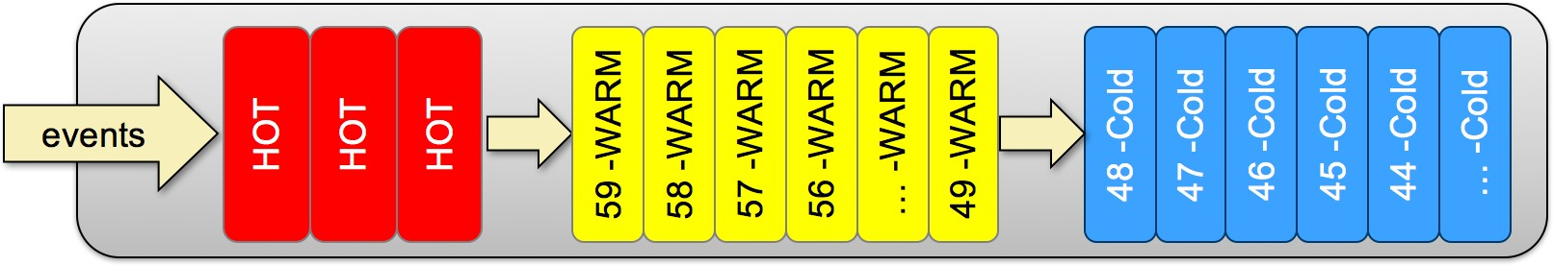

* When you search, Splunk uses the time range to choose which buckets to search and then uses the bucket indexes to find qualifying events



How Splunk Searches – Searching

|  |  |  |
| --- | --- | --- |
| Hot: Now to -3h | index | raw events |
| Hot: -3 to -6h | index | raw events |
| Hot: -5 to -8h | index | raw events |
| Warm: -9 to -12h | index | raw events |
| Warm: -12 to -15h | index | raw events |
| Warm: -14 to -17h | index | raw events |
| ..... | index | raw events |
| Warm: -42 to -45h | index | raw events |
| Warm: -45 to -48h | index | raw events |
| Cold: -48 to -51h | index | raw events |
| Cold: -51 to -54h | index | raw events |
| Cold: -54 to -57h... | index | raw events |

* When you search for index=web password fail* during the last 24 hours:
  + Splunk identifies the buckets for the last 24 hours

⬇ And searches the indexes of those buckets for the search terms

* As events are stored by time, time is the most efficient filter
* After time, most powerful keywords are host, source, sourcetype
* To make searches more efficient, include as many terms as possible
  + e.g., searching for sourcetype=*x* failure is better than failure
* Use the fields command to extract (discover) only fields you need
* Example: Search last 365 days, scans 566,720 events (in secs):

|  |  |  |  |  |  |  |  |
| --- | --- | --- | --- | --- | --- | --- | --- |
| index=web | sourcetype=access_combined |  |  |  |  |  | 15.16 |
| index=web | sourcetype=access_combined | | | fields | clientip | bytes | referrer | 4.49 |

* Splunk only searches for whole words, but wildcards allowed
* Only *trailing* wildcards make efficient use of index
  + Wildcards at *beginning* of string scan all events within time frame
  + Wildcards in *middle* of string may return inconsistent results
  + So use fail* (not *fail or *fail* or f*il)
* Wildcards tested after all other terms
* Inclusion is generally better than exclusion
  + Searching for "access denied" is faster than

NOT "access granted"

* Filter as early in your search as possible
  + Removing duplicates then sorting is faster than sorting then removing duplicates
* Use the appropriate search mode
  + Fast - performance over completeness
  + Smart [default]
  + Verbose - completeness over performance
* A transforming command:
  + Massages raw data into a data table
  + 'Transforms' specified cell values for each event into numerical values that you can use for statistical purposes
  + Is required to 'transform' search results into visualizations
* Transforming commands include:
  + top
  + rare
  + chart
  + timechart
  + stats
  + geostats
* Emphasizes performance, returning only essential and required data



Reviewing Search Mode – Fast Mode

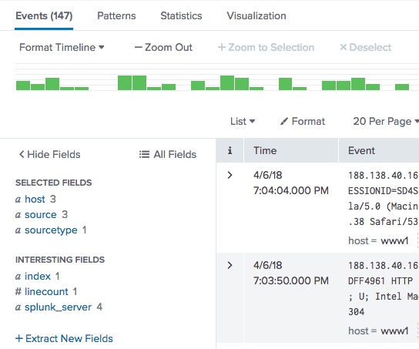

index=web sourcetype=access_combined

* For non-transforming searches:
* Events – fields sidebar displays only those fields required for the search
* Patterns

✗ Statistics or visualizations

* Contents of interesting fields sidebar are lost
* For transforming searches:



Reviewing Search Mode – Fast Mode (cont.)

index=web sourcetype=access_combined

| stats count by action

✗ Events

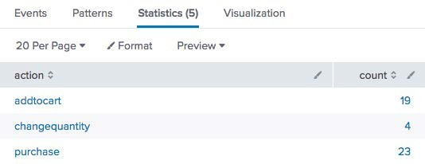

✗ Patterns

* Statistics or visualizations
* Designed to give you the best results for your search



Reviewing Search Mode – Smart Mode (Default)

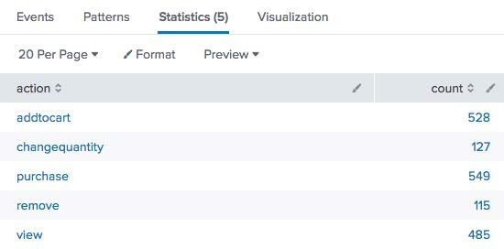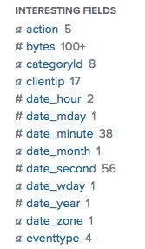

* Combination of Fast and Verbose modes
* For non-transforming searches [Verbose]:
* Events – fields sidebar displays all fields
* Patterns

✗ Statistics or visualizations

* For transforming searches:

✗ Events

✗ Patterns

* Statistics or visualizations

# Reviewing Search Mode – Verbose Mode

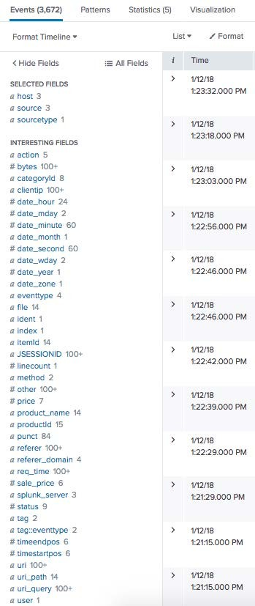

* Emphasizes completeness by returning all possible field and event data
* For non-transforming searches:
* Events – fields sidebar displays all fields
* Patterns

✗ Statistics or visualizations

* For transforming searches:
* Events
* Patterns
* Statistics or visualizations
* Use the most appropriate search mode:



Search Performance – Modes



Note

These searches were run in our lab environment, not a production environment - your results may vary.

index=web sourcetype=access_combined

| chart count by product_name

* Time range: last 365 days

|  |  |  |  |
| --- | --- | --- | --- |
| Mode | Returned Results | Events Scanned | Time |
| Fast | 14 | 566,731 | 1.82 |
| Smart | 14 | 566,731 | 1.91 |
| Verbose | 14 | 566,731 | 15.21 |

# Search Performance – Types of Searches

Search Description Indexer throughput

A large percentage of the data matches the search

Dense

Sparse

Super Sparse

Use Cases: computing stats, reporting

index=web sourcetype=access_combined | timechart count

A small percentage of data matches the search Use Cases: troubleshooting, error analysis

index=web sourcetype=access_combined status=404 | timechart count Returns a small number of results from each index bucket matching the search I/O intensive as the indexer looks through all of an index's buckets

With a lot of data, with a lot of buckets, it can take a long time to finish

index=network sourcetype=cisco_wsa_squid action=denied src_ip=10.2.3.11

The indexer checks all buckets to find results, but bloom filters eliminate those buckets

Up to 50K matching EPS

(Events per second)

*CPU bound*

Up to 5K matching EPS

*CPU bound*

Up to 2 seconds per index bucket

*I/O bound*

that don’t include search results Up to 10-50 index

Rare

Use Cases: user behavior tracking

index=web sourcetype=access_combined sessionID=1234

buckets/second

*I/O bound*

**Generated for mastinder singh (mastinder.singh@jpmchase.com) (C) Splunk Inc, not for distribution**



Splunk Fundamentals 2

27

Copyright © 2018 Splunk, Inc. All rights reserved | 14 June 2018

* Tool allows you to examine:
  + Overall stats of search (e.g., records processed and returned, processing time)
  + How search was processed
  + Where Splunk spent its time
* Use to troubleshoot search’s performance and understand impact of knowledge objects on processing (e.g., event types, tags, lookups)
* Any existing (i.e., not expired) search job can be inspected



Note

For more information, see: [docs.splunk.com/Documentation/Splunk/latest/Sear ch/ViewsearchjobpropertieswiththeJobInspector](http://docs.splunk.com/Documentation/Splunk/latest/Search/ViewsearchjobpropertieswiththeJobInspector)

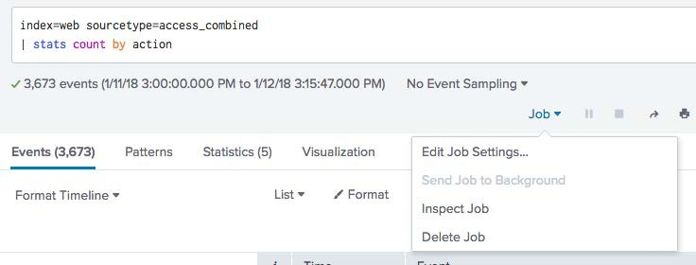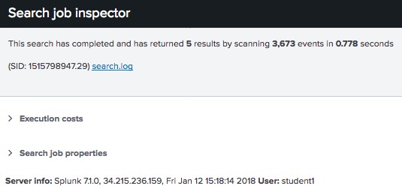

### Header

* Execution costs
* Search job properties



Search Job Inspector – Header

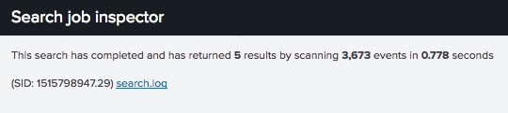

Top of Search job inspector provides basic information, including time to run and # of events scanned

* Provides details on cost to retrieve results, such as:



Search Job Inspector – Execution Costs

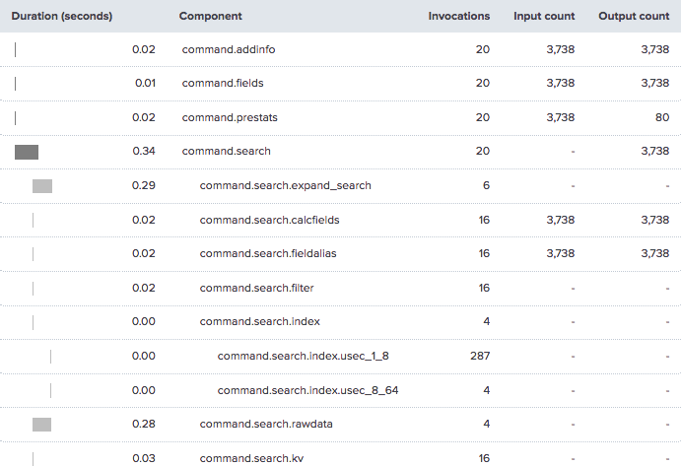

* + command.search.index Time to search the index for the location to read in rawdata files
  + command.search.filter Time to filter out events that do not match
  + command.search.rawdata Time to read events from the rawdata files

Example:



Search Job Inspector – Search Job Properties



* Produces scanCount of 127,201 events
* Returns resultCount of 2,144 in 3.01 seconds
* To calculate performance:

|  |  |  |  |  |
| --- | --- | --- | --- | --- |
| – Do **not** use resultCount/time | 2,144 / 3.01 | = | 712 | EPS* |
| – Rather, calculate scanCount/time | 127,201/ 3.01 | = | 40,892 | EPS |

* EPS= events per second

Module 3: Commands for Visualizations

* Explore data structure requirements
* Explore visualization types
* Create and format charts
* Create and format timecharts
* Explain when to use each type of reporting command

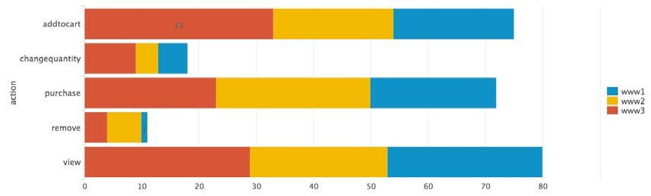

**Generated for mastinder singh (mastinder.singh@jpmchase.com) (C) Splunk Inc, not for distribution**

35

Splunk Fundamentals 2

Copyright © 2018 Splunk, Inc. All rights reserved | 14 June 2018

* When a search returns statistical values, results can be viewed with a wide variety of visualization types

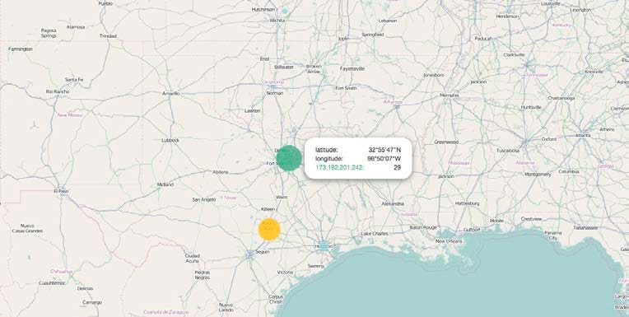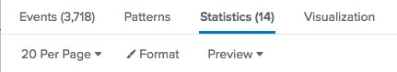

* + 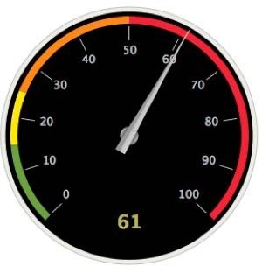Statistics table
  + Charts: Line, column, pie, etc
  + Single value, gauges
  + Maps
  + Many more
* Not all searches can be visually represented

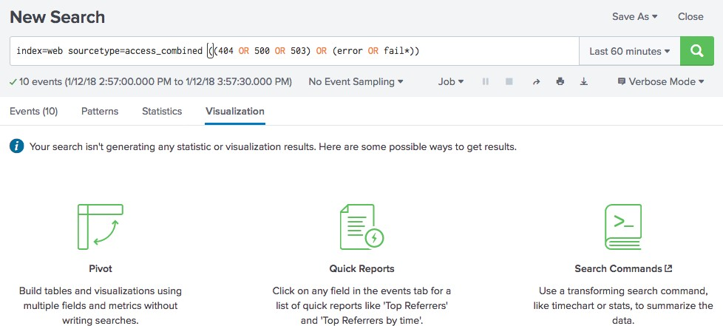

* A data series is a sequence of related data points that are plotted in a visualization
* Data series can generate any statistical or visualization results
* Most visualizations require search results structured as tables, with at least two columns, a **single series**



Data Structure Requirements – Single Series

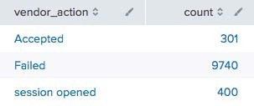

* + Leftmost column provides x-axis values
  + Subsequent columns provide numeric y-axis values for each series in the chart

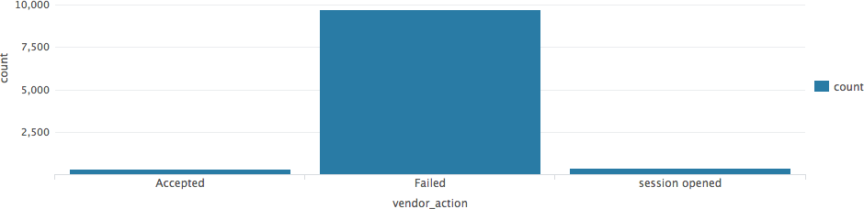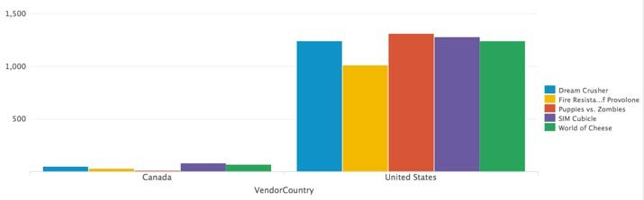

Copyright © 2018 Splunk, Inc. All rights reserved | 14 June 2018

Splunk Fundamentals 2

38

To get **multi-series** tables, you need to set up the underlying search with reporting search commands like **chart** or **timechart**



**Generated for mastinder singh (mastinder.singh@jpmchase.com) (C) Splunk Inc, not for distribution**

* **Time series** displays statistical trends over time

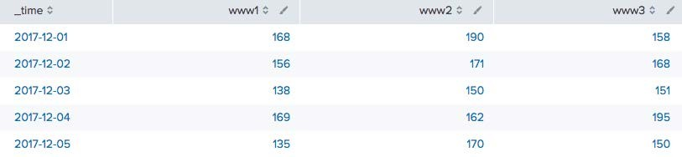

* Can be single-series or multi- series

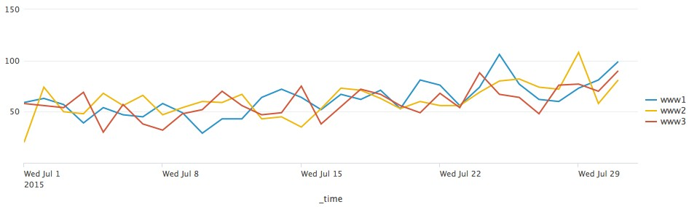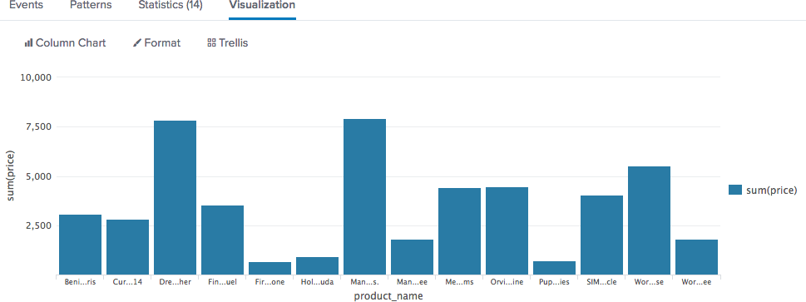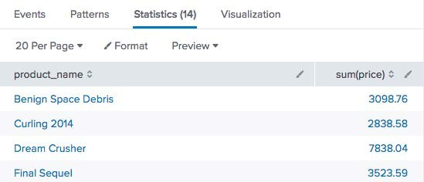

* There are seven chart types:
  + Line
  + Area
  + Column
  + Bar
  + Bubble
  + Scatter
  + Pie

| timechart count

| timechart count by action

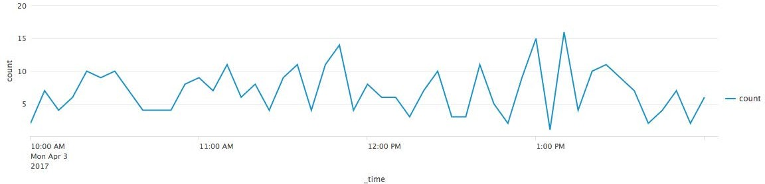

index=web sourcetype=access_combined action=*

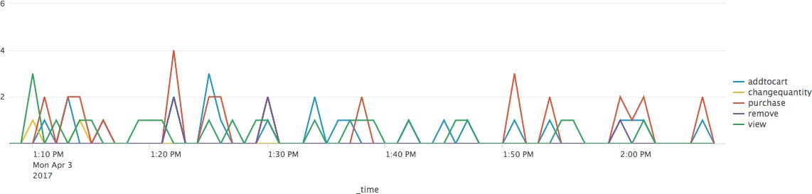

index=web sourcetype=access_combined action=*

| timechart count

| timechart count by action

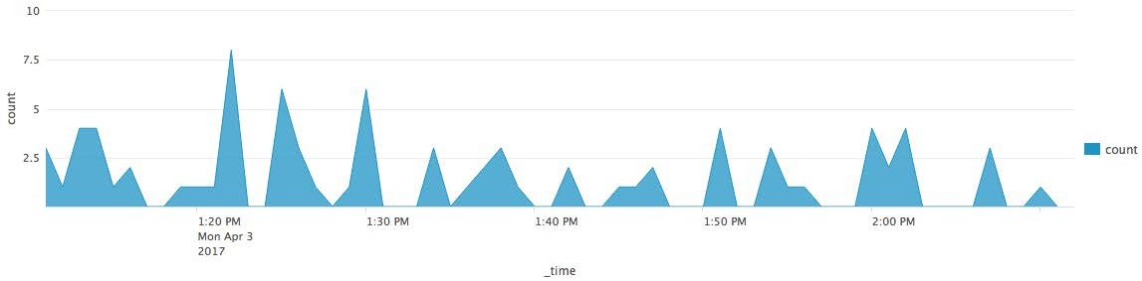

index=web sourcetype=access_combined action=*

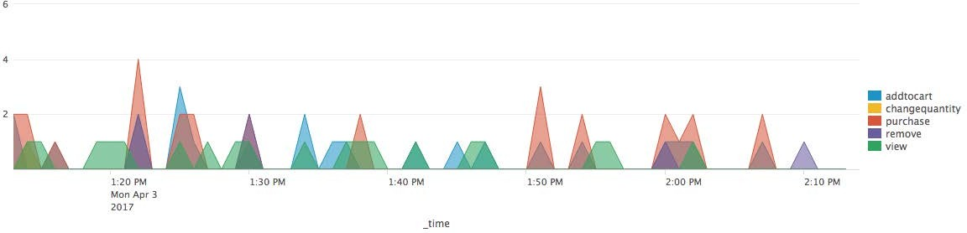

index=web sourcetype=access_combined action=*

| chart count over action

| chart count over action by host

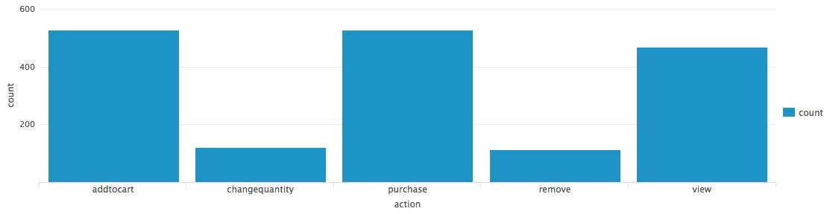

index=web sourcetype=access_combined action=*

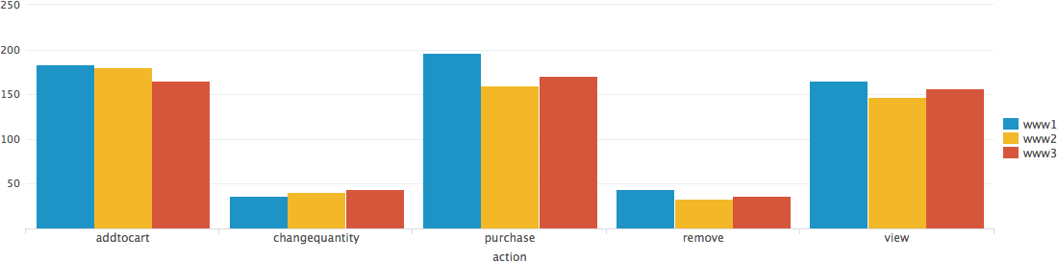

index=web sourcetype=access_combined action=*

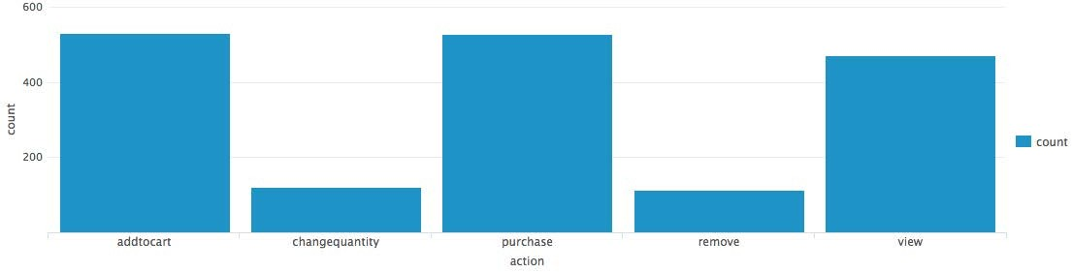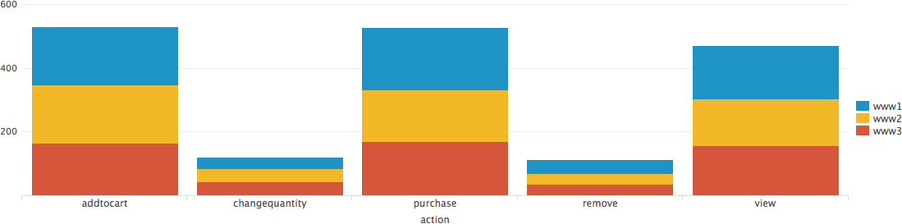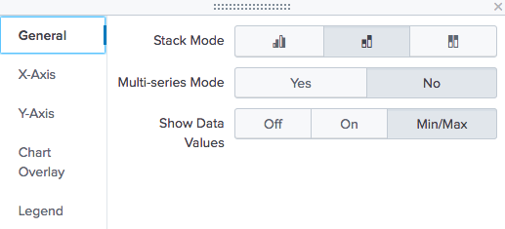

index=web sourcetype=access_combined action=*

| chart count over action

index=web sourcetype=access_combined action=*

| chart count over action by host

count over action

count over action by host

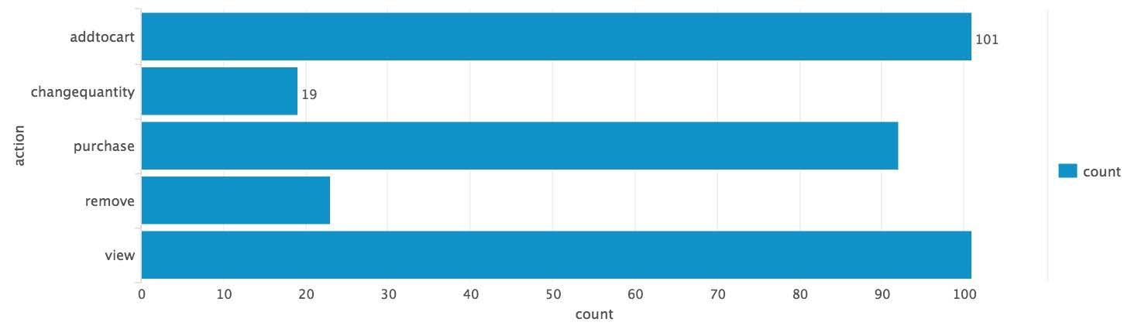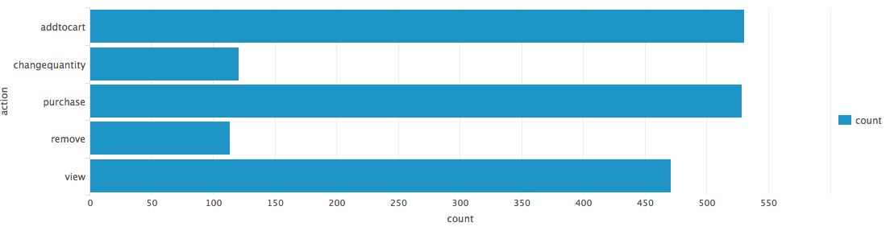

index=web sourcetype=access_combined action=*

| chart

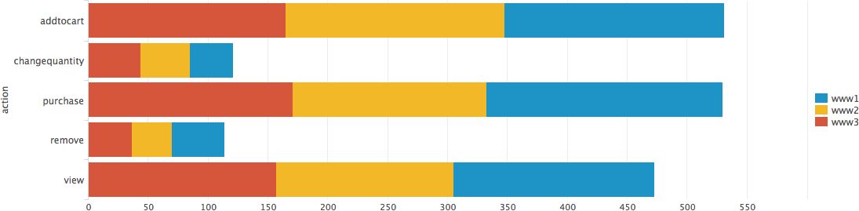

pe=access_combined action=*

| chart

index=web sourcety

index=web sourcetype=access_combined action=*

| chart count over action

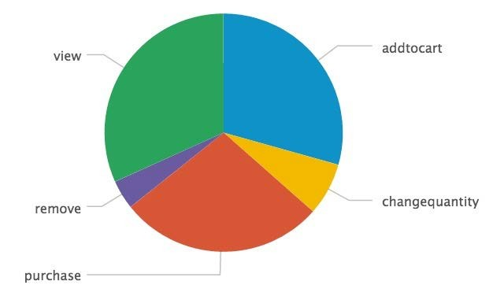

* Scatter chart shows trends in the relationships between discrete data values

| stats sum(price) as "Total Sales",

values(price) as "Price",

count by VendorCountry, product_name

index=sales sourcetype=vendor_sales VendorID >=7000 AND VendorID <=8999

* Generally, it shows discrete values that do not occur at regular intervals or belong to a series

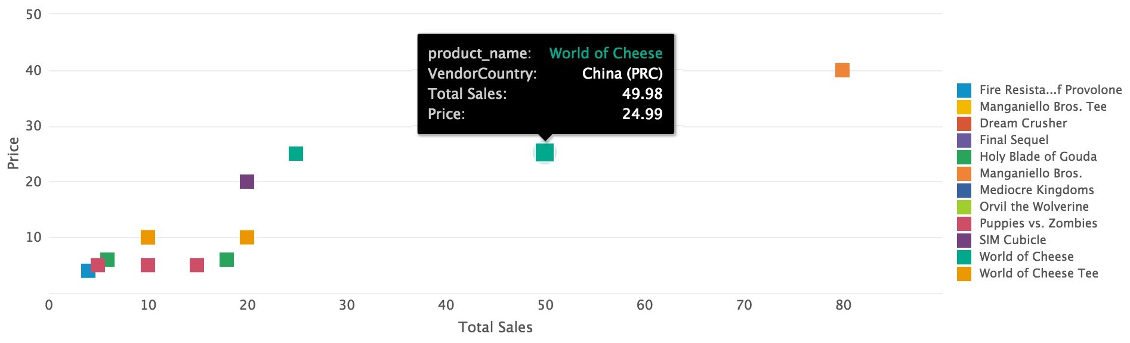

Note

Although three values are returned from this search, a scatter chart can only **show** two dimensions.

* Bubble chart provides a visual way to view a three dimensional series

| stats sum(price) as "Total Sales",

values(price) as "Price",

count by VendorCountry, product_name

index=sales sourcetype=vendor_sales VendorID >=7000 AND VendorID <=8999

* Each bubble plots against two dimensions on the X and Y axes
* The **size** of the bubble represents the value for the **third**

dimension

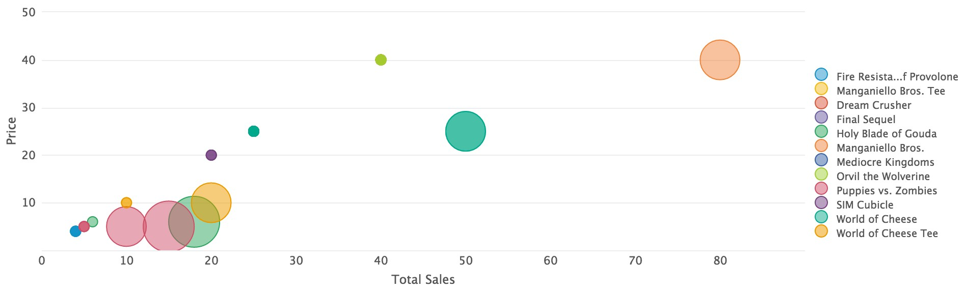

Note

Compare this with the two- dimensional scatter chart from the same search, shown on the previous slide.

* For line, area, and column charts, the x axis is horizontal

| chart count over vendor_action by app

index=security sourcetype=linux_secure

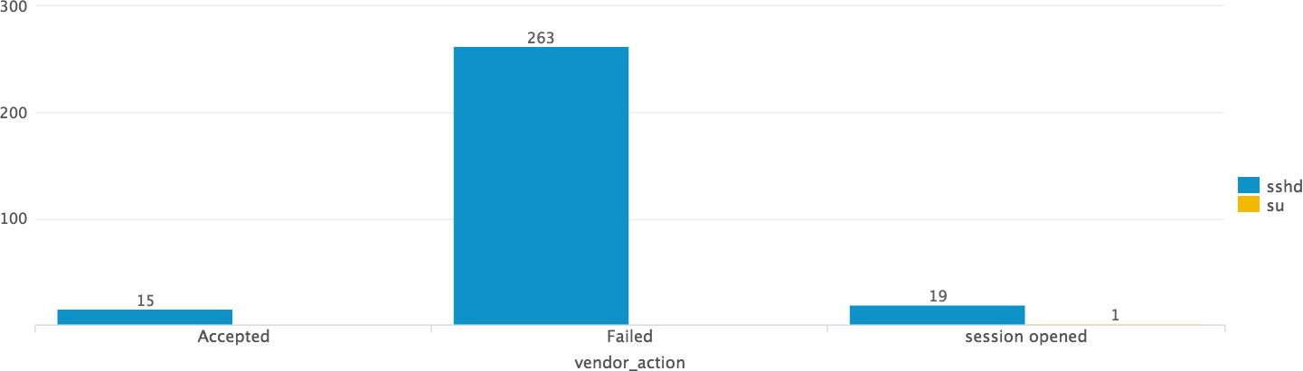

* For bar chart, the x axis is vertical

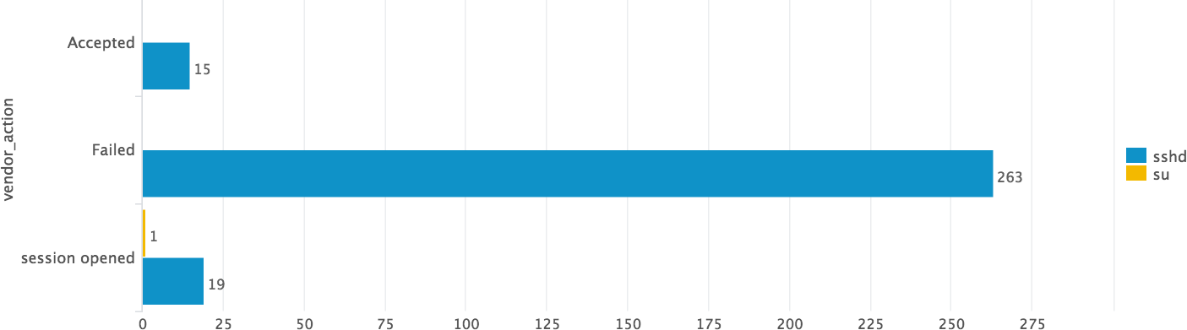

* chart command can display any series of data that you want to plot



chart Command

* You decide which field to plot on the x-axis
  + The function defines the value of the y-axis, therefore it should be numeric
  + The first field after the over clause is the x-axis
  + Using the over and by clauses divides the data into sub-groupings

⬇ The values from the by clause display in the legend

chart avg(bytes) over host

* + The host values display over the x-axis

chart avg(bytes) over host by product_name

* + The host field is the x-axis and the series is further split by product_name

count function tallies the number of events for each value in the result set

| chart count over vendor_action



chart Command – over *field*



Scenario

Display a count of vendor actions over the last 60 minutes.

index=security sourcetype=linux_secure

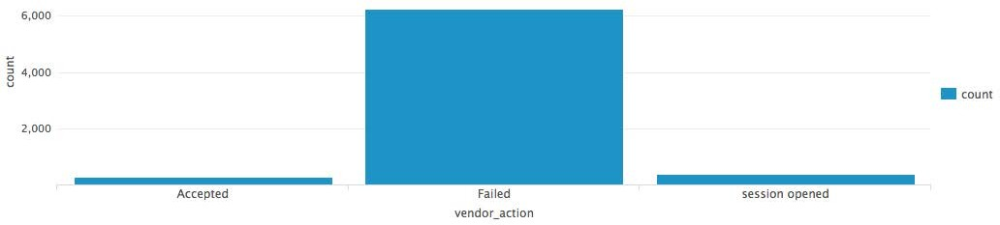

* You can use the **by** clause with the **over** clause to split results (over vendor_action by user)



chart Command – over *field* by *field*



Scenario

Display a count of vendor actions **by user**

over the last 60 minutes.

* Alternatively, you can just use two **by** clauses (by vendor_action, user)

index=security sourcetype=linux_secure

* You can only split chart results over TWO dimensions (unlike stats results)

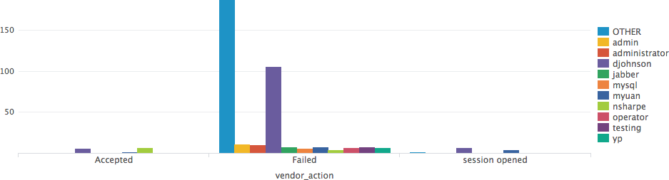

| chart count over vendor_action by user

Stack Mode **OFF**



Stack Mode

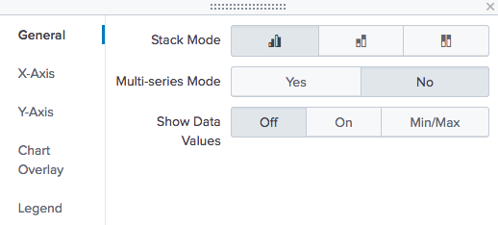

Stack Mode **ON**

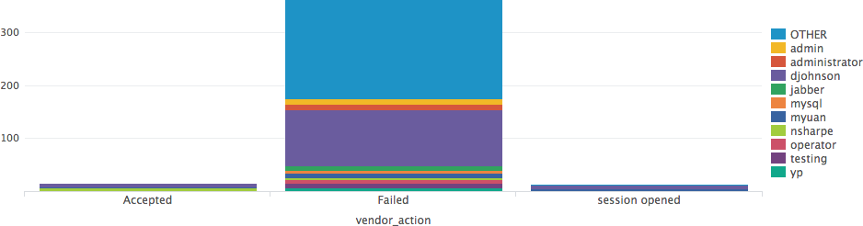

* chart and timechart commands automatically filter results to include the ten highest values



Scenario

Display a count of unsuccessful web transactions by host for each item over the last 7 days.

* + Surplus values are grouped into OTHER
* In this example, the results are skewed by NULL

index=web sourcetype=access_combined status>399

and OTHER

| chart count over host by itemId

* + These values are shown by default

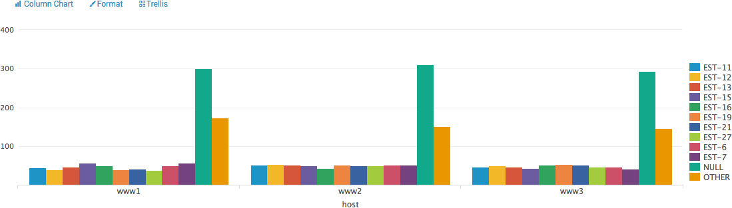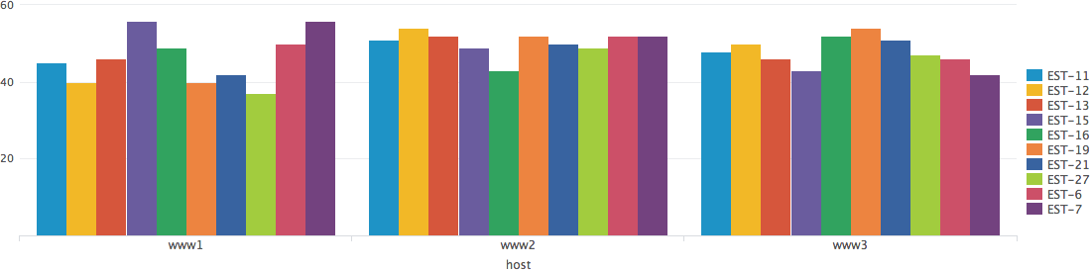

* To remove empty (NULL) and OTHER field values from the displa use these options:

y,

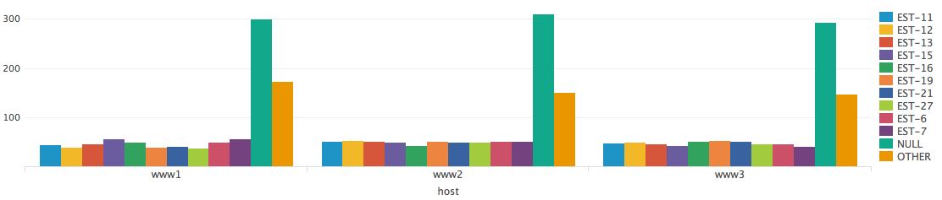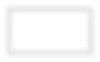

* + useother=f
  + usenull=f

| chart count over host by itemId

useother=f usenull=f

index=web sourcetype=access_combined status>399



Note

To remove null values, add

itemId=* to the base search.

| chart sum(price) over host

by product_name limit=5 useother=f

* To adjust the number of plotted series, use the limit argument
* For unlimited values, use limit=0



Scenario

Display sales per host for the top 5 best selling products over the last 7 days.



Note

When splitting on two dimensions, the limit option applies to the second split (so in this case, product_name).

index=web sourcetype=access_combined action=purchase status=200

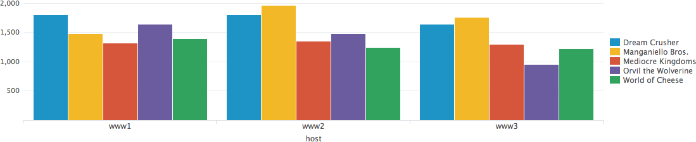

* timechart command performs statistical aggregations against time
* Plots and trends data over time
* _time is always the x-axis
* You can optionally split data using the by clause for one other field

- Each distinct value of the split by field is a separate series in the chart

* Timecharts are best represented as line or area charts

| timechart count



Scenario

How many usage violations have occurred during the last 7 days?

index=network sourcetype=cisco_wsa_squid usage=Violation

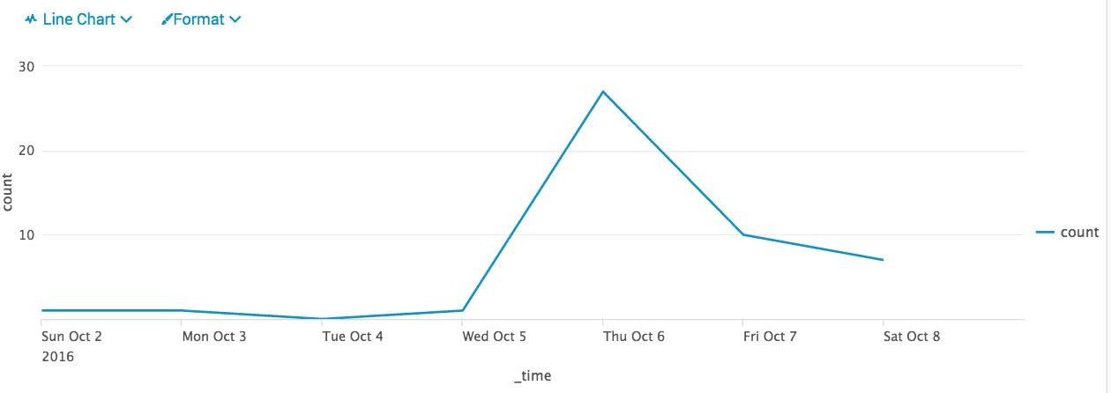

Note

Functions and arguments used with stats and

chart can also be used with timechart.

* Splitting by the usage field, each line represents a unique field value
  + Unlike stats, only ONE field can be specified after by
* y-axis represents the count for each field value



Scenario

What is the overall usage trend for the last 24 hours?

index=network sourcetype=cisco_wsa_squid



Note

Using timechart, you can split by a maximum of one field because

_time is the implied first by field.

| timechart count by usage

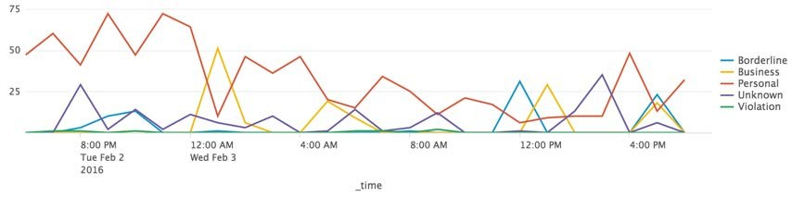

When the multi-series mode is set to **No**, all fields share the y-axis

| timechart count by usage

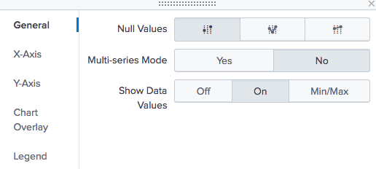

index=network sourcetype=cisco_wsa_squid



Scenario

What is the overall usage trend for the last 24 hours?

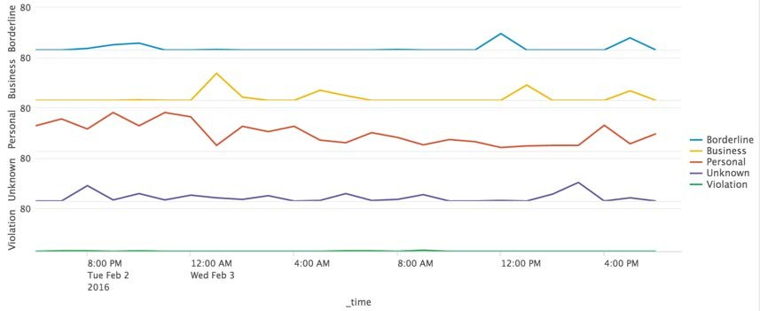

* Setting multi-series mode to **Yes** causes the y-axis to split for each field value
* y-axis is divided into sections, each spanning the same max and min count

**Generated for mastinder singh (mastinder.singh@jpmchase.com) (C) Splunk Inc, not for distribution**

Splunk Fundamentals 2

61

Copyright © 2018 Splunk, Inc. All rights reserved | 14 June 2018

* The timechart command "buckets" the values of the

| timechart span=15m count by vendor_action



timechart Command – Adjusting the Sampling Interval

index=security sourcetype=linux_secure vendor_action=*

_time field

* + This provides dynamic sampling intervals, based upon the time range of the search

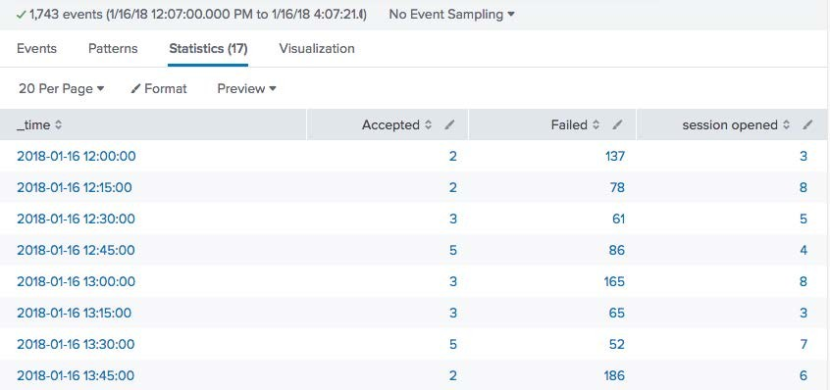

* Example defaults:
  + Last 60 minutes uses span=1m
  + Last 24 hours uses span=30m
* Adjust the interval using the

span argument, e.g. span=15m

As with the stats and chart commands, you can apply statistical functions to the timechart command

index=web sourcetype=access_combined action=*

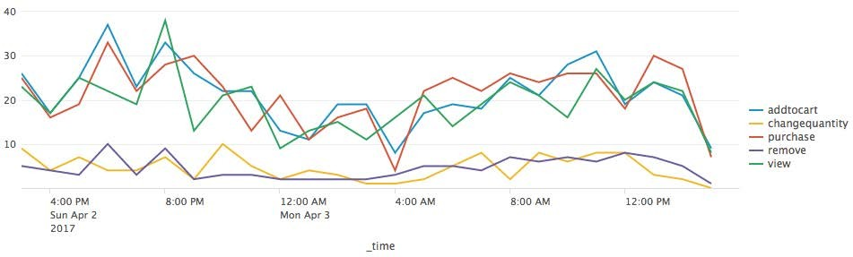

| timechart span=1h count by action



timechart Command – Statistical Functions



Scenario

How much Web activity of each type took place during the last 24 hours?

* Display multiple charts based on one result set

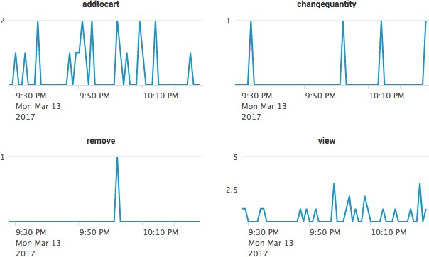

index=web sourcetype=access_combined action=*

| timechart count by action

* Allows visual comparison between different categories
* Data only fetched once

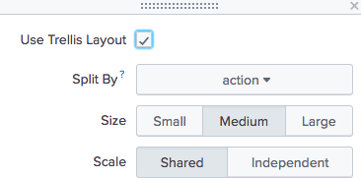

| chart count by host

index=web sourcetype=access_combined

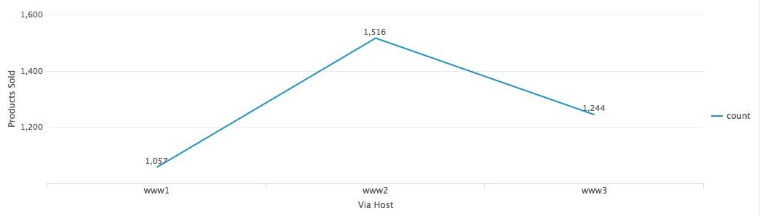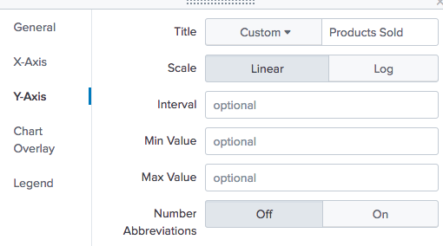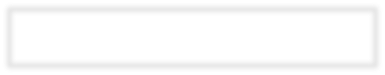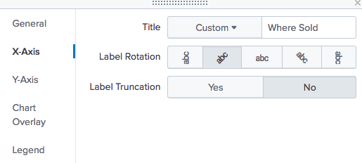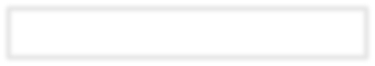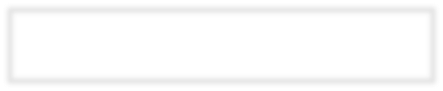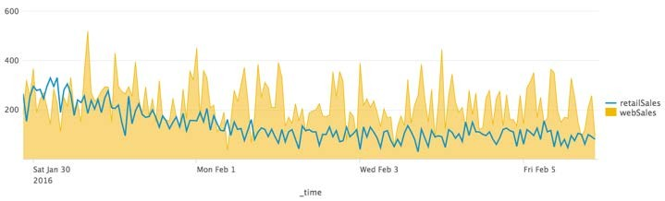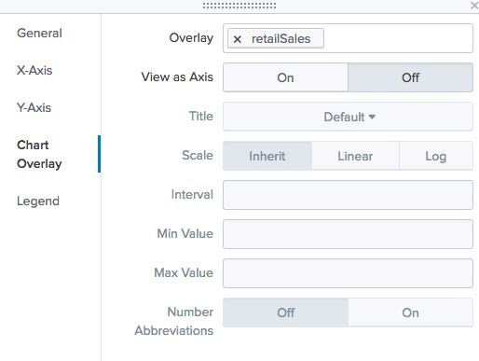

**A**



Scenario

Graphically compare the total price of online sales to sales made in physical stores for the last 7 days, on an hour-by-hour basis.

(index=web sourcetype=access_combined action=purchase status<400) OR (index=sales sourcetype=vendor_sales)

| timechart span=1h sum(price) by sourcetype

| rename access_combined as webSales, vendor_sales as retailSales

**A**

**A**

|  |  |  |  |
| --- | --- | --- | --- |
| Feature | stats | chart | timechart |
| Multi-level breakdown [by clause] | Many | 2 | 1 |
| Limit # series shown | NA | limit=*n*  *Default=10* | limit=*n*  *Default=10* |
| Filter other series | NA | useother=f | useother=f |
| Filter null values | NA | usenull=f | usenull=f |
| Set time value on x axis | NA | NA | span |

To count the frequency of a field(s), use top/rare



Transforming Command Summary (cont.)

| top src_ip, user, vendor_action, app

| rare src_ip, user, vendor_action, app

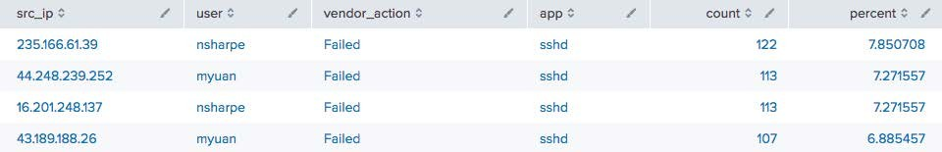

index=security sourcetype=linux_secure

index=security sourcetype=linux_secure

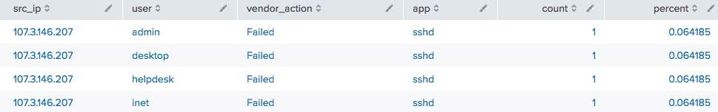

Use stats to calculate statistics for two or more by fields (non time- based)

| stats count by src_ip, user, vendor_action, app



Transforming Command Summary (cont.)

index=security sourcetype=linux_secure

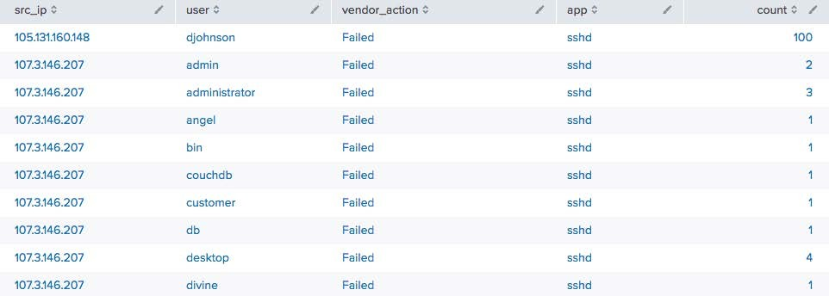

* To calculate statistics with an arbitrary field as the x-axis (not _time), use chart
  + When you use a by field, the output is a table

| chart count over src_ip

by vendor_action

index=security sourcetype=linux_secure

* + Each column represents a distinct value of the split-by field

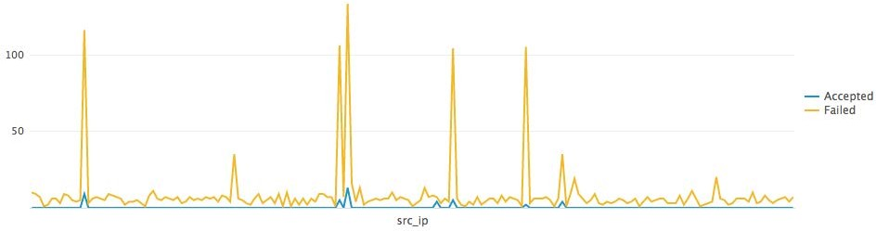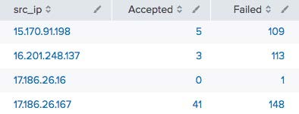

* Use timechart to calculate statistics with _time as the x-axis

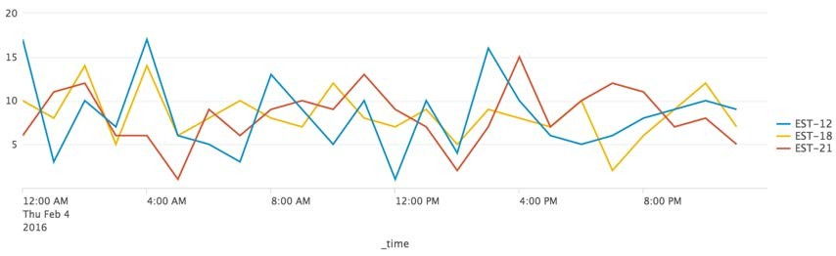

* If a by field is used, the output is a table
* Each column represents a distinct value of the split-by field

... | timechart span=1h count by itemId limit=3 useother=f

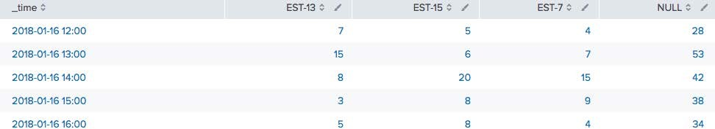

Module 4: Advanced Visualizations

* Create a trendline



Module Objectives

* Create maps
  + iplocation
  + geostats
  + geom
* Create and format single values
* Use the addtotals command
* Allows you to overlay a computed moving average on a chart
* trendline computes the moving averages of a field

trendline <*trendtype><period>(field)* [AS *newfield*]

* *trendtype*:
  + sma - simple moving average
  + ema - exponential moving average
  + wma - weighted moving average
* Must define the *period* over which to compute the trend
* *period* must be an integer between 2 and 10000
  + For example, sma2(sales) is valid



Scenario

Display total sales and sales trends over the past 24 hours.

* + But sma(sales) would *fail* as it is missing an integer, the defining period

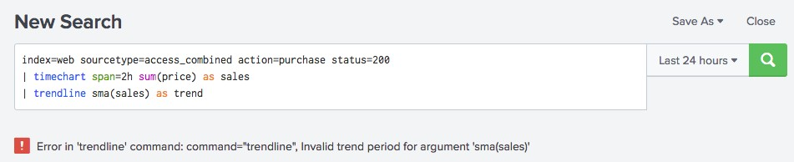

Note

e. Here however, since it does not recognize sma as a function, it is shown in black.

Autocomplete displays functions in purpl

| trendline sma2(sales) as trend



Scenario

Display total sales and sales trends over the past 24 hours.

index=web sourcetype=access_combined action=purchase status=200

| timechart span=2h sum(price) as sales

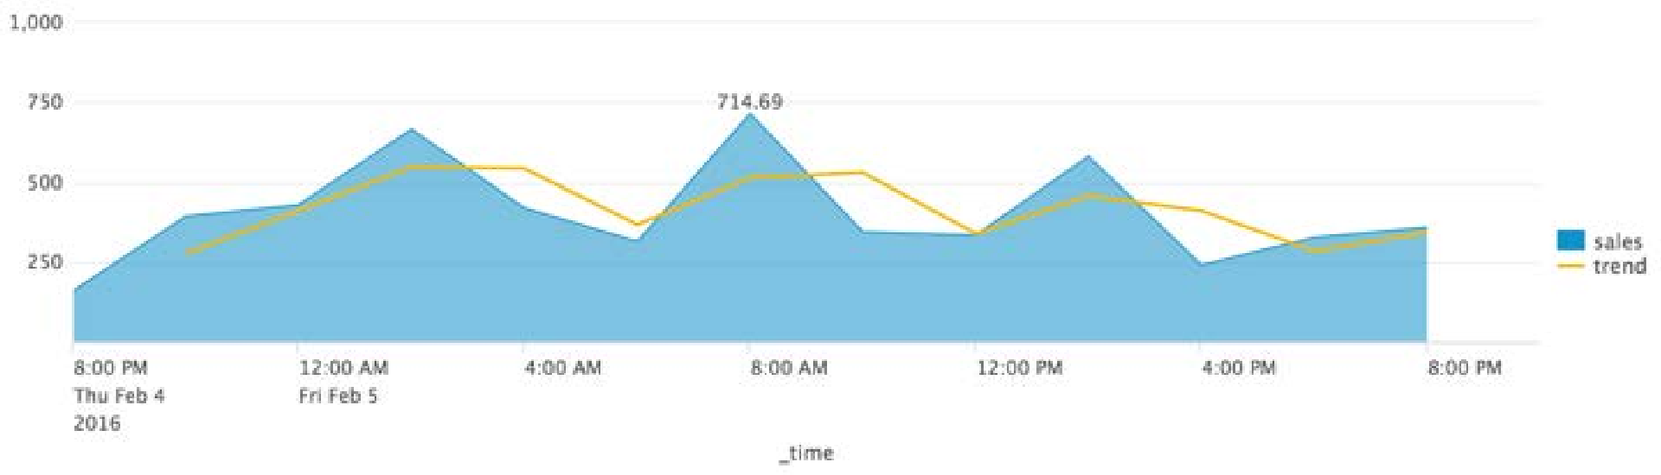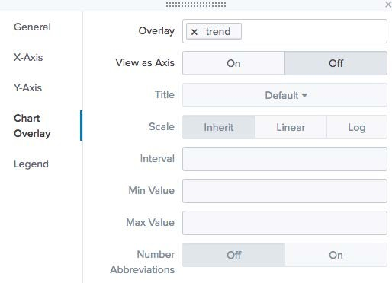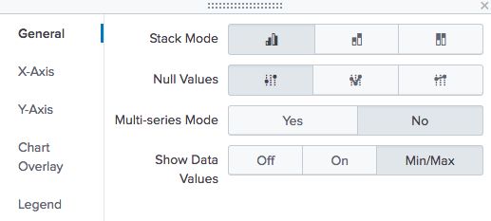

There are two map types



Viewing Results as a Map

Cluster Map

Choropleth Map

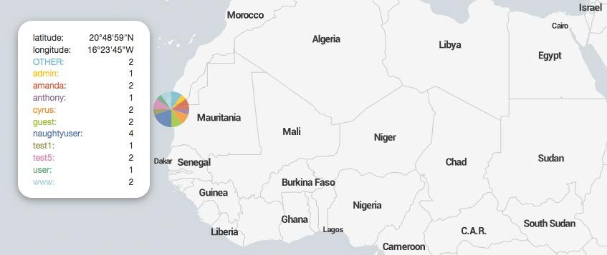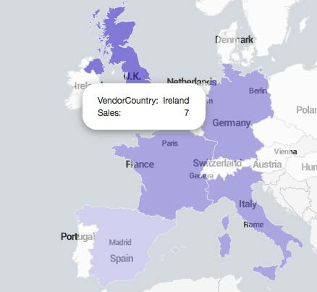

Scenario

Discover longitude and latitude data for

src_ip for the last 60 minutes.

index=security sourcetype=linux_secure (fail* OR invalid)

* 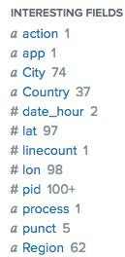Use iplocation to look up and add location information to an event

| iplocation src_ip

|  |
| --- |
|  |
|  |
|  |
|  |
|  |
|  |
|  |
|  |

* + This information includes city, country, region, latitude and

longitude

* Not all of the information is available for all ip address ranges
* Automatically defines the default lat and lon fields required by geostats
* Use geostats to compute statistical functions and render a cluster map

geostats [latfield=*string*] [longfield=*string*] [*stats-agg- term*]* [by-clause]

* Data must include latitude and longitude values
* Define the *latfield* and *longfield* only if they differ from the default lat and lon fields
* To control the column count:
  + On a global level, use the globallimit argument
  + On a local level, depending on where your focus is (i.e., where you’ve zoomed in), use the locallimit argument

| iplocation src_ip

| geostats globallimit=5 count by user

index=security sourcetype=linux_secure (fail* OR invalid)



Scenario

Map the users of failed actions on the network worldwide during the last 24 hours.

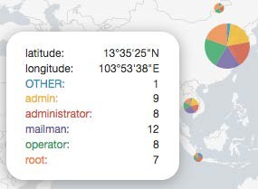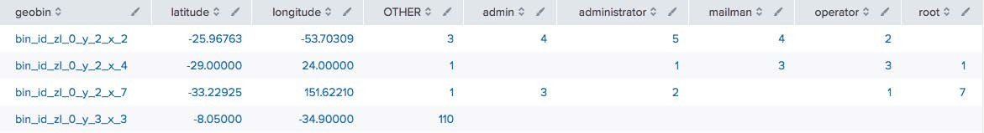

* Uses shading to show relative metrics, such as sales, network intruders, etc. for predefined geographic regions



Choropleth Map

* To define regional boundaries, you must have either a:
  + 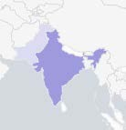KML (Keyhole Markup Language) file
  + KMZ (compressed Keyhole Markup Language) file
* Splunk ships with:
  + geo_us_states, United States
  + geo_countries, countries of the world

…| geom [*featureCollection*] [featureIdField=*string*]

| geom geo_countries featureIdField=VendorCountry



geom Command

index=sales sourcetype=vendor_sales VendorID > 4999 AND VendorID < 6000

| stats count as Sales by VendorCountry



Scenario

Display the previous week’s retail sales in EMEA.

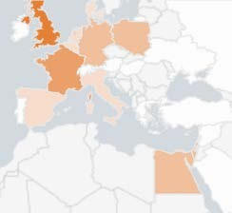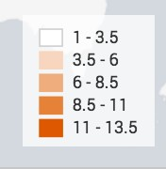

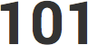Single value visualizations provide various formatting options

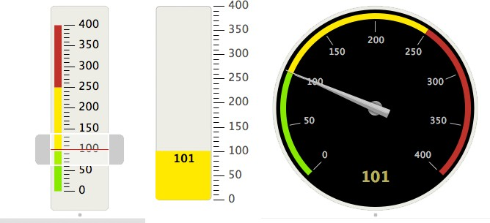

Marker Filler Radial

| stats count



Viewing Results as a Single Value

index=security sourcetype=linux_secure vendor_action=failed

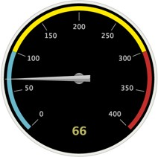

| gauge count 0 5000 10000 15000

sourcetype=access_combined action=purchase

| stats sum(price) as count

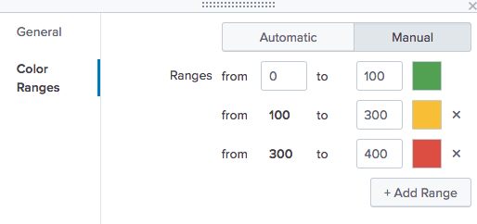

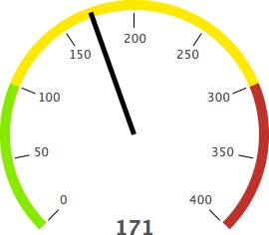Set color using UI or with the



Single Value Visualizations: Formatting

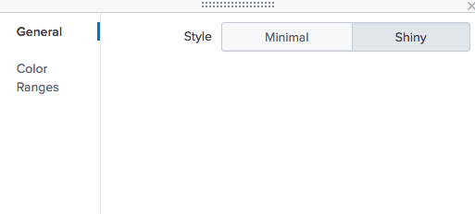

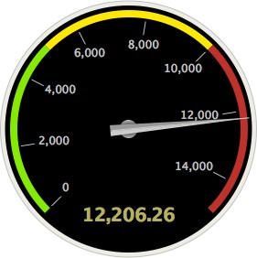gauge command

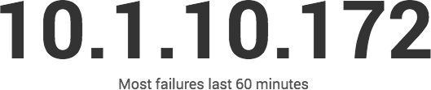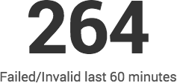

| stats count(vendor_action)

| chart count by src_ip

| sort -count

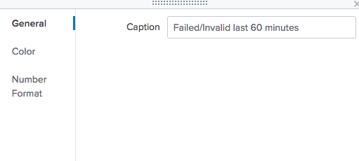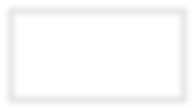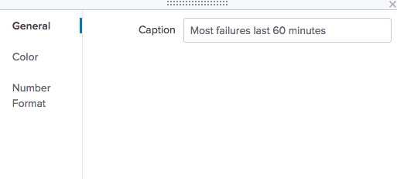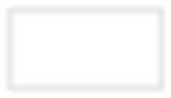

index=security sourcetype=linux_secure (fail* OR invalid)

index=security sourcetype=linux_secure (fail* OR invalid)

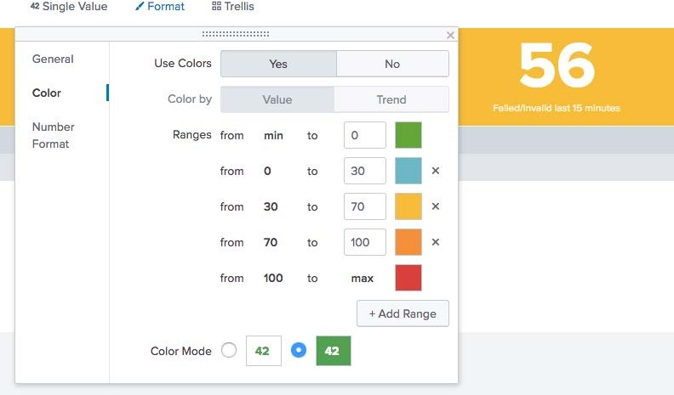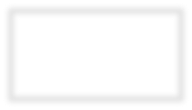

index=security sourcetype=linux_secure (fail* OR invalid)

| stats count

To resize the font, resize the pane

Optionally, specify number format information for the single value on the **Number Format** tab

| stats count

index=security sourcetype=linux_secure (fail* OR invalid)

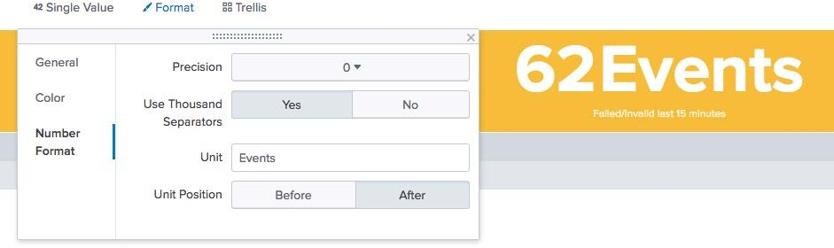

* With the timechart command, you can add a sparkline and a trend

| timechart span=15m count(vendor_action)

index=security sourcetype=linux_secure fail* OR invalid

* A **sparkline** is an inline chart

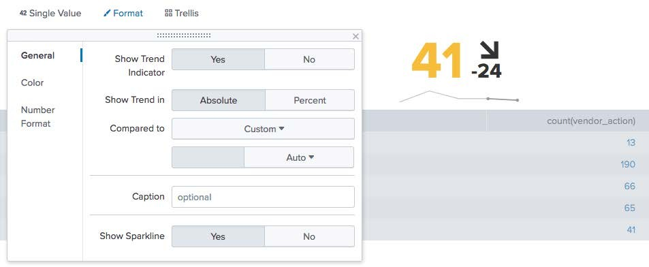

* + It is designed to display time- based trends associated with the primary key
* The **trend** shows the direction in which values are moving
  + It appears to the right of the single value
* Automatically total every column using the Format options



Scenario

For the last 60 minutes, display the total number of events, with the total and average size (in bytes) by web server. Also, calculate the total bytes.

* When using this approach, you:

index=web sourcetype=access_combined

| stats sum(bytes) as Bytes, avg(bytes) as avgBytes, count as totalEvents by host

* + Cannot indicate which column to total; all columns are always totaled
  + Cannot add labels

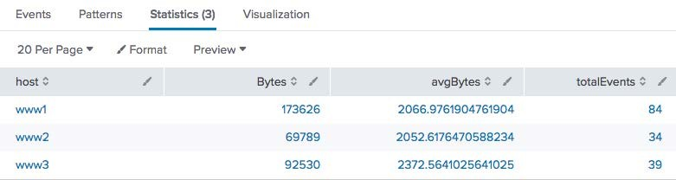

1

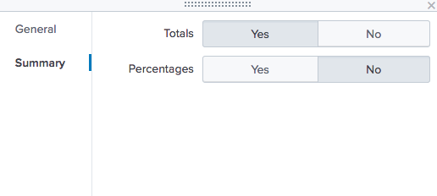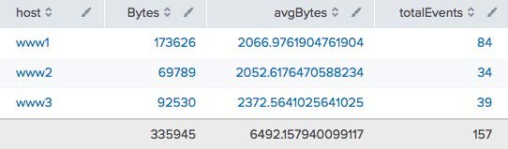

3

2

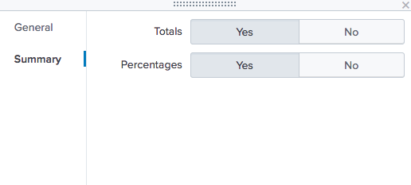

**Generated for mastinder singh (mastinder.singh@jpmchase.com) (C) Splunk Inc, not for distribution**

90

Splunk Fundamentals 2

Copyright © 2018 Splunk, Inc. All rights reserved

|

14 June 2018

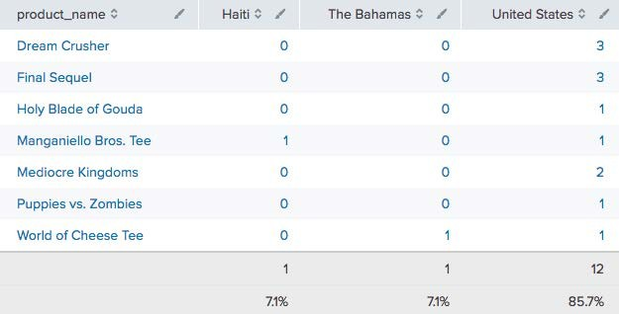

* Using the **Summary** tab, you can add a % row to the end of the statistics table
* *All* columns are used to compute the percentage – i.e., all percentages from all columns combined will equal approximately 100%



Scenario

Display the retail products sold by country with totals by product and by country during the last 4 hours.

index=sales sourcetype=vendor_sales

| chart count over product_name by VendorCountry

* Alternatively, use the addtotals command to:



Adding Totals Using addtotals Command

* + Compute the sum of all **or selected** numeric fields for each column and place the total in the last row
  + Compute the sum of all **or selected** numeric fields for each **row** and place the total in the last column

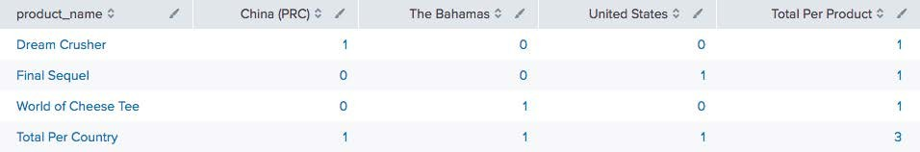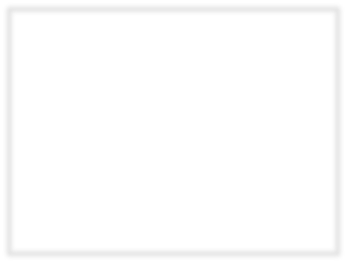

|  |  |
| --- | --- |
|  |  |
|  |  |

addtotals [row=*bool*] [fieldname=*field*]

[col=*bool*][labelfield=*field*] [label=*string*] *field-list*

|  |  |  |  |
| --- | --- | --- | --- |
| **Row Options** | | **Column Options** | |
| row=true/false  (Default= true) | A column is created that contains numeric totals for each row. | col=true/false  (Default= false) | A row is created that contains numeric totals for each column. |
| fieldname=*field*  (Default=Total) | Defines a string used to create a field name for the totals column. | label=*string*  (Default=Total) | Defines a string used to name the totals row. |
|  |  | labelfield=  *fieldname* | Defines where the label string is placed. (Generally, you should make this the first column.) |



Defines the numeric fields to be totaled.

*field-list*=one or more numeric fields. (Default: all numeric fields)

**General Options**

* row=t (default) counts the fields in each row under a column named "Total Per Product”

index=sales sourcetype=vendor_sales

| chart count over product_name by VendorCountry

| addtotals

fieldname="Total Per Product" **A**

col=t B

label="Total Per Country" labelfield=product_name

C



**A**

B

C

A

B

C

* col=t counts the fields in each row in a row named "Total Per Country"



Scenario

Calculate the total retail products sold by country totaled by product and by country during the last 60 minutes.



Scenario

For the last 60 minutes, display the total number of events with the total and average size (in bytes) by web server, and then total the bytes.

Do not total rows

index=web sourcetype=access_combined

| stats sum(bytes) as Bytes, avg(bytes) as avgBytes, count as totalEvents by host

| addtotals row=f

labelfield=host

**A**

D

col=t

Bytes

B

E

label=totalBytes C

**A**

1. Total columns

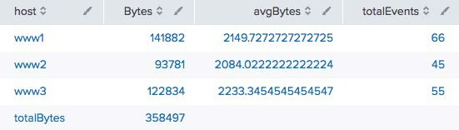

B

D

C

E

1. Add the label totalBytes

Place the label under the host column

D

Only total the Bytes column

E

Module 5: Filtering and Formatting Data

* Use the eval command to:



Module Objectives

* + Perform calculations
  + Convert values
  + Round values
  + Format values
  + Use conditional statements
* Use the search and where commands to filter calculated results
* Use fillnull command
* eval allows you to calculate and manipulate field values in your report

eval *fieldname1* = *expression1 [, fieldname2 = expression2...]*

* Supports a variety of functions
* Results of eval written to either new or existing field you specify
* If the destination field exists, the values of the field are replaced by the results of eval
* Indexed data is not modified, and no new data is written into the index
* Field values are treated in a case-sensitive manner
* The eval command allows you to:

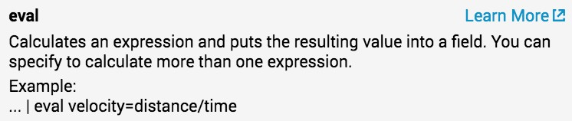

* + Calculate expressions
  + Place the results in a field
  + Use that field in searches or other expressions
* Type Operators

|  |  |  |  |  |
| --- | --- | --- | --- | --- |
| Arithmetic  Concatenation | + -  + . | * / | % |  |
| Boolean | AND | OR | NOT | XOR |

Comparison < > <= >= != = == LIKE



Note

For more info on common eval functions, see [http://docs.splunk.com/Documenta tion/Splunk/latest/SearchReferenc e/CommonEvalFunctions](http://docs.splunk.com/Documentation/Splunk/7.0.3/SearchReference/CommonEvalFunctions)

* This example report displays the sum of bytes used for each usage category

index=network sourcetype=cisco_wsa_squid



Scenario

What types of websites used the most bandwidth in bytes during the previous month?

* It is difficult to determine how much bandwidth is being used by looking at bytes

| stats sum(sc_bytes) as Bytes by usage

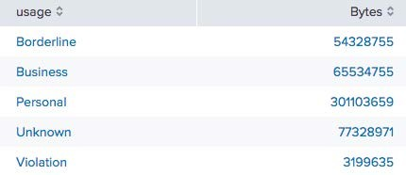

* First, use eval to convert the

bytes value into megabytes

* Results of eval must be set to a new or existing field



Scenario

What types of websites used the most bandwidth in megabytes during the previous month?

* In this example:

index=network sourcetype=cisco_wsa_squid

| stats sum(sc_bytes) as Bytes A by usage

Calculate the number of bytes for each usage type

| eval bandwidth B = Bytes/(1024*1024) C

A

Create a new field named

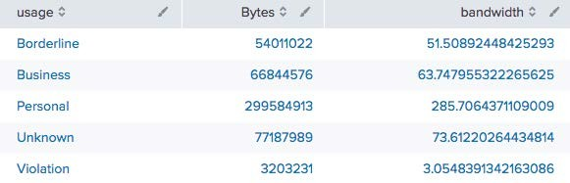

B

C

A

B

bandwidth

Convert the values of the Bytes field into MB by dividing Bytes field values by (1024*1024)

C

* The results of Bandwidth are hard to read with so many decimal points



eval Command – Round Values



Scenario

What types of websites used the most bandwidth in megabytes, rounded to 2 decimal places, during the previous month? Sort by bandwidth.

* round(*field*/*number*, *decimals*) function sets the value of a field to the number of decimals you specify

round(Bytes/(1024*1024), 2)

index=network sourcetype=cisco_wsa_squid

| stats sum(sc_bytes) as Bytes by usage

| eval bandwidth =

| sort -bandwidth

| rename bandwidth as "Bandwidth (MB)"

A

* In this example:
  + Divide the value of the Bytes field by (1024*1024)

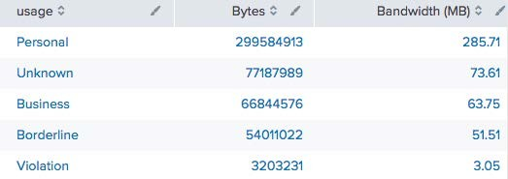

A

- Round the result to two decimal points

* If the number of decimals is unspecified, the result is a whole number
* The "Bandwidth (MB)" field has the data in the desired format



Removing Fields



Scenario

What types of websites used the most bandwidth in megabytes, rounded to 2 decimal places, during the previous month? Sort by bandwidth.

* The Bytes field is no longer needed

index=network sourcetype=cisco_wsa_squid

| stats sum(sc_bytes) as Bytes by usage

| eval bandwidth = round(Bytes/(1024*1024), 2)

| sort -bandwidth

| rename bandwidth as "Bandwidth (MB)"

| fields A

* + The Bytes field can be removed

- Bytes

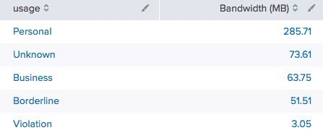

|  |  |  |
| --- | --- | --- |
|  | A |  |

You can perform mathematical functions against fields with numeric field values



eval Command – Calculating Values

index=web sourcetype=access_combined product_name=* action=purchase

1. | stats sum(price) as tp, sum(sale_price) as tsp by product_name
2. | eval Discount = round(((tp - tsp)/ tp)*100)

| sort -Discount

| eval Discount = Discount."%"

| rename tp as "Total List Price", tsp as "Total Sale Price", product_name as Product



Scenario

Calculate total online sales for last week; include price, sales price, and discount percentage. Sort by descending discount value.

In this example, stats calculates the total list price and total sale price by product_name

A

eval calculates the discount percentage and formats the discount field

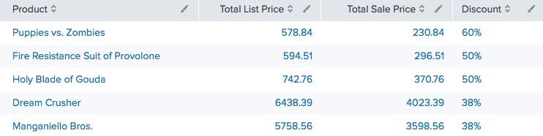

B

sort lists the highest discounted items first



eval Command – Calculating Values (cont.)

C



Scenario

Calculate total online sales for last week; include price, sales price, and discount percentage. Sort by descending discount value.

eval converts Discount to a string and concatenates the % character

D

index=web sourcetype=access_combined product_name=* action=purchase

| stats sum(price) as tp, sum(sale_price) as tsp by product_name

| eval Discount = round(((tp - tsp)/ tp)*100)

1. | sort -Discount
2. | eval Discount = Discount."%"
3. | rename tp as "Total List Price", tsp as "Total Sale Price", product_name as Product

rename provides user friendly headings

E



* tostring converts a numeric field value to a string



Scenario

How much potential online sales revenue was lost during the previous week due to 503 server errors?

tostring(field,"*option*")

index=web sourcetype=access_combined

action=purchase status=503

A

avg(price) as AverageLostSales,

sum(price) as TotalLostRevenue

, B

C

* Options:
  + "commas": applies commas

| stats count(price) as NumberOfLostSales,

⬇ If the number includes decimals, it rounds to two decimal places

| eval AverageLostSales =

"$" + tostring(AverageLostSales, "commas") TotalLostRevenue =

"$" + tostring(TotalLostRevenue, "commas")

* + "duration": formats the number as

"hh:mm:ss"

* + "hex": formats the number in hexadecimal



A B C

This example shows "duration"



Scenario

Identify the five longest client sessions over the last 4 hours in HH:MM:SS format.

option of tostring function

stats calculates sessionTime for each session (JSESSIONID)

index=web sourcetype=access_combined

| stats range(_time) as sessionTime by JSESSIONID A

| sort 5 -sessionTime

B

C

A

– Use the range function to return the difference between the max and min values of _time

| eval duration = tostring(sessionTime,"duration")

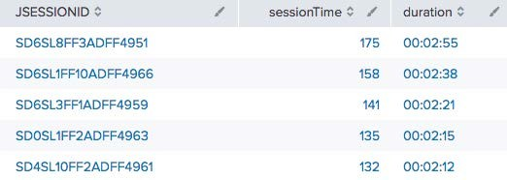

A

A

C

B

sort 5 displays the top 5 most frequent values

B

The duration option formats the time as "hh:mm:ss"

C

* eval with added characters converts numeric field values to strings



Formatting and Sorting Values

* To order numerically, first sort, then use eval

| eval price = "$".price

| eval price = "$".price

index=web sourcetype=access_combined price=*

| stats values(price) as price by product_name

| sort -price

index=web sourcetype=access_combined price=*

| stats values(price) as price by product_name

| sort -price

Alpha Numeric

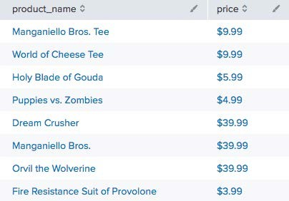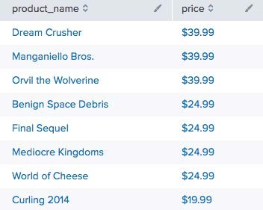

### Multiple expressions can be combined into one eval command



eval Commands with Multiple Expressions

* Each subsequent expression references the results of previous expressions
* Expressions must be separated by commas

eval *fieldname1* = *expression1, fieldname2 = expression2,*

*fieldname3 = expression3...*

Based on the values of list_price and current_sale_price, calculate the current_discount percentage



eval Commands with Multiple Expressions – Example

A



Scenario

Calculate a new sale price that is 5% less than the current discount percentage for online sales data over the last hour.

Calculate the new_discount value by subtracting 5 from current_discount

| eval current_discount = round((list_price – A

current_sale_price)/list_price*100,2),

new_discount = (current_discount - 5), B new_sale_price = list_price - (list_price * (new_discount/100)) C

index=web sourcetype=access_combined price=*

| stats values(price) as list_price, values(sale_price) as current_sale_price by product_name

B

Calculate the new_sale_price by applying the new_discount percentage

C

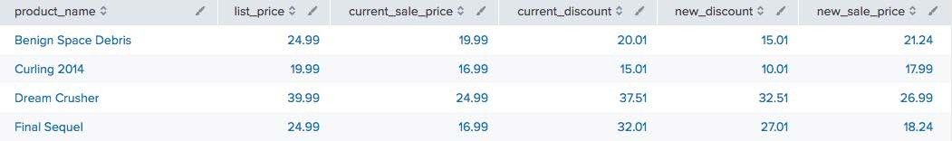

if(*X*,*Y*,*Z*)



eval Command – if Function Syntax

* The if function takes three arguments
* The first argument, *X*, is a Boolean expression
* If it evaluates to TRUE, the result evaluates to the second argument, *Y*
* If it evaluates to FALSE, the result evaluates to the third argument, *Z*
* Non-numeric values must be enclosed in "double quotes"
* Field values are treated in a case-sensitive manner



eval Command – if Function Example



Scenario

Display retail sales for the previous week, broken down by Asia and the Rest of the World.

index=sales sourcetype=vendor_sales

| eval SalesTerritory =

| stats sum(price) as TotalRevenue by SalesTerritory

| eval TotalRevenue = "$" + tostring(TotalRevenue, "commas")

* Create a new field, SalesTerritory

if((VendorID >= 7000 AND VendorID < 8000), "Asia", "Rest of the World")

X Y Z

* Evaluate VendorID

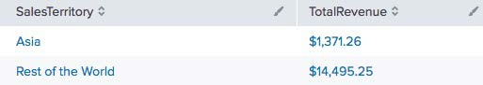

* + If >= 7000 AND < 8000 is TRUE, set result to "Asia"

⬇ Remember, arguments must be enclosed in quotes

* + If it evaluates to FALSE, set result to

"Rest of the World"



index=web sourcetype=access_combined

X1

Y1

X2

Y2

**G**X**en**3**erated f**Y**o**3**r mastinder singh (mastinder.singh@jpmchase.com) (C) Splunk Inc, not for distribution**

112

Splunk Fundamentals 2

Copyright © 2018 Splunk, Inc. All rights reserved

|

14 June 2018

case(X1,Y1,X2,Y2...)



eval Command – case Function



Note

The **like** operator is discussed later in this module.

* The first argument, *X1*, is a Boolean expression
* If it evaluates to TRUE, the result evaluates to *Y1*
* If it evaluates to FALSE, the next Boolean expression, *X2*, is evaluated, etc.
* If you want an “otherwise” clause, just test for a condition you know is true at the end (e.g., 0=0)

| eval rating = case(productId LIKE "WC%", "Teen", productId LIKE "FS%", Mature",

0=0, "Unrated")

* To count the number of events that contain a specific field value, use the count and eval functions



eval function

index=security sourcetype=linux_secure vendor_action=*



Scenario

Count the number of events that occurred yesterday where the vendor action was Accepted, Failed, or session opened.

* + Used within a transforming command, such as stats

| stats

count(eval(vendor_action="Accepted")) as Accepted, A count(eval(vendor_action="Failed")) as Failed, B count(eval(vendor_action="session opened")) as SessionOpened C

* + Requires an as clause
  + Double quotes are required for character field values

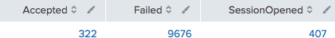

A B C

* + Field values are case-sensitive
* The search and where commands both filter results



Filtering Results – search and where

* + search

⬇ May be easier if you’re familiar with basic search syntax

⬇ Treats field values in a case-insensitive manner

⬇ Allows searching on keyword

⬇ Can be used at any point in the search pipeline

* + where

⬇ Can compare values from two different fields

⬇ Functions are available, such as isnotnull()

⬇ Treats field values in a case-sensitive manner

⬇ Can’t appear before first pipe in search pipeline

* To filter results, use search at any point in the search pipeline



Scenario

Report which products during the last 24 hours have sold more than $500 online.

* Behaves exactly like search strings before the first pipe

index=web sourcetype=access_combined action=purchase status=200

| stats sum(price) as sales by product_name

A

| sort –sales

| eval sales="$"+sales

| rename sales as "Popular Products", product_name as "Product Name"

* + Uses the "*" wildcard

| search sales>500

* + Treats field values in a case- insensitive manner

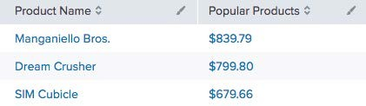

A

*where eval-expression*

* Uses same expression syntax as eval command
* Uses boolean expressions to filter search results and only keeps results that are True
* Double quoted strings are interpreted as field values
  + Treats field values in a case-sensitive manner
* Unquoted or single-quoted strings are treated as fields



Note

To view all of the functions for where, see: <http://docs.splunk.com/Documentation/Splunk/latest/SearchReference/Where?r=searchtip>

* Filters search results using eval expressions



Scenario

Report which days over the previous week have seen more remove actions than change quantity actions.

* Used to compare two different fields

| where removals > changes

index=web sourcetype=access_combined

| timechart count(eval(action="changequantity"))

as changes, count(eval(action="remove")) as removals

A

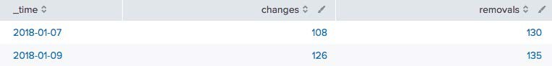

A

* Can do wildcard searches with



Scenario

Report the number of events over the past 24 hours by IP address for a specific range of addresses.

where command

* Use (_) for one character and

(%) for multiple characters

index=security sourcetype=linux_secure

| stats count by src_ip

* Must use the like operator with wildcards

| where src_ip like "10_.%"

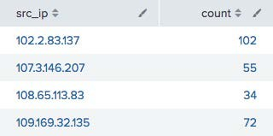

Note

As you've seen, the **like** operator can also be used with the **case** function.

* Use fillnull to replace null values in fields
* Use *value*=*string* to specify a string you want displayed instead

Example: fillnull value=NULL

* If no value= clause, default replacement value is 0
* Optionally, restrict which fields fillnull apply to by listing them at end of command

Example: fillnull VALUE=“N/A” discount refund

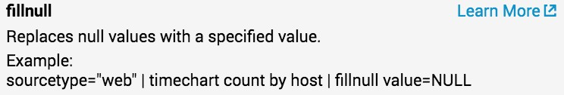

| fillnull

| fillnull value="No Value"

index=sales sourcetype= vendor_sales

| chart sum(price) over product_name by VendorCountry



Scenario

Evaluate vendor sales by country for the last hour.

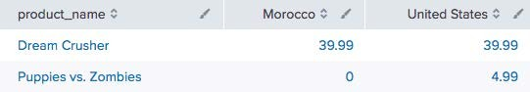

index=sales sourcetype= vendor_sales

| chart sum(price) over product_name by VendorCountry

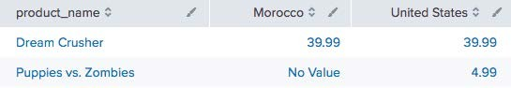

Module 6: Correlating Events

* Identify transactions
* Group events using fields
* Group events using fields and time
* Search with transactions
* Report on transactions
* Determine when to use transaction vs. stats
* A transaction is any group of related events that span time
* Events can come from multiple applications or hosts
* Events related to a single purchase from an online store can span across an application server, database, and e-commerce engine
* One email message can create multiple events as it travels through various queues
  + Each event in the network traffic logs represents a single user generating a single http request
  + Visiting a single website normally generates multiple http requests

⬇ HTML, JavaScript, CSS files

⬇ Flash, images, etc.

* transaction *field-list*



transaction Command

* + *field-list* can be one field name or a list of field names
  + Events are grouped into transactions based on the values of these fields
  + If multiple fields are specified and a relationship exists between those fields, events with related field values are grouped into a single transaction
* Common constraints:

maxspan maxpause startswith endswith

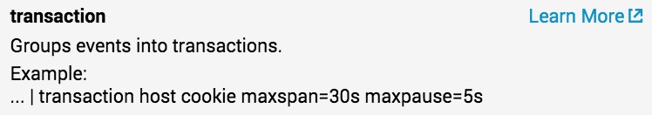

* The log shows a number of events that share the same JSESSIONID value (SD0SL10FF3ADFF4950)



Events That Have the Same JSESSIONID

index=web sourcetype=access_combined



Scenario

Display customer transactions in the online store during the last 60 minutes.

* However, it is difficult to:
  + View the events as a group

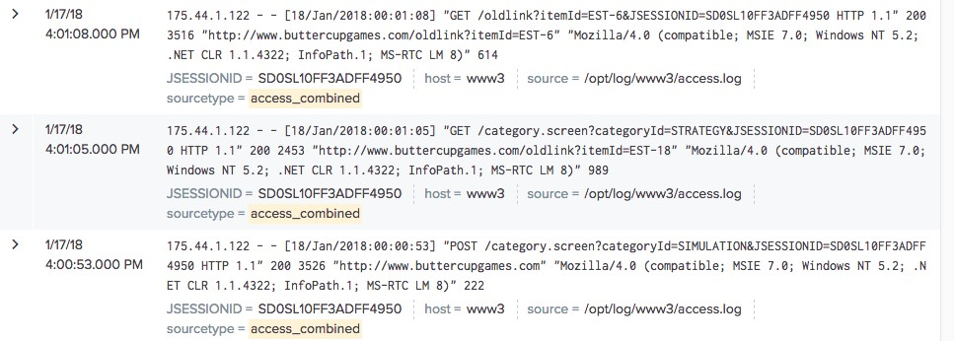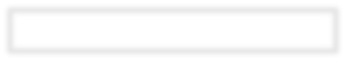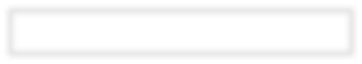

* + Gain insight as to what is happening with these events
  + Know if there are other events scattered in the results set
* The transaction command creates a single event from a group of events



Scenario

Group together Buttercup Games online store events based on the JSESSIONID value for the last 15 minutes.

– The events must share the same value in a specified field

index=web sourcetype=access_combined

* Transactions can cross multiple tiers such as web servers or

| transaction JSESSIONID

application servers

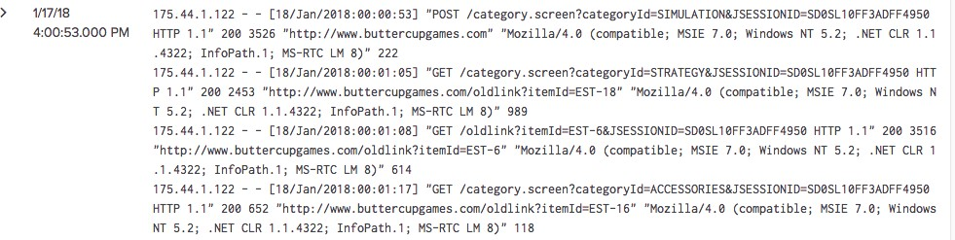

* For example, you can easily view the events for JSESSIONID SD0SL10FF3ADFF4950
* Use the search command at any point in the search pipeline to filter results



Scenario

Display transactions that included a 404 error during the last 60 minutes.

* Behaves exactly like search strings before the first pipe

A

index=web sourcetype=access_combined

| transaction JSESSIONID

| search status=404

| highlight JSESSIONID, 404 B

* search uses the "*" wildcard and treats field values in a case-insensitive manner

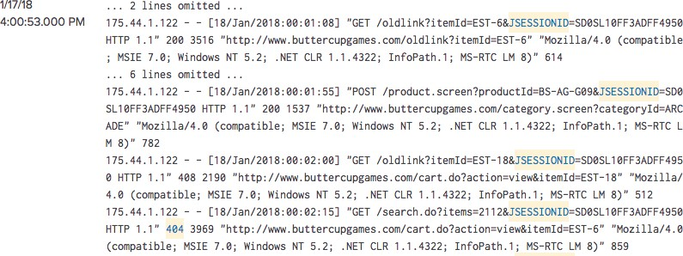

A

A

A

A

B

* status=404 finds the errors
* highlight highlights the terms you specify

| transaction src_ip



Scenario

For failed network logins, display different users from the same IP during the last 60 minutes.

index=security sourcetype=linux_secure failed

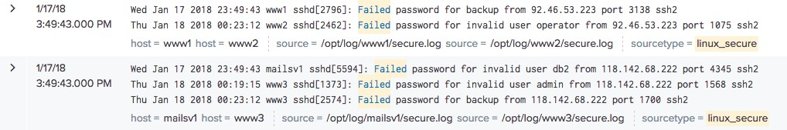

The transaction command produces additional fields, such as:

* duration – the difference between the timestamps for the first and last event in the transaction
* eventcount – the number of events in the transaction
* You can also define a max overall time span and max gap between events



transaction Command – maxspan/maxpause

index=web sourcetype=access_combined

| eval duration = tostring(duration,"duration")

| sort -duration

| table clientip duration action

| rename clientip as "Client IP", action as "Client Actions"



Scenario

Display customer actions on the website during the last 4 hours.

- maxspan=10m

| transaction clientip maxspan=10m maxpause=1m

▸Maximum total time between the

*earliest* and *latest* events

▸If not specified, default is -1 (or no limit)

- maxpause=1m

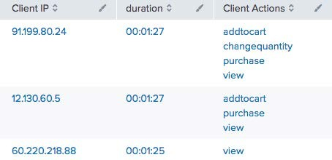

▸Maximum total time *between* events

▸If not specified, default is -1 (or no limit)



Note

Assumptions: Transactions spanning more than 10 minutes with the same client IP are considered unrelated. Also, there can be no more than one minute between any two related events.

* To form transactions based on terms, field values, or evaluations, use startswith and endswith options

| transaction clientip JSESSIONID

startswith=eval(action="addtocart") endswith=eval(action="purchase")



transaction Command – startswith/endswith

index=web sourcetype=access_combined

| table clientip, JSESSIONID, duration, eventcount



Scenario

Determine the length of time spent to complete a purchase by customers in the online store over the last 24 hours.

* In this example:
* The first event in the transaction includes addtocart

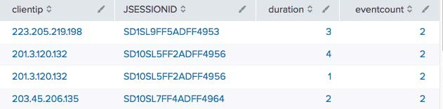

* The last event includes

purchase

* Transactions can be useful when a single event does not provide enough information



Scenario

Find emails that were rejected during the last 24 hours.

* This example searches email logs for the term “REJECT”

index=network sourcetype=cisco_esa REJECT

* Events that include the term do not provide much information about the rejection

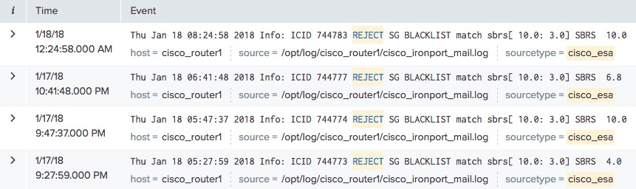

* By creating a transaction, you can then search and see additional events related to the rejection, such as:

| transaction mid dcid icid

| search REJECT

index=network sourcetype=cisco_esa



Scenario

Find emails that were rejected in the last 24 hours.

* IP address of sender
* Reverse DNS lookup results

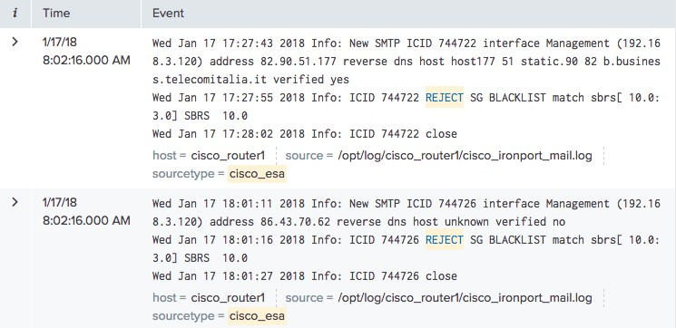

* Action taken by the mail system following the rejection
* mid – Message ID
* dcid – Delivery Connection ID
* icid – Incoming Connection ID
* You can use statistics and reporting commands with transactions



Reporting on Transactions



Scenario

Create a chart to show the number of purchase transactions based on their duration.

* In this example, a transaction is defined by events that share clientip and fit within a 10 minute span

| transaction clientip maxspan=10m

| chart count BY duration span=log2

index=web sourcetype=access_combined status=200 action=purchase

* count() function counts number of transactions and separates the count by the duration of each

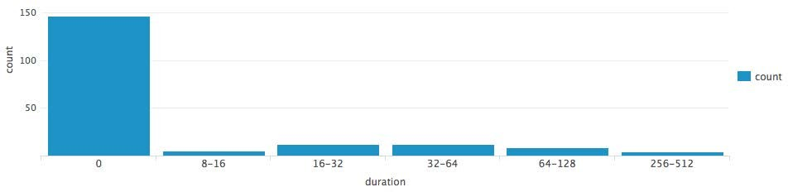

* When you have a choice, use stats—it’s faster and more efficient, especially in large Splunk environments
* Only use transaction when you:
* Need to see events correlated together
* Must define event grouping based on start/end values or segment on time
* Use stats when you:
* Want to see the results of a calculation
* Can group events based on a field value (e.g., by src_ip)
* By default, there’s a limit of 1,000 events per transaction
* No such limit applies to stats
* Admins can change limit by configuring max_events_per_bucket in

limits.conf

* + Searches produce same result

index=web sourcetype=access_combined

A earliest=-1y@y latest=@y



Scenario

Find online purchase transactions over the past year.

* + A took 23.381 seconds

| transaction JSESSIONID

| table JSESSIONID, action, product_name

| sort JSESSIONID

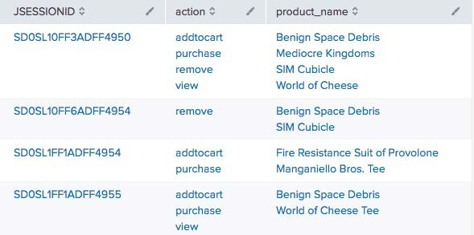

* + B took 2.077 seconds

index=web

sourcetype=access_combined earliest=-1y@y latest=@y

B

* + stats faster than

transaction

| stats values(action)

as "action", values(product_name) as "product_name”

by JSESSIONID

| sort JSESSIONID

A

index=security sourcetype=linux_secure failed



Note

1. **transaction** has a limit of 1,000
2. Count of transactions vs. count of IPs

B

index=security sourcetype=linux_secure failed

* 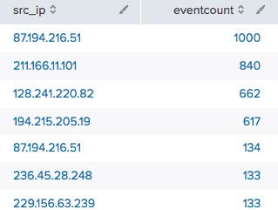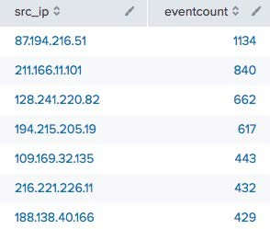A took 6.163 seconds

| transaction src_ip

| table src_ip, eventcount

| sort - eventcount

| stats count as eventcount

by src_ip

| sort - eventcount

|  |
| --- |
|  |
|  |
|  |

|  |
| --- |
|  |
|  |
|  |
|  |
|  |

* B took 4.643 seconds

Module 7:

Introduction to Knowledge Objects

* Identify the categories of knowledge objects



Module Objectives

* Define the role of a knowledge manager
* Identify naming conventions
* Review permissions
* Manage knowledge objects
* Describe the Splunk Common Information Model (CIM)
  + 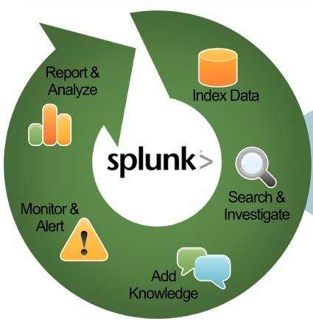Knowledge objects are tools you use to discover and analyze various aspects of your data



What are Knowledge Objects?

* + - Data interpretation – Fields and field extractions
    - Data classification – Event types
    - Data enrichment – Lookups and workflow actions
    - Normalization – Tags and field aliases
    - Datasets – Data models
* Shareable

– Can be shared between users

* Reusable

– Persistent objects that can be used by multiple people or apps, such as macros and reports

* Searchable

– Since the objects are persistent, they can be used in a search



Note

For more information go to: [http://docs.splunk.com/Documenta tion/Splunk/7.0.0/Knowledge/What isSplunkknowledge](http://docs.splunk.com/Documentation/Splunk/latest/Knowledge/WhatisSplunkknowledge)

* Oversees knowledge object creation and usage for a group or deployment
* Normalizes event data
* Creates data models for Pivot users
* This course uses simple names for lab exercises, but using a naming convention in your production environment is recommended. For example:



Defining Naming Conventions

–**Group:** Corresponds to the working group(s) of the user saving the object (examples: SEG. NEG. OPS. NOC)

–**Object Type:** Indicates the type of object (alert, report, summary- index-populating) (examples: Alert, Report, Summary)

–**Description:** A meaningful description of the context and intent of the search, limited to one or two words if possible;



Note

For more information go to: [http://docs.splunk.com/Documenta tion/Splunk/7.0.0/Knowledge/Deve lopnamingconventionsforknowledg eobjecttitles](http://docs.splunk.com/Documentation/Splunk/latest/Knowledge/Developnamingconventionsforknowledgeobjecttitles)

ensures the search name is unique

* So, for example: SEG_Alert_WinEventlogFailures

|  |  |  |  |  |
| --- | --- | --- | --- | --- |
|  | **Description** | **Create** | **Read** | **Edit (write)** |
| **Private** | Only the person who created the object can use it and edit it | User Power Admin | Person who created it Admin | Person who created it Admin |
| **This app only** | Object persists in the context of a specific app | Power Admin | User* Power* Admin | User* Power* Admin |
| **All apps** | Object persists globally across all apps |  | User* Power* Admin | User* Power* Admin |
|  | Admin |

* Permission to read and/or write if creator gives permission to that role

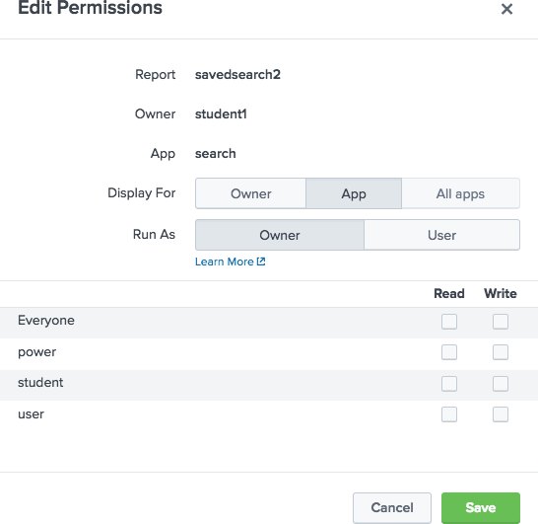

* When an object is created, Display For is set to **Owner** by default
* When object’s permissions are set to **App** or **All apps**, all roles are given read permission

– Write permission is reserved for admin and the object creator unless the creator edits permissions

* Only the admin role can promote an object to **All apps**

– Other roles have **All Apps** button grayed out

# Managing Knowledge Objects

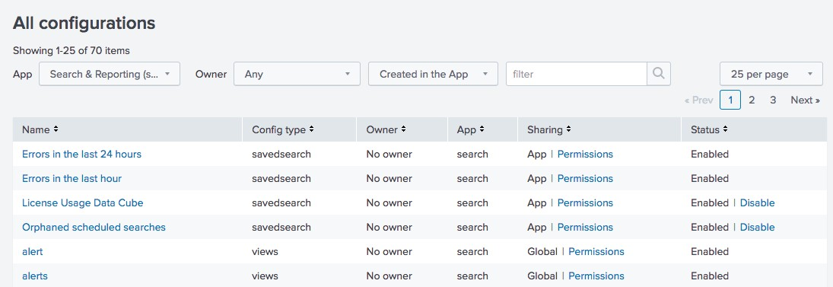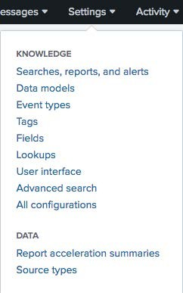

* Knowledge objects are centrally managed from **Settings > Knowledge**
* Your role and permissions determine your ability to modify an object’s settings



Note

By default, objects for all owners are listed.

* Methodology for normalizing data



Using the Splunk Common Information Model (CIM)

* Easily correlate data from different sources and source types
* Leverage to create various objects discussed in this course—field extractions, field aliases, event types, tags
* More details discussed in Module 13

Web

Network

Unix

CIM

Search

Module 8: Creating and Managing

Fields

* Review the Field Extractor (FX) methods
* Regex
* Delimiter
* Identify the different options to get to the Field Extractor
* Settings
* Fields sidebar
* Event actions
* Review the process of extracting fields manually using regular expressions
* Use the Field Extraction Manager to modify extracted fields
* Splunk automatically discovers many fields based on source type and key/value pairs found in the data
* Prior to search time, some fields are already stored with the event in the index
* Meta fields, such as host, source, and sourcetype
* Internal fields such as _time and _raw
* At search time, *field discovery* discovers fields directly related to the search’s results
* Splunk may also extract other fields from raw event data that aren’t directly related to the search
* In addition to the many fields Splunk auto-extracts, you can also extract your own fields with the Field Extractor (FX)
* Use FX to extract fields that are static and that you use often in searches
* Graphical UI
* Extract fields from events using regex or delimiter
* Extracted fields persist as knowledge objects
* Can be shared and re-used in multiple searches



Note

For more information, see: [http://docs.splunk.com/Documenta tion/Splunk/7.0.0/Knowledge/Extra ctfieldsinteractivelywithIFX](http://docs.splunk.com/Documentation/Splunk/latest/Knowledge/ExtractfieldsinteractivelywithIFX)

* Access FX via Settings, Fields Sidebar, or Event Actions menu

## Regex



Field Extraction Methods

* Use this option when your event contains unstructured data like a system log file
* FX attempts to extract fields using a Regular Expression that matches similar events

## Delimiter

* Use this option when your event contains structured data like a .csv file
* The data doesn’t have headers and the fields must be separated by delimiters (spaces, commas, pipes, tabs, or other characters)

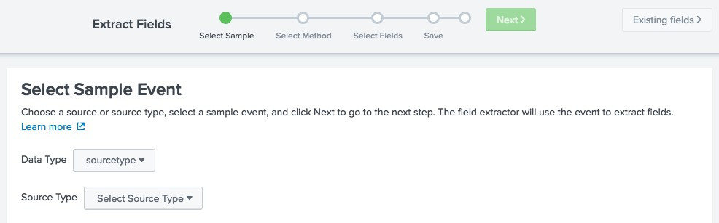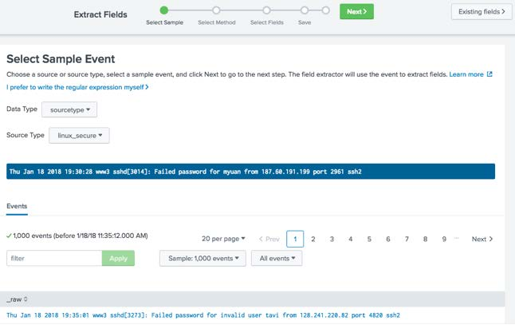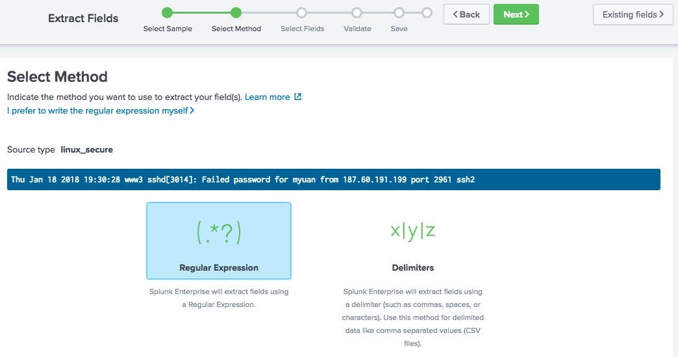

Settings

Fields Sidebar

Event Actions

Settings > Fields > Field extractions > Open Field Extractor

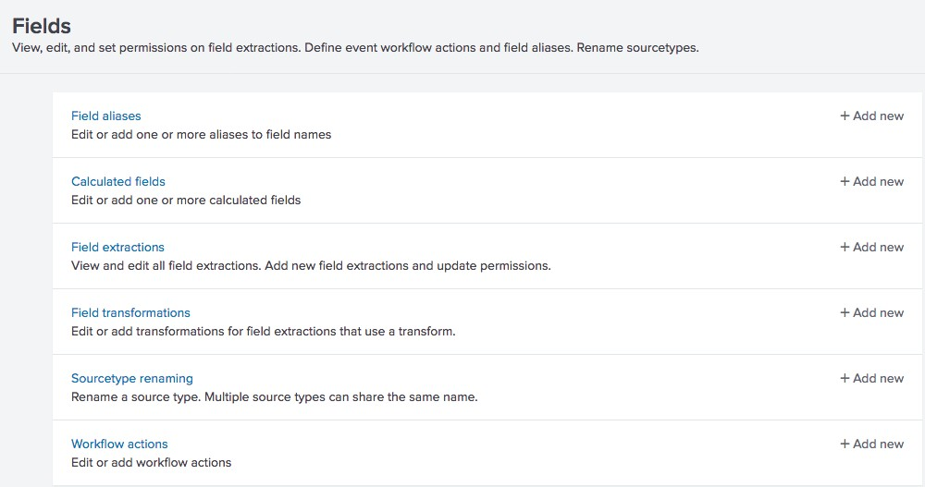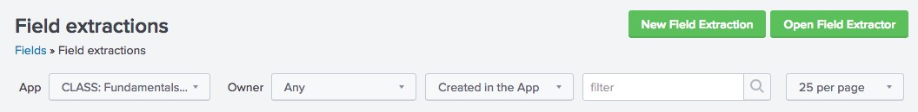

1. Select the Data Type



Regex Field Extractions from Settings (cont.)

* + sourcetype
  + source

1. Select the Source Type

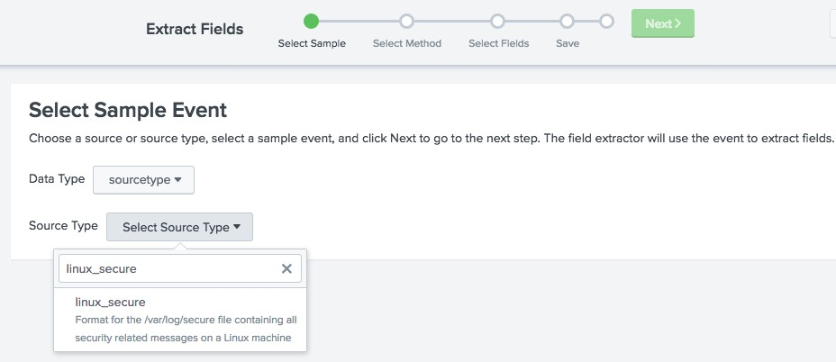

1

2



Regex Field Extractions from Settings – Select

Sample

1. Select a sample event by clicking on it

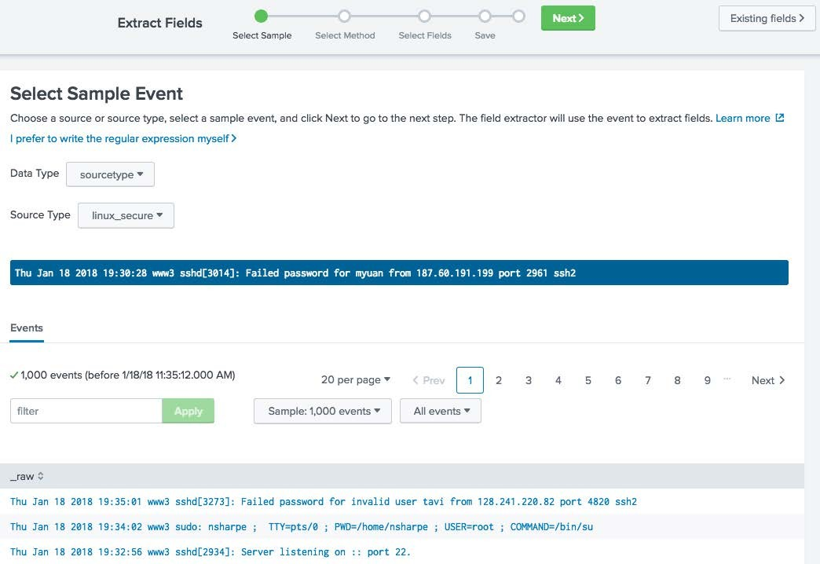

4

3

1. Click Next >
2. Select Regular Expression



Regex Field Extractions from Settings – Select Method



6

5

1. Click Next >
2. Select the value(s) you want to extract. In this example, two fields are being extracted



Regex Field Extractions from Settings – Select Values

1. Provide a field name

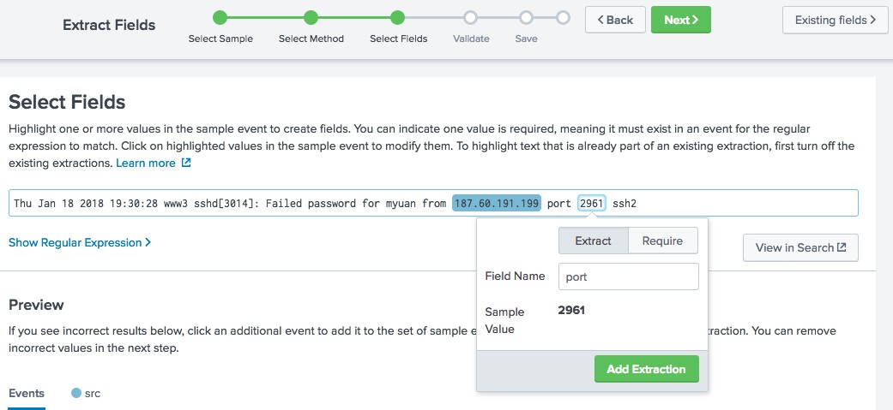

7

8

9

1. Click Add Extraction



Note

Require option – only events with the highlighted string are included in the extraction.



Regex Field Extractions from Settings –

Preview

1. Preview the sample events

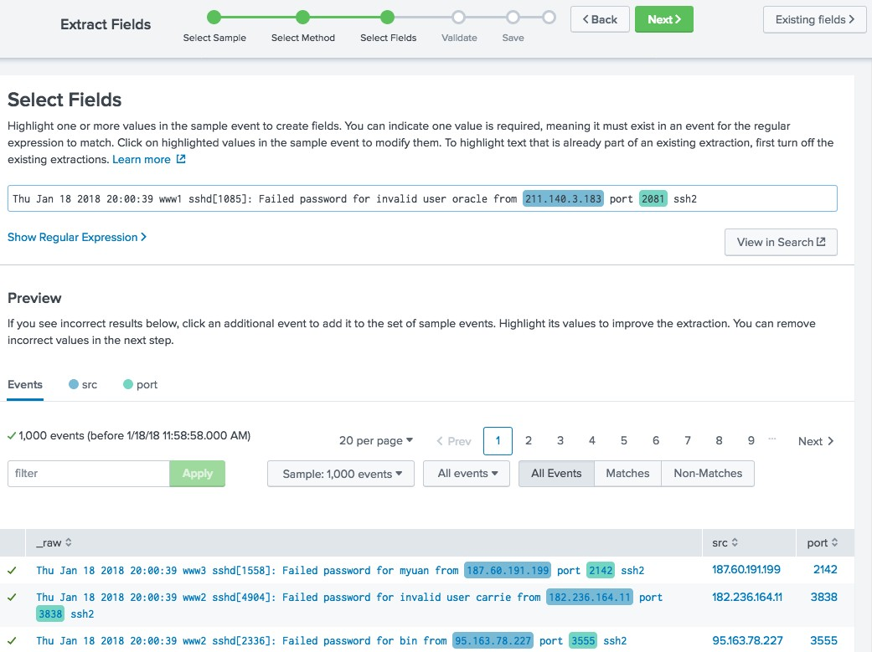

11

1. Click Next >

10

1. Validate the proper field values are extracted 13.Click Next >



Regex Field Extractions from Settings – Validate

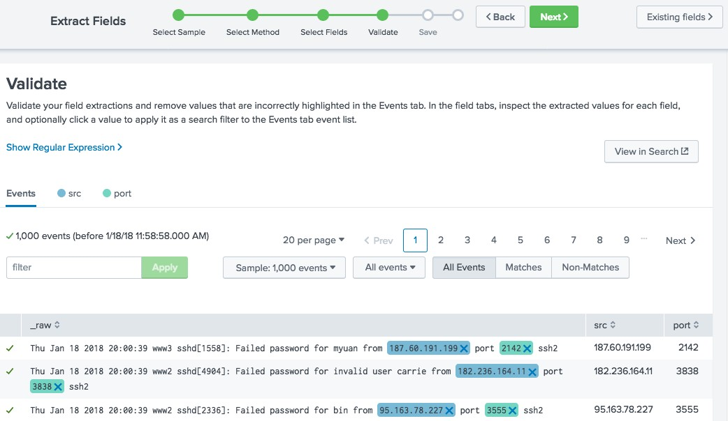

13

12

1. Review the name for the newly extracted fields and set permissions



Regex Field Extractions from Settings – Save

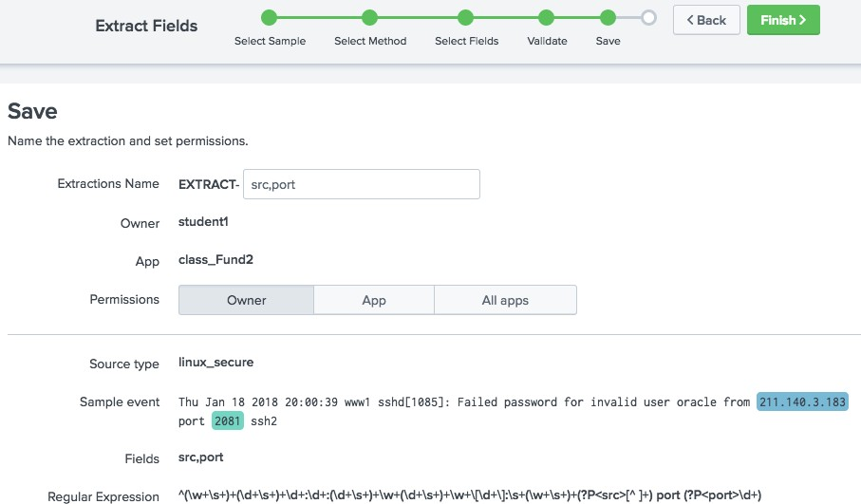

15

14

1. Click Finish



Note

An extractions name is provided by default. However, this name can be changed.

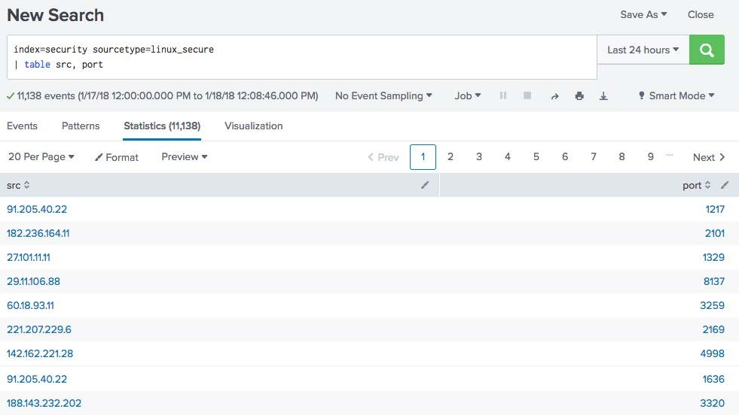

1. From Select Method, click Regular Expression

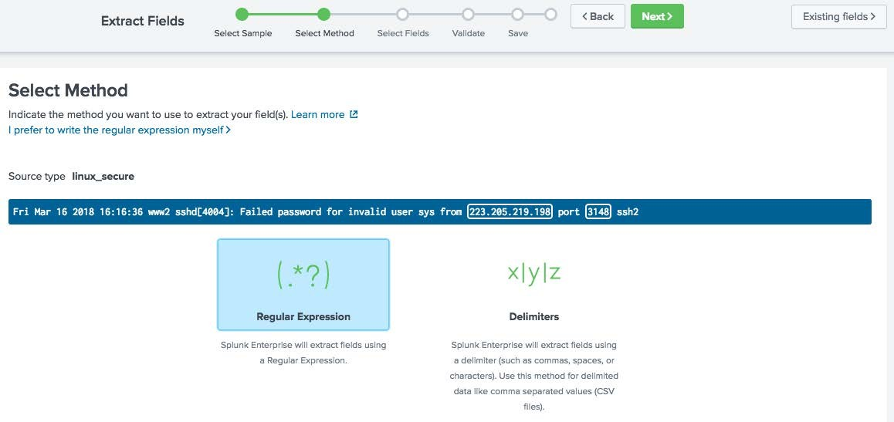

2

1. Click Next >

1

Editing Regex for Field Extractions – Select Field



1. Select the field to extract
2. Provide a Field Name
3. Click Add Extraction

Note

For more information about Splunk Regular Expressions, see: [http://docs.splunk.com/Documentation/ Splunk/7.0.0/Knowledge/AboutSplunkre gularexpressions](http://docs.splunk.com/Documentation/Splunk/latest/Knowledge/AboutSplunkregularexpressions)

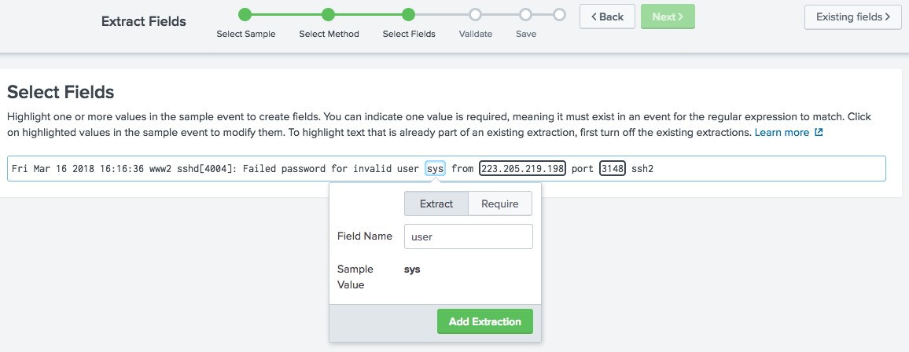

3

4

5

1. Click Show Regular Expression >



Editing Regex for Field Extractions – Show Regex

1. Click Edit the Regular Expression

6

7

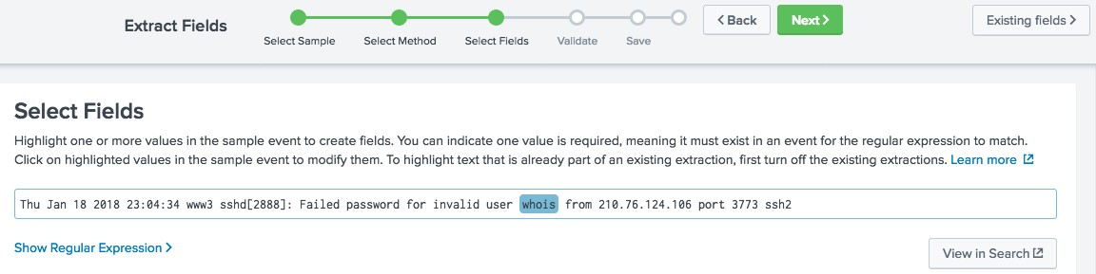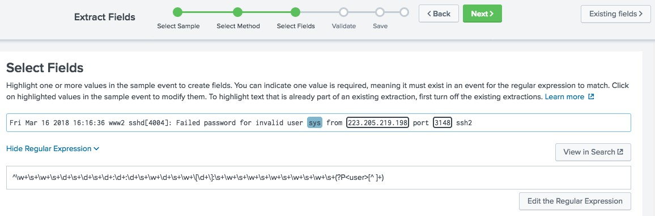

1. Update the regular expression



Editing Regex for Field Extractions – Modify RegEx



Warning

After you edit the regular expression, you cannot go back to the Field Extractor UI.

1. Click Save

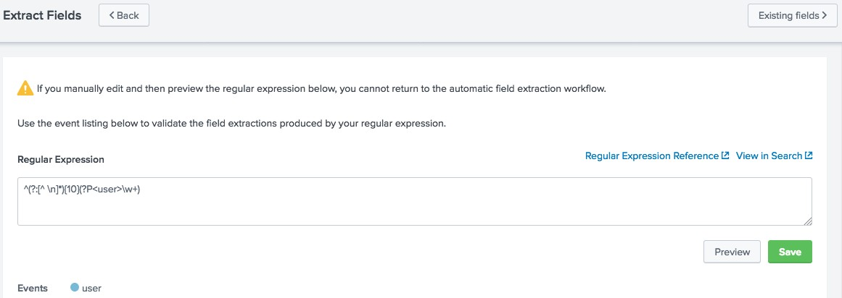

8

9

1. Review the Extractions Name and set permissions 11.Click >Finish



Editing Regex for Field Extractions - Save

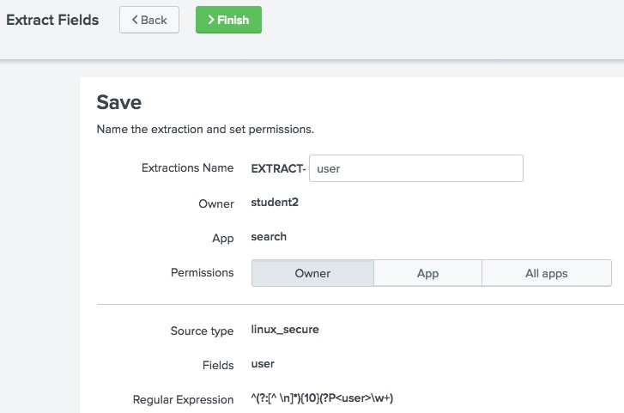

11

10



Note

[http://docs.splunk.com/Documentation/ Splunk/7.0.0/Admin/Transformsconf](http://docs.splunk.com/Documentation/Splunk/latest/Admin/Transformsconf)

For more information about directly editing these objects go to: [http://docs.splunk.com/Documentation/ Splunk/7.0.0/Admin/Propsconf](http://docs.splunk.com/Documentation/Splunk/latest/Admin/Propsconf)

* Use delimited field extractions when the event log does not have a header and fields are separated by spaces, commas, or characters
* In this example, the fields are separated by commas

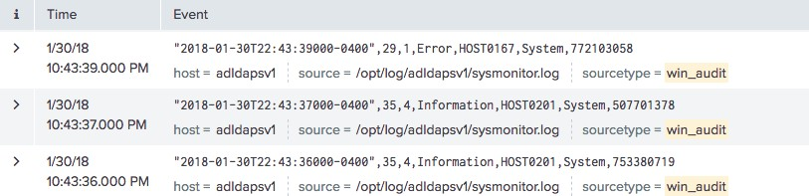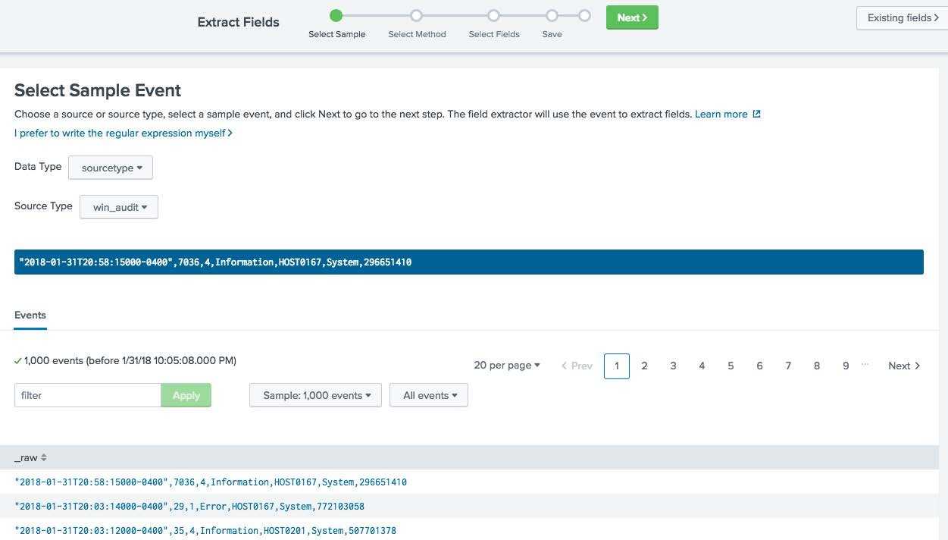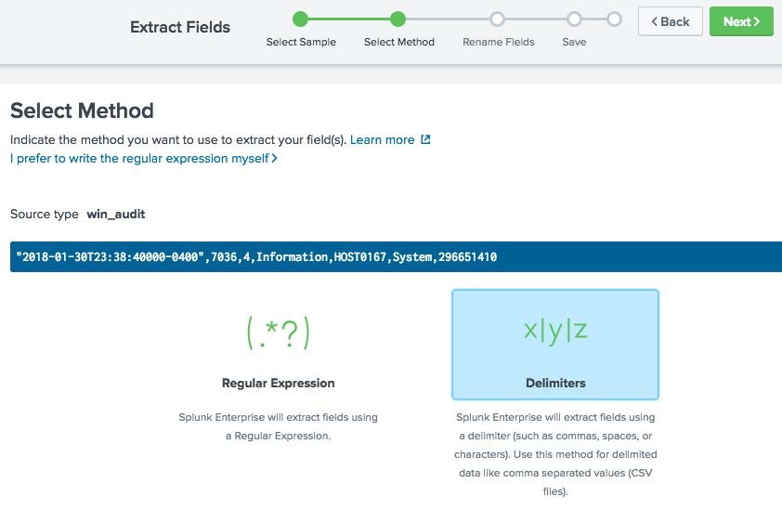

Settings

Fields Sidebar

Event Actions

Settings > Fields > Field extractions > Open Field Extractor



1. Select the Data Type



Delimited Field Extractions (Settings) – Select Sample

* + sourcetype
  + source

1. Select the Source Type

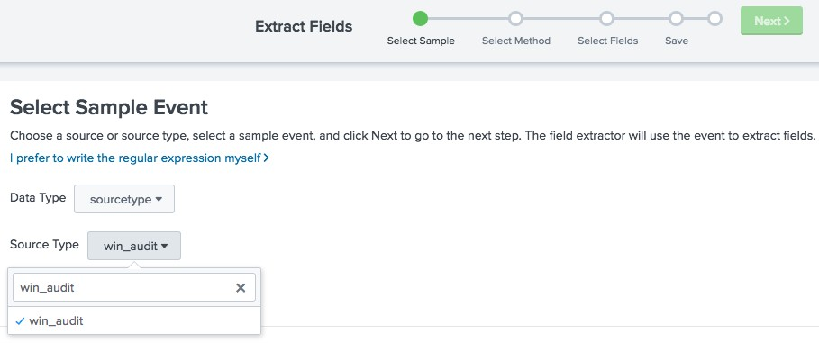

1

2

1. Select a sample event



Delimited Field Extractions (Settings) – Select Event



4

1. Click Next >

3

1. Select Delimiters



Delimited Field Extractions (Settings) – Select Method

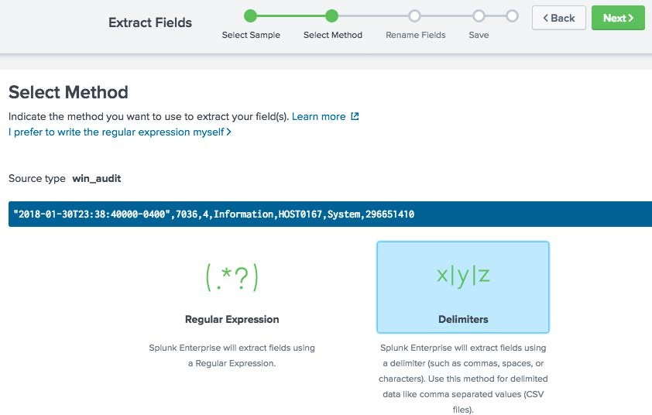

6

5

1. Click Next >
2. Select the Delimiter used in your event



Delimited Field Extractions (Settings) - Select Delimiter

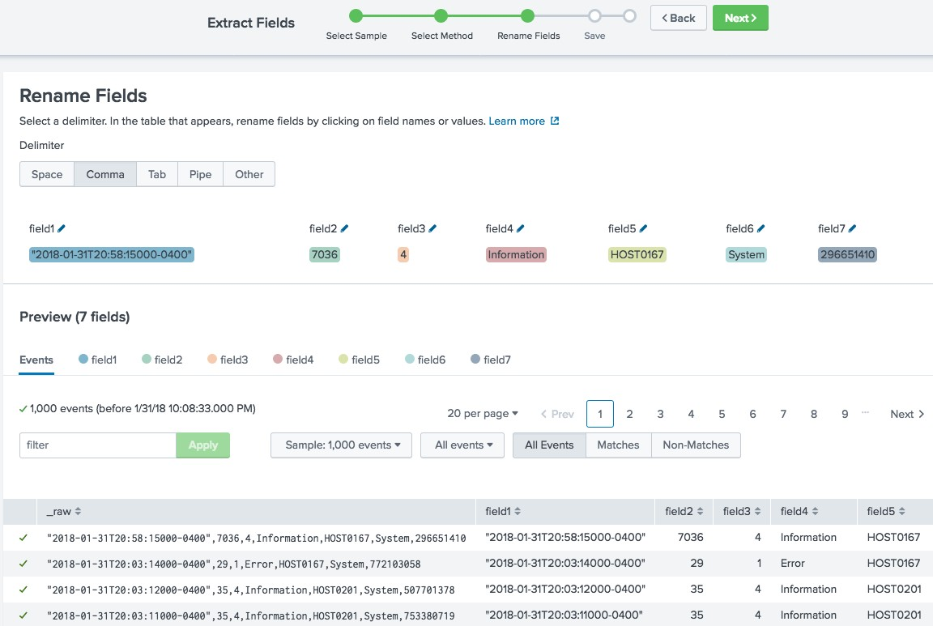

7

1. Click the icon next to the default field name



Delimited Field Extractions (Settings) – Rename Field

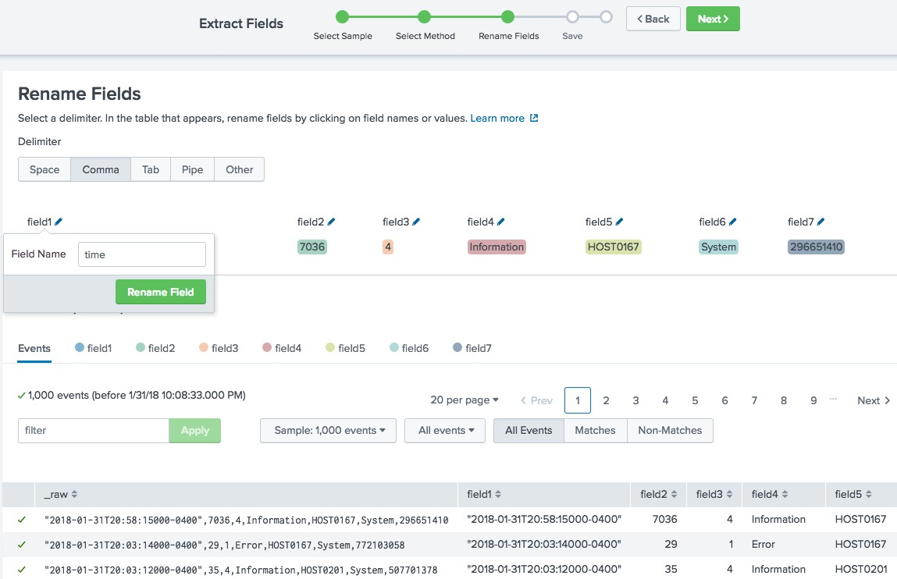

11

8

9

10

1. Enter a new field name
2. Click Rename Field
3. Repeat these steps for all fields
4. After all the fields are renamed, click Next >



Delimited Field Extractions (Settings) – Rename Field (cont.)

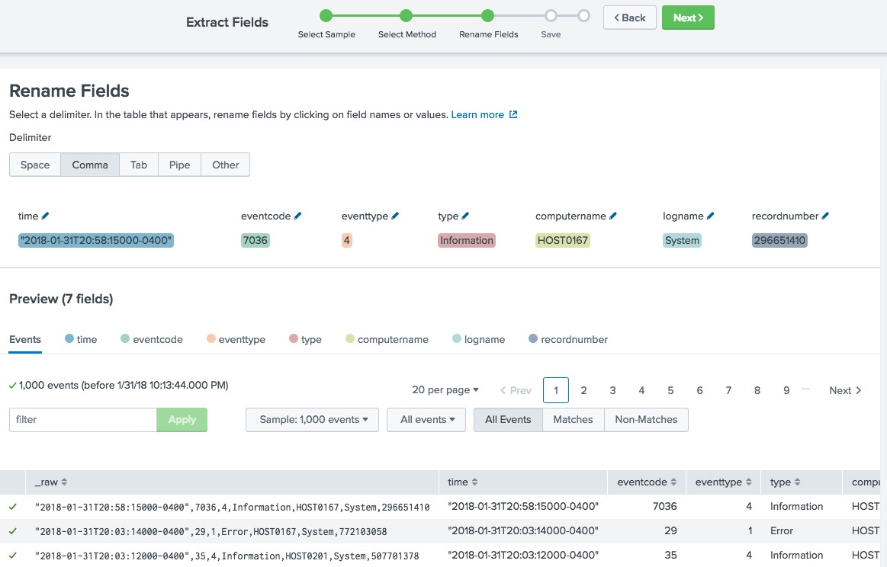

12

1. Name your extraction



Delimited Field Extractions (Settings) – Save

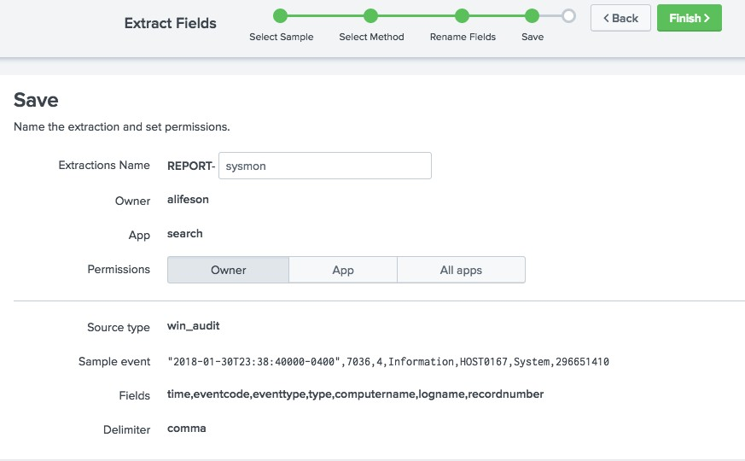

14

13

1. Click Finish>



Using a Delimited Field Extraction

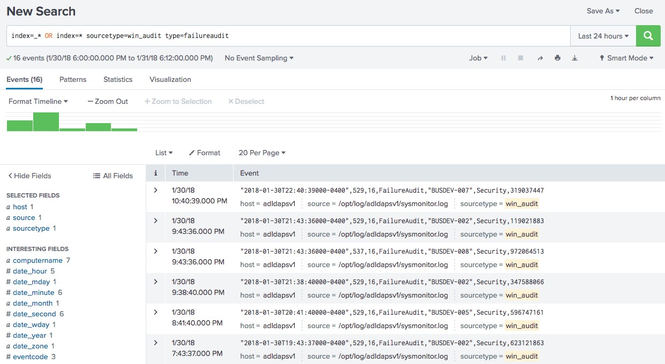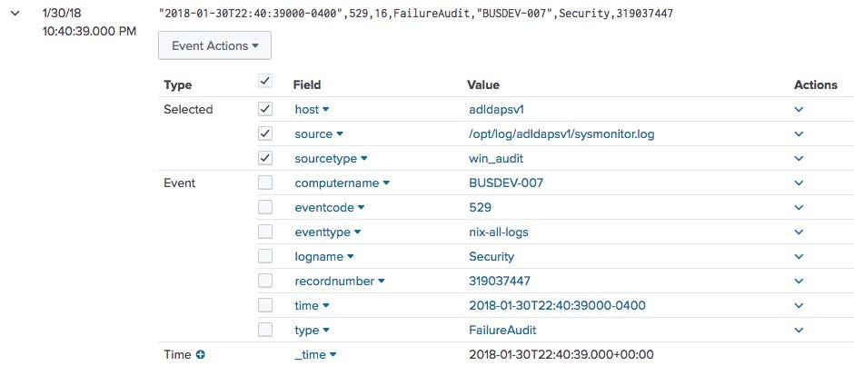

Module 9: Creating Field Aliases and Calculated Fields

* Create and use field aliases
* Create calculated fields
* A way to normalize data over any default field (host, source or sourcetype)
* Multiple aliases can be applied to one field
* Applied after field extractions, before lookups
* Can apply field aliases to lookups
* Several source types contain some type of a username field
* To make data correlation and searching easier, normalize the username field

sourcetype=cisco_firewall

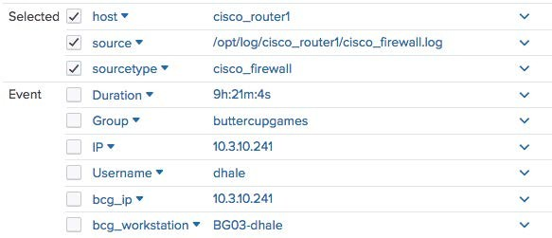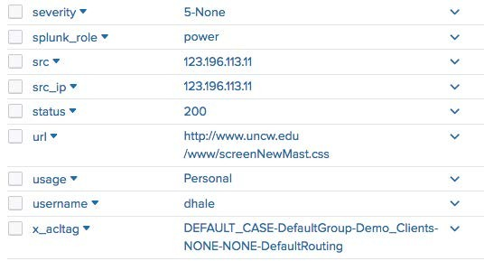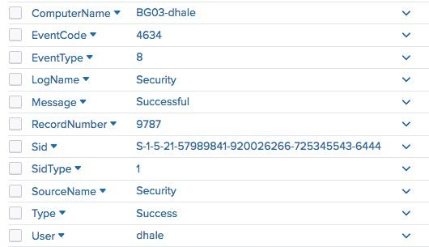

sourcetype=cisco_wsa_squid

sourcetype=winauthentication_security

**Settings > Fields > Field Aliases > New Field Alias**

1. Select the app associated with the field alias

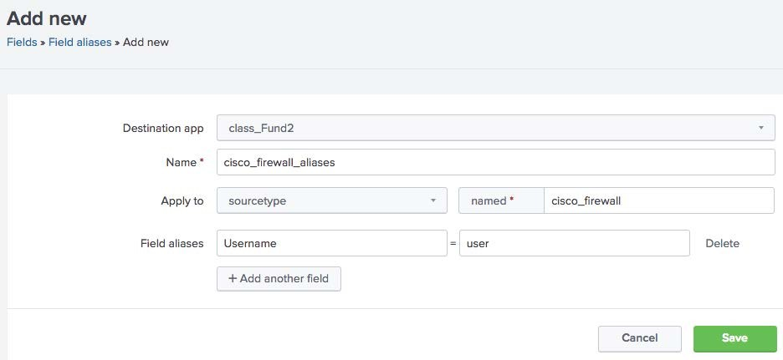

new field alias

existing field name

4

3

2

1

1. Enter a Name for the field alias
2. Apply the field alias to a default field:
   * Host
   * Source
   * Sourcetype
3. Enter the name for the existing field and the new alias

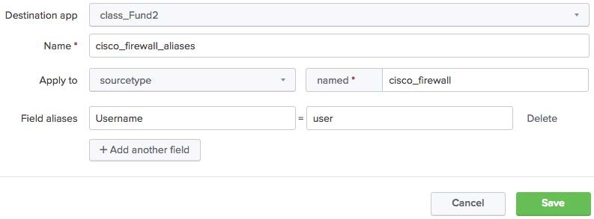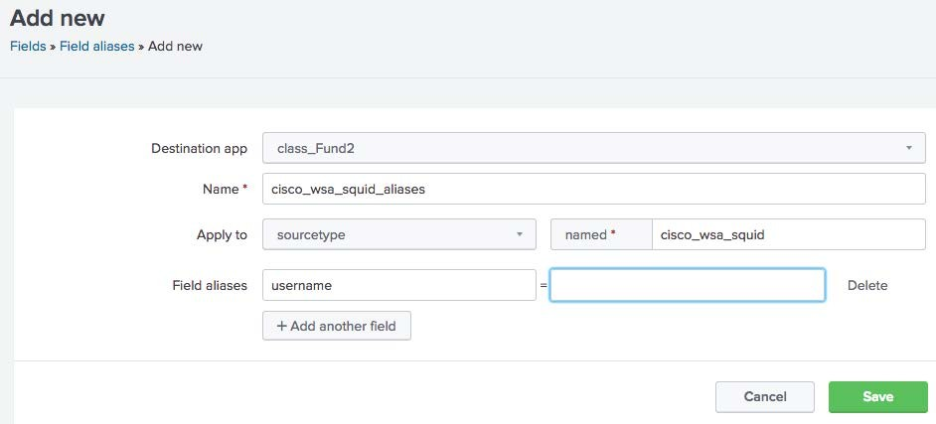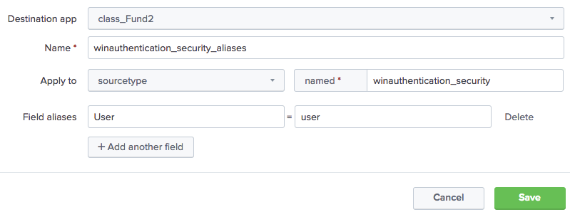

In this example, one field alias used for new ‘user’ fields in multiple source types

New field alias required for each sourcetype

After the field alias is created, perform a search using the new field alias

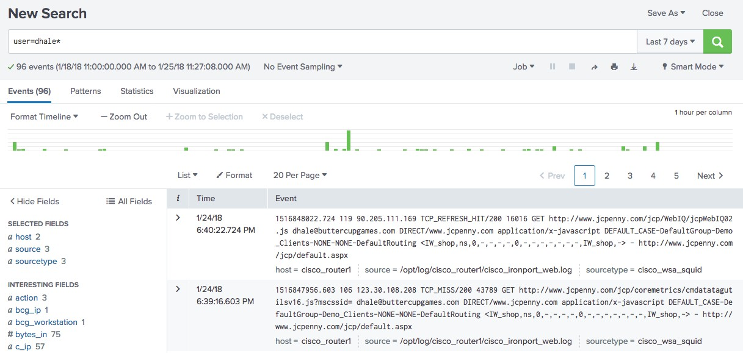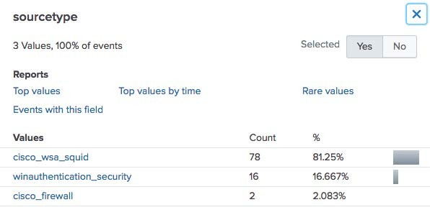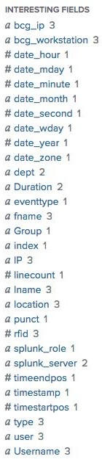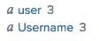

field alias

original field

* When you create a field alias, the original field is not affected
* Both fields appear in the All Fields and Interesting Fields lists, if they appear in at least 20% of events

After you have defined your field aliases, you can reference them in a lookup table

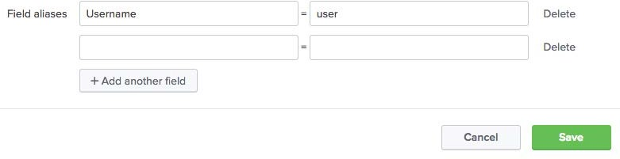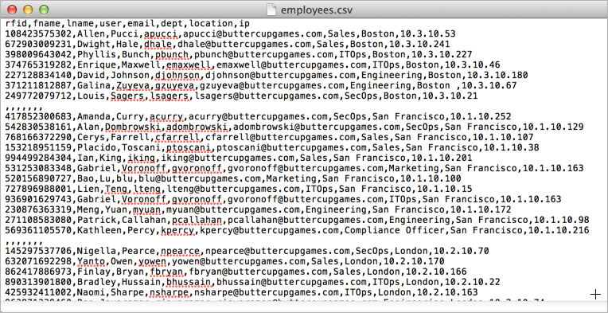

* Shortcut for performing repetitive, long, or complex transformations using the eval command



What is a Calculated Field?

* Must be based on an extracted field



Note

Output fields from a lookup table or fields/columns generated from within a search string are not supported.

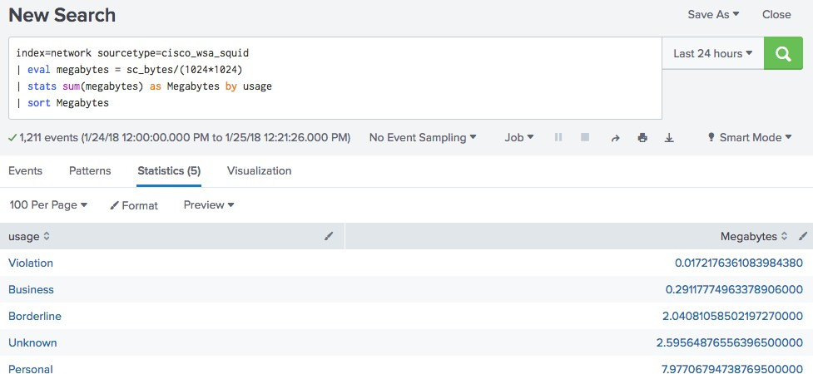

#### Settings > Fields > Calculated Fields > New Calculated Field

1. Select the app that will use the calculated field

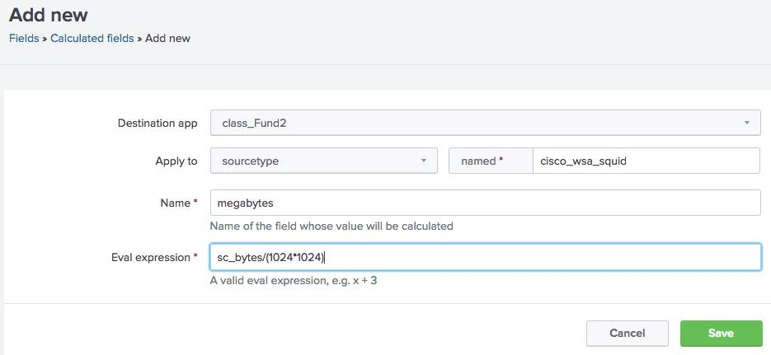

1

1. Select host, source, or 2

sourcetype to apply to the 3

calculated field and specify 4

the related name

1. Name the calculated field
2. Define the eval expression

After you have created a calculated field, you can use it in a search like any other extracted field

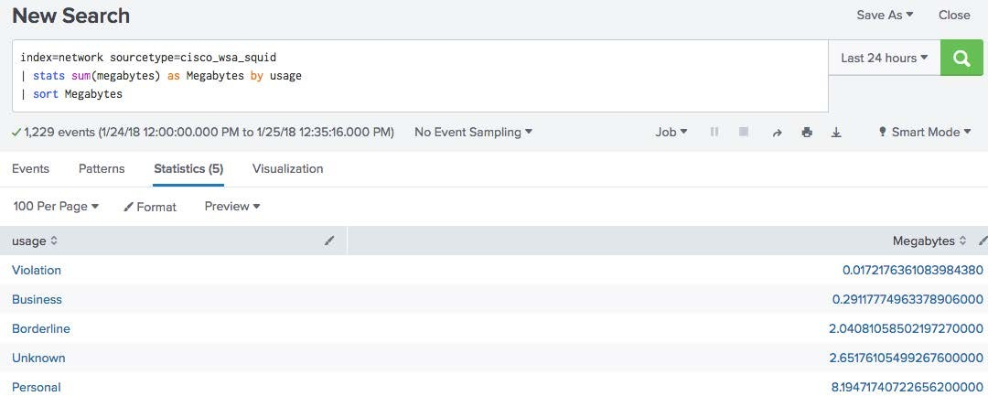

Module 10: Working with Tags and

Event Types

* Create and use tags
* Describe event types and their uses
* Create an event type
* Tags are like nicknames that you create for related field/value pairs
* Tags make your data more understandable and less ambiguous
* You can create one or more tags for any field/value combination
* Tags are case sensitive

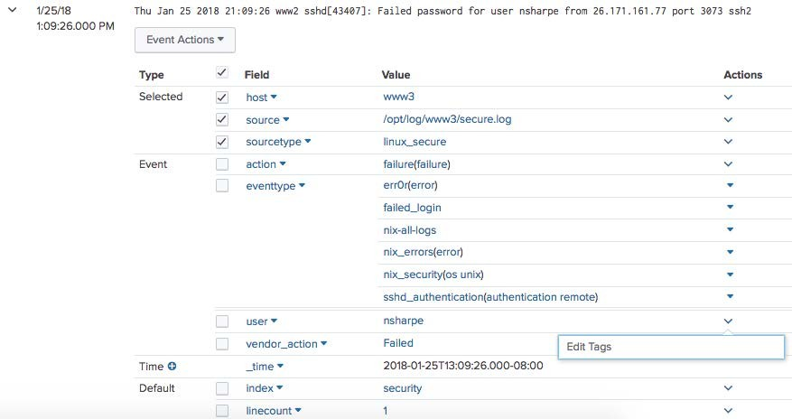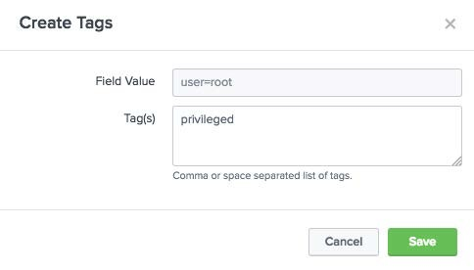

To create a tag:

1. Click on the arrow for event details
2. Under Actions, click the down arrow
3. Select Edit Tags
4. Name the tags, separated by 2

commas 3

1

4

* + When tagged field/value pairs are selected, the tags appear: A



Viewing Tags

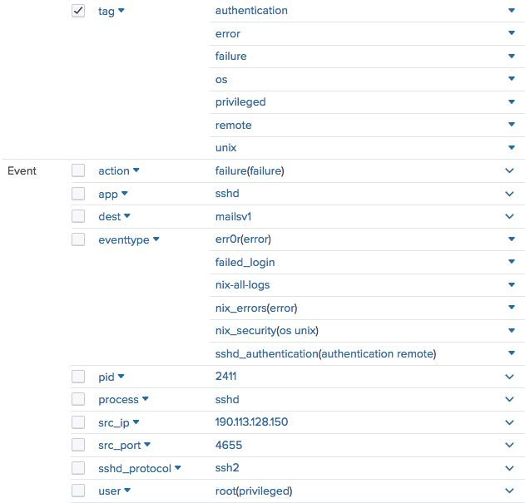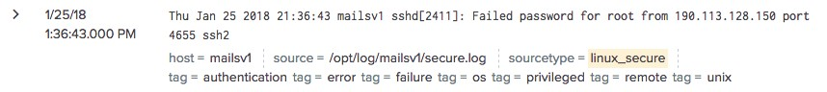

* + - In the results as tags

B

A

* + - In parentheses next to the

associated field/value pairs B

A

B

To use tags in a search, use the syntax: **tag=*<tag name>***



Using Tags

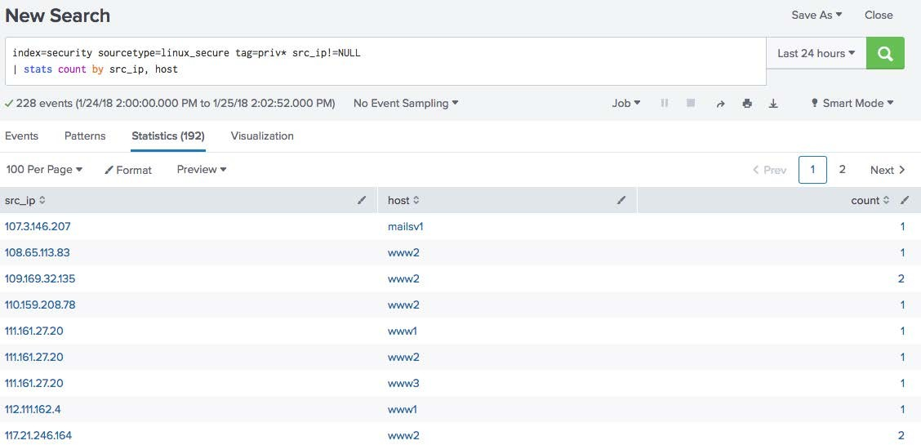

* + To search for a tag associated with a value:



Note

Tag names are case sensitive.

* + - 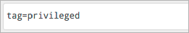tag=<tagname>
  + To search for a tag associated with a value on a specific field:
    - tag::<field>=<tagname>

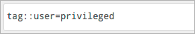

* + To search for a tag using a partial field value:
    - Use (*) wildcard

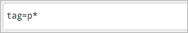

#### Settings > Tags > List by field value pair

* + - Edit permissions
    - Disable all tags for pair – disables the tag in searches and prevents it from being listed under List by Tag Name and All unique tag objects

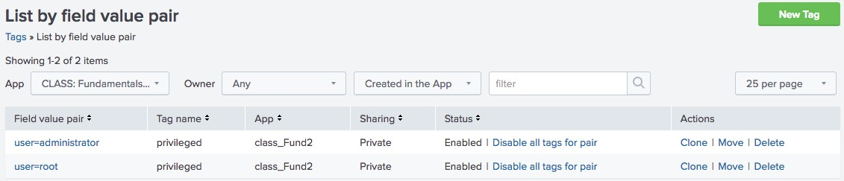

Click **List by field value pair** to add another tag or change the name of the tag

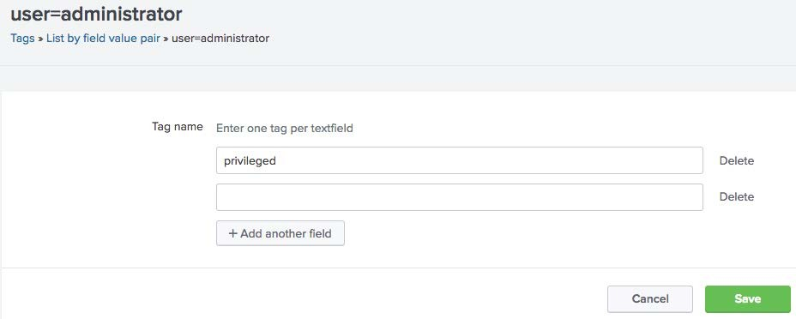

Click **List by tag name** to add or edit the field value pair for the tag

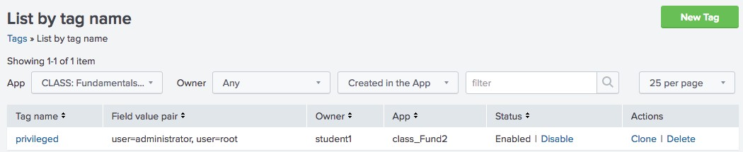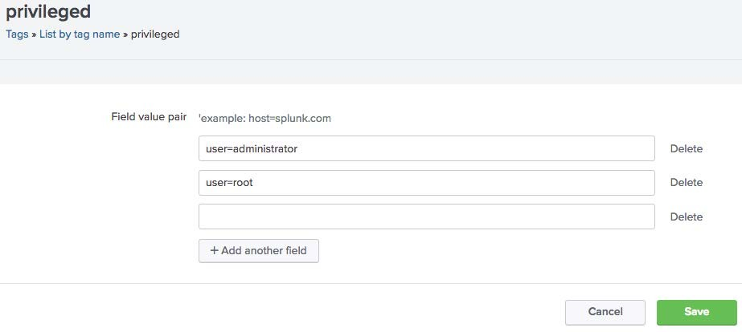

* + A method of categorizing events based on a search
  + A useful method for institutional knowledge capturing and sharing
  + Can be tagged to group similar types of events

1. Run a search and verify that all results meet your event type criteria



Creating an Event Type from the Search Page

1. From the Save As menu, select **Event Type**
2. Provide a Name for your event type (name should not contain spaces)

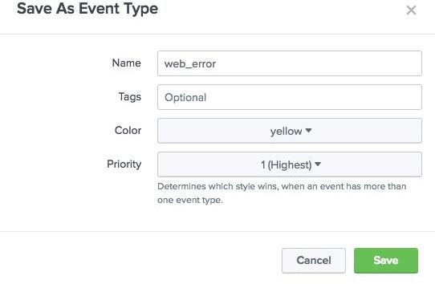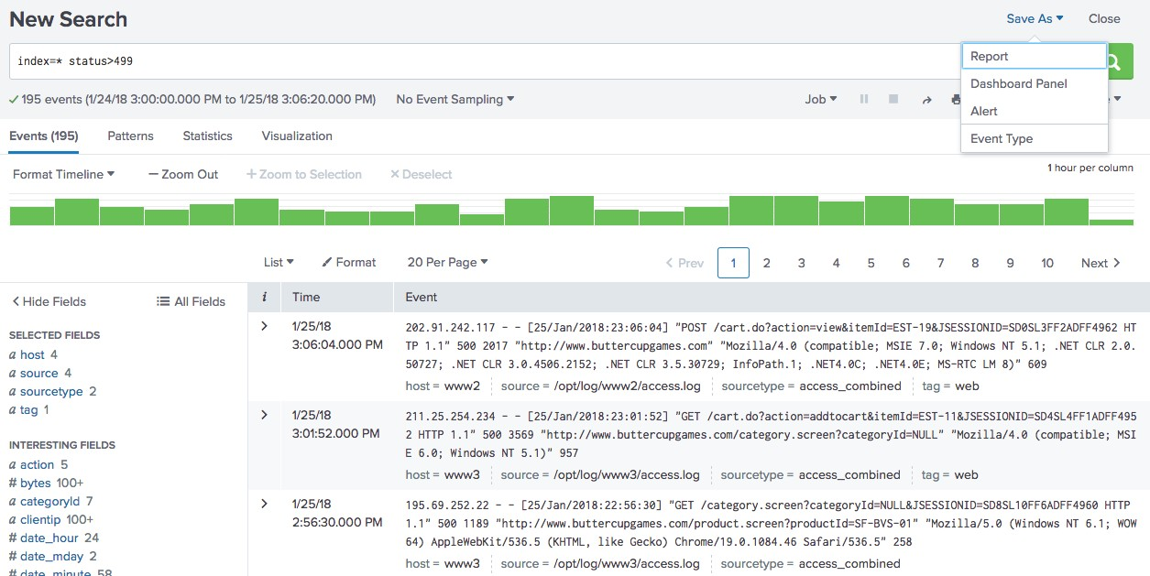

Note

Must be a basic search (cannot contain pipes or subsearches).

1. From the event details, select **Event Actions > Build Event Type**

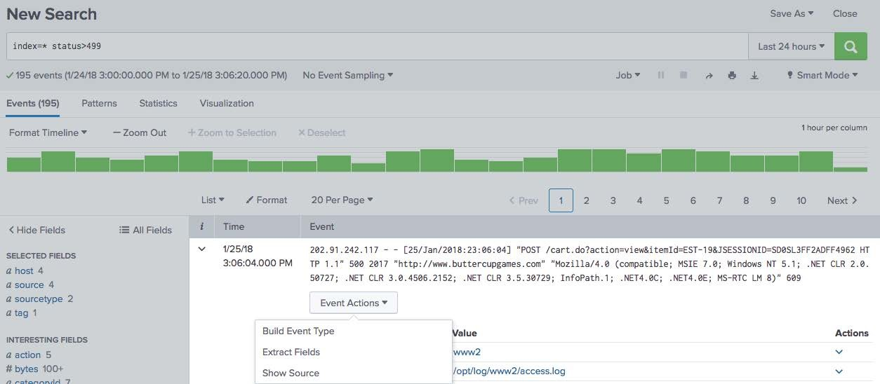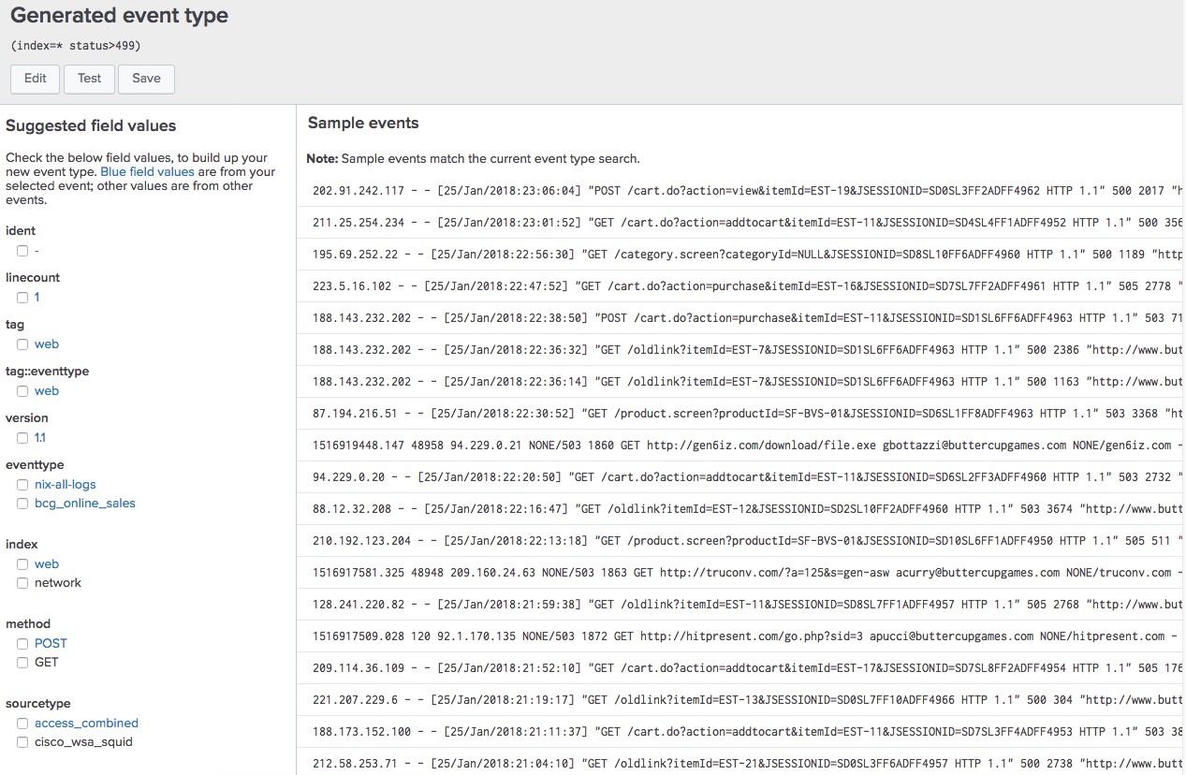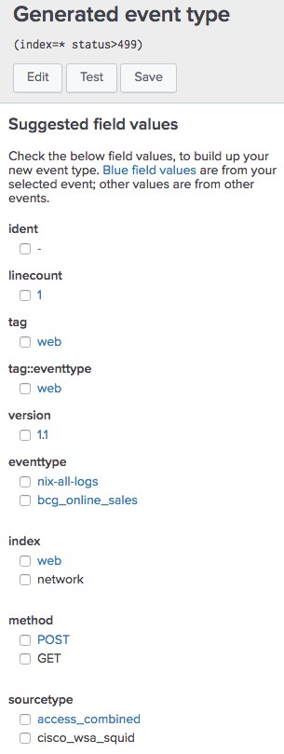

1. Refine the criteria for your event type such as:
   * Search string
   * Field values
   * Tags
2. Verify your selections and click Save
   * To verify the event type, search for eventtype=web_error
   * ‘eventtype’ displays in the Fields sidebar and can be added as a selected field

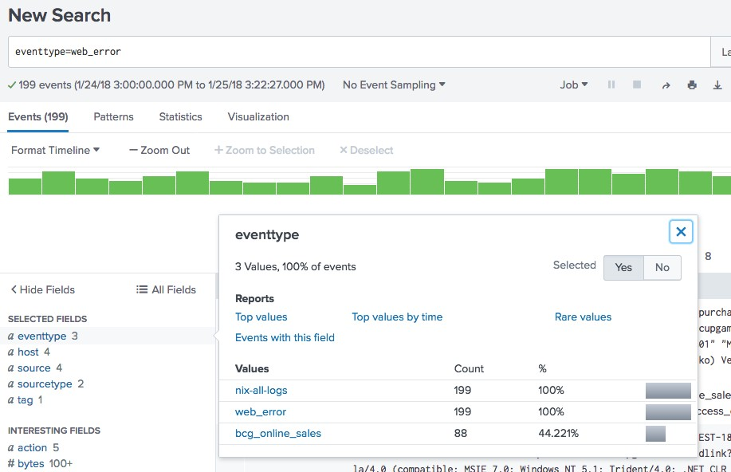

* + Splunk evaluates the events and applies the appropriate event types at search time
  + Using the Fields sidebar, you can easily view the individual event types, the number of events, and percentage

You can tag event types two ways:

1. **Settings > Event Types**

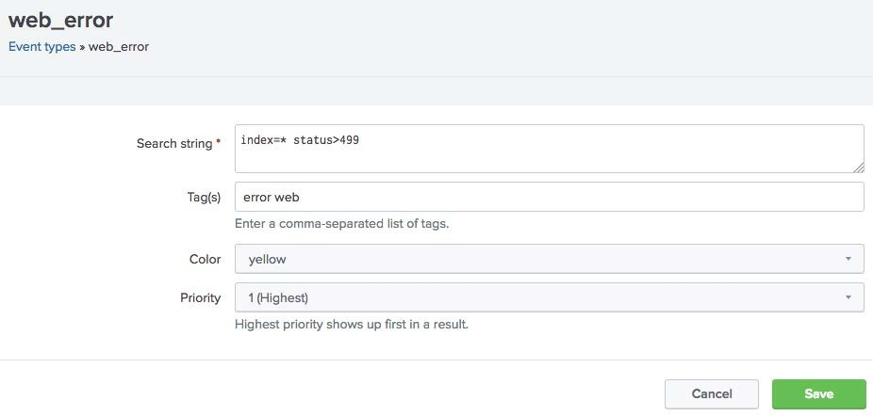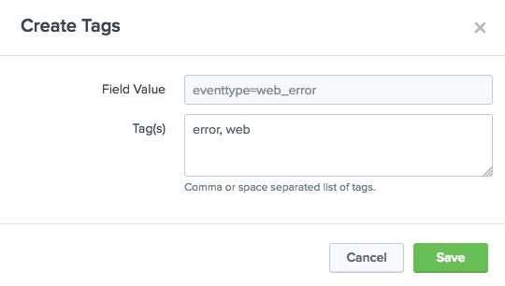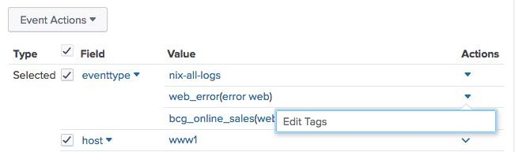

1. **Event details > Actions**

Priority determines which event type color displays for an event

## Event Types



Event Types vs. Saved Reports

* + - Categorize events based on a search string
    - Tag event types to organize data into categories
    - The eventtype field can be included in a search string
    - Does not include a time range

## Saved Reports

* + - Search criteria will not change
    - Includes a time range and formatting of the results
    - Can be shared with Splunk users and added to dashboards

Module 11: Creating and Using Macros

* + Describe macros
  + Manage macros
  + Create a basic macro
  + Use a basic macro
  + Define arguments / variables for a macro
  + Add and use arguments with a macro
  + Useful when you frequently run searches or reports with similar search syntax
  + The time range is selected at search time
  + Macros can be a full search string or a portion of a search that can be reused in multiple places
  + Allows you to define one or more arguments within search segment
    - Pass parameter values to macro at execution time
    - Macro uses values to resolve search string

#### Settings > Advanced search > Search Macros

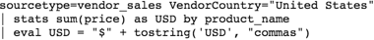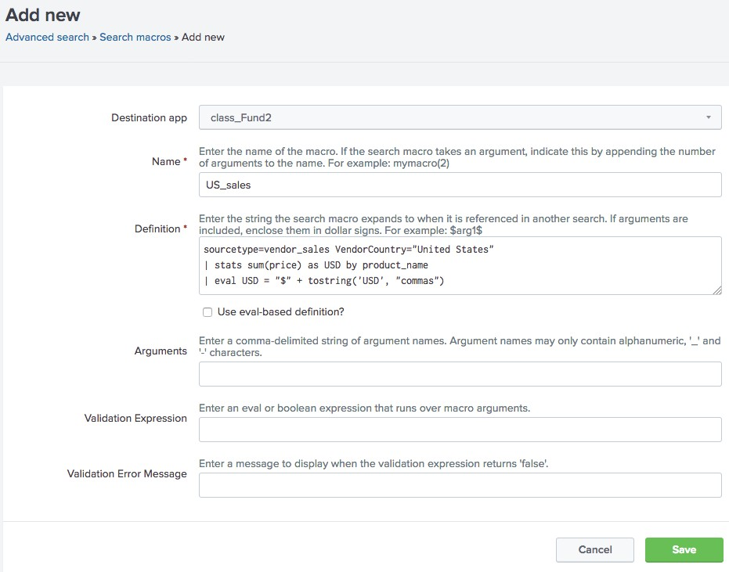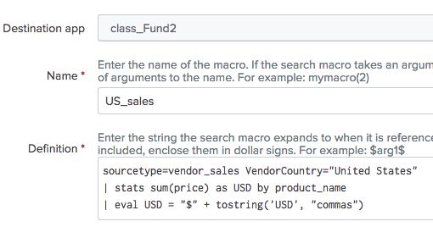

1. Click New Search Macro
2. Select the destination app
3. Enter a name
4. Type the search string
5. Save



Note

Test your search string before saving your macro. You can check the contents of your macro with keyboard shortcuts (Command-Shift-E on Mac OS or Control-Shift-E on Linux or Windows) from the Search bar in the Search page.

* + Type the macro name into the search bar



Using a Basic Macro

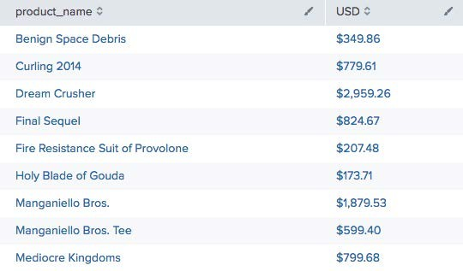

`US_sales`

sourcetype=vendor_sales VendorCountry="United States"

| stats sum(price) as USD by product_name

| eval USD = "$" + tostring('USD’,"commas")

* + Surround the macro name with the **backtick** (or grave accent) character
* **`macroname`** != ‘macroname’
* Do not confuse with single-quote character (‘)
  + Pipe to more commands, or precede with search string
  + Include the number of arguments in parentheses after the macro name



Adding Arguments

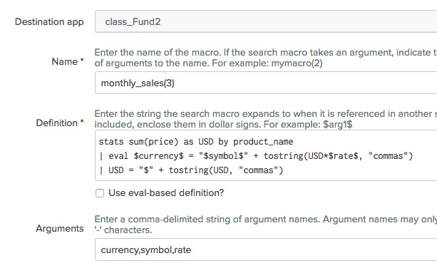

- monthly_sales(3)

* + Within the search definition, use

$arg$

* currency=$currency$
* symbol=$symbol$
* rate=$rate$
  + In the **Arguments** field, enter the name of the argument(s)
  + Provide one or more variables of the macro at search time

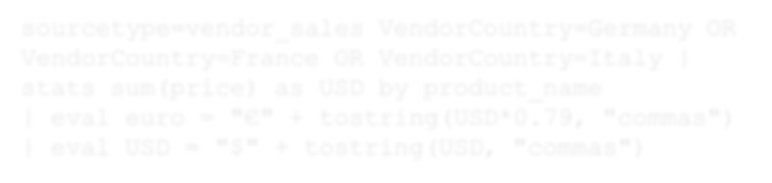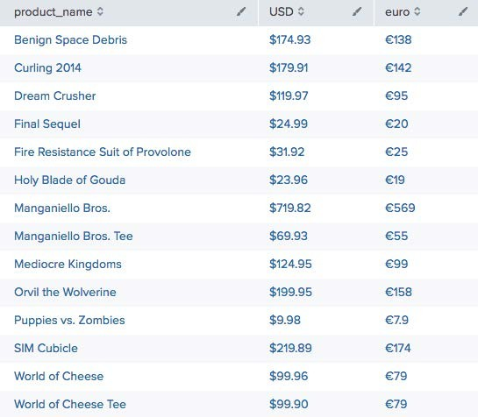

* + When using a macro with arguments, include the argument(s) in parentheses following the macro name
  + Be sure to pass in the arguments in the same order as you defined them

sourcetype=vendor_sales VendorCountry=Germany OR VendorCountry=France OR VendorCountry=Italy

| `monthly_sales(euro,€,0.79)`

sourcetype=vendor_sales VendorCountry=Germany OR VendorCountry=France OR VendorCountry=Italy | stats sum(price) as USD by product_name

| eval euro = "€" + tostring(USD*0.79, "commas")

| eval USD = "$" + tostring(USD, "commas")

You can validate argument values in your macro



Note

Don’t create macros with leading pipes—someone may put a pipe in front of the macro when using it in the actual search string.

* Validation Expression: you can enter an expression for each argument

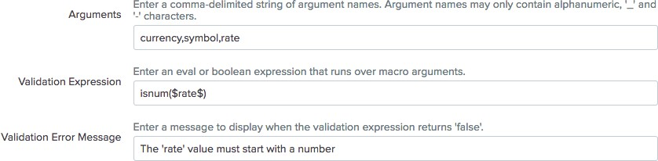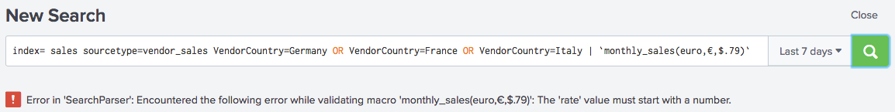

* + Argument must be enclosed in dollar signs
* Validation Error Message: message that appears when you run the macro

Module 12: Creating and Using Workflow Actions

* + Create a GET workflow action
  + Create a POST workflow action
  + Create a Search workflow action
  + Execute workflow actions from an event in your search results to interact with external resources or run another search
    - **GET** - retrieve information from an external resource
    - **POST** - send field values to an external resource
    - **Search** - use field values to perform a secondary search

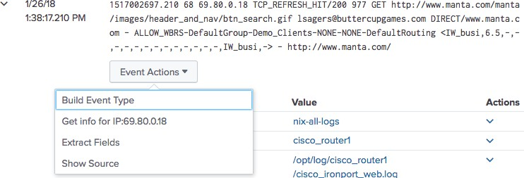

#### Settings > Fields > Workflow actions > New Workflow Action



Creating a GET Workflow Action

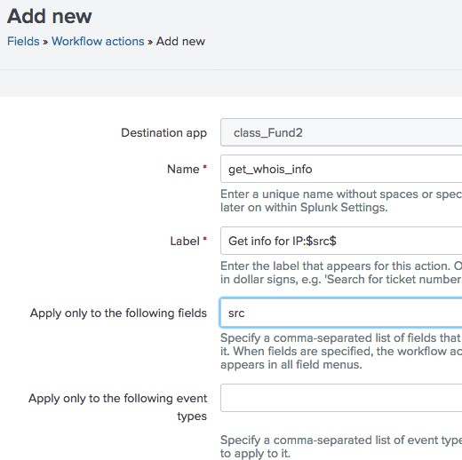

1

2

3

4

1. Select the app
2. Name the workflow action with no spaces or special characters
3. Define the label, which will appear in the Event Action menu
4. Determine if your workflow action applies to a field or event type
5. From the **Show action in** drop- down list, select **Event menu**



Creating a GET Workflow Action (cont.)

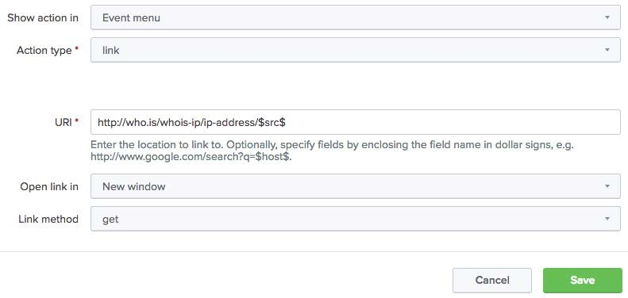

5

6

7

8

9

10

1. From Action type dropdown list, select link
2. Enter the URI of where the user will be directed
3. Specify if the link should open in a New window or Current window
4. Select the Link method of **get**
5. Save

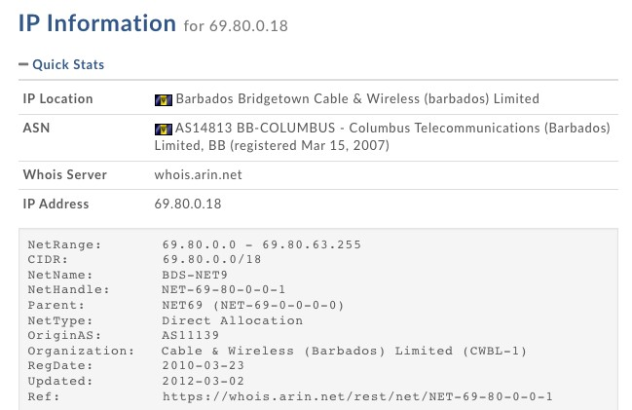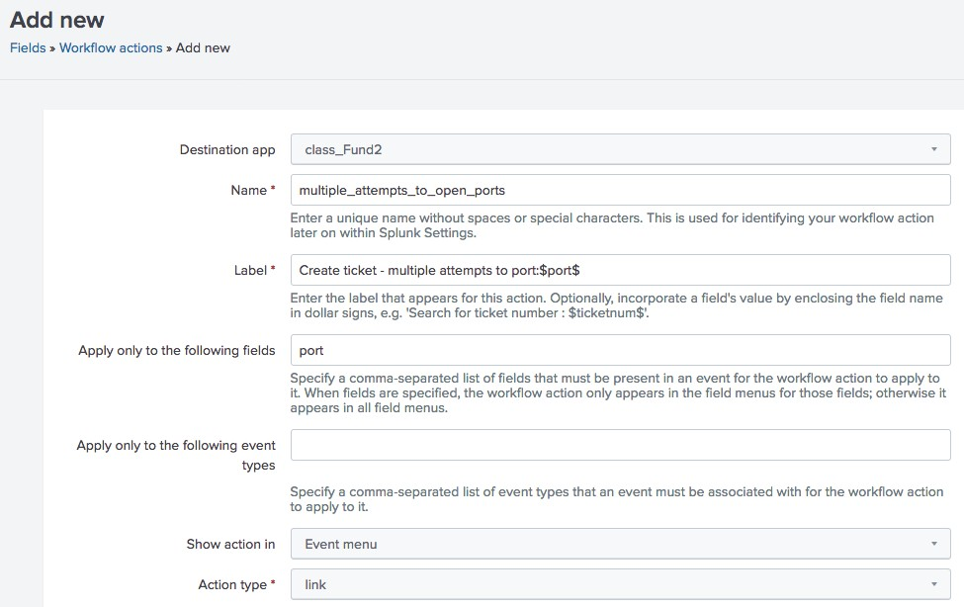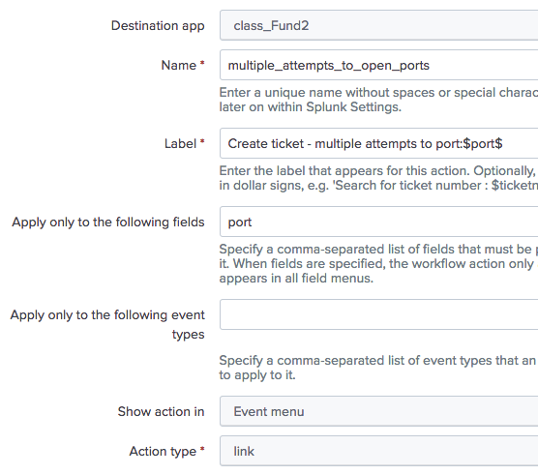

5

6

4

3

2

1

#### Settings > Fields > Workflow actions > New Workflow Action

Complete steps 1 – 6 as described in the previous example, Creating a GET Workflow Action

* 1. Enter the URI of where the user will be directed

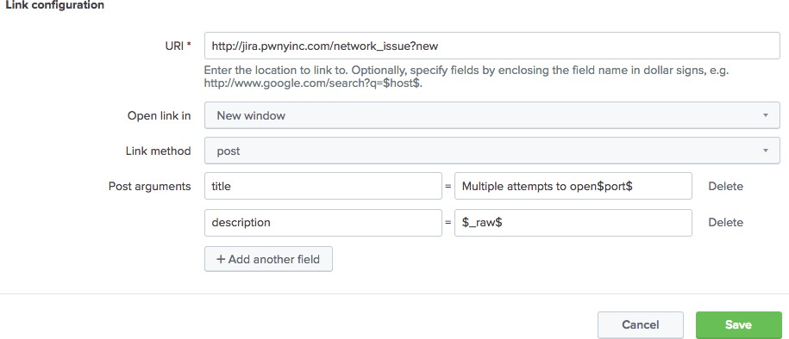

7

8

9

10

* 1. Open the link in a **New window** or Current window
  2. Select the Link method of **post**
  3. Provide post argument parameters

11

* 1. Save

**Generated for mastinder singh (mastinder.singh@jpmchase.com) (C) Splunk Inc, not for distribution**

#### Settings > Fields > Workflow actions> New



Creating a Search Workflow Action

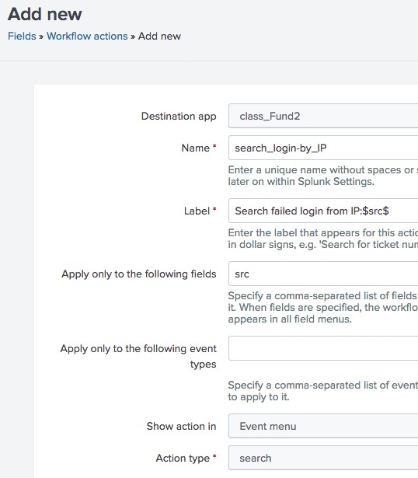

1

2

3

4

5

6

Complete steps 1 – 5 as described in the previous example, Creating a GET Workflow Action

1. From the Action type dropdown list, select **search**
2. Enter the Search string



Creating a Search Workflow Action (cont.)

1. Select the app if it is different from the current app

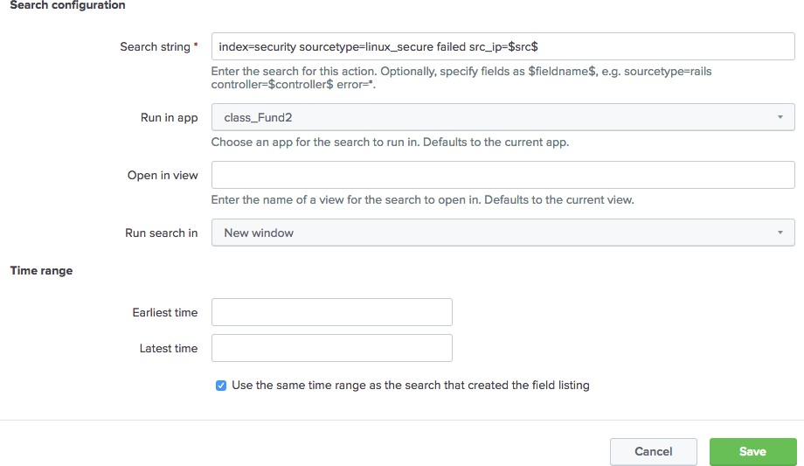

7

8

9

10

11

1. Enter the view name where the search will execute
2. Indicate if the search should run in a New window or the Current window
3. Enter the time range for the search or choose to use the same time range as the search
4. Save

12



Testing the Search Workflow Action

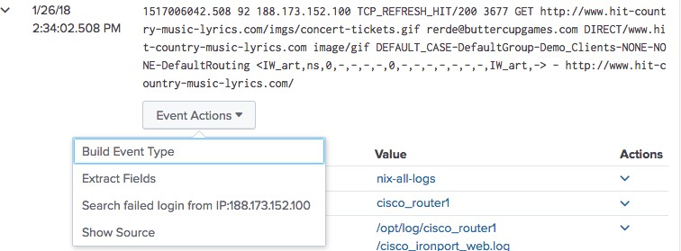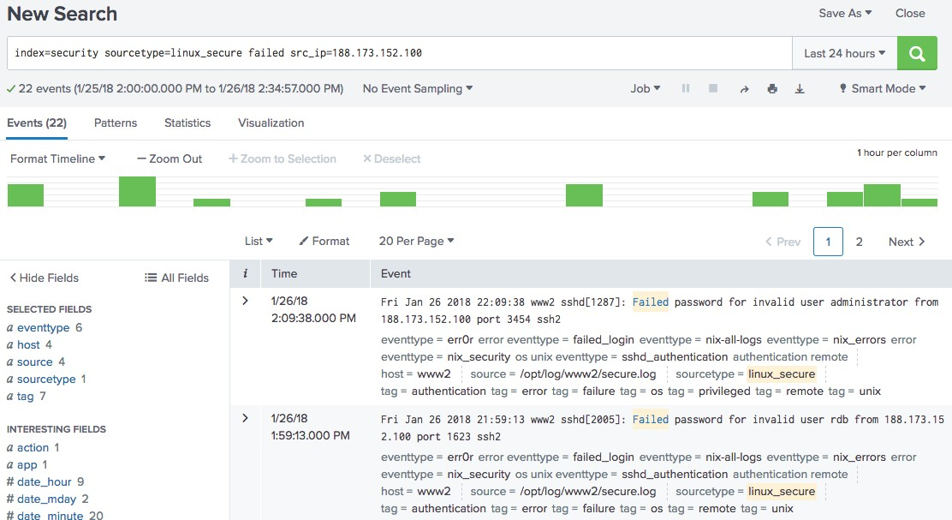

Module 13: Creating Data Models

* + Describe the relationship between data models and Pivot



Objectives

* + Identify data model datasets
  + Identify dataset fields
  + Create a data model
  + Use a data model in Pivot
  + Used for creating reports and dashboards (discussed in Splunk Fundamentals 1)



Reviewing Pivot

* + As a knowledge manager, you’re responsible for building the data model that provides the datasets for Pivot

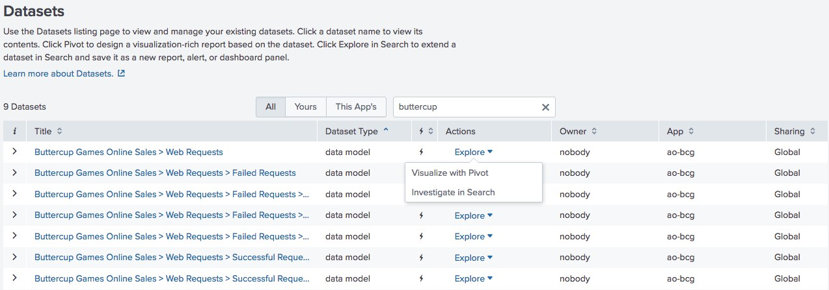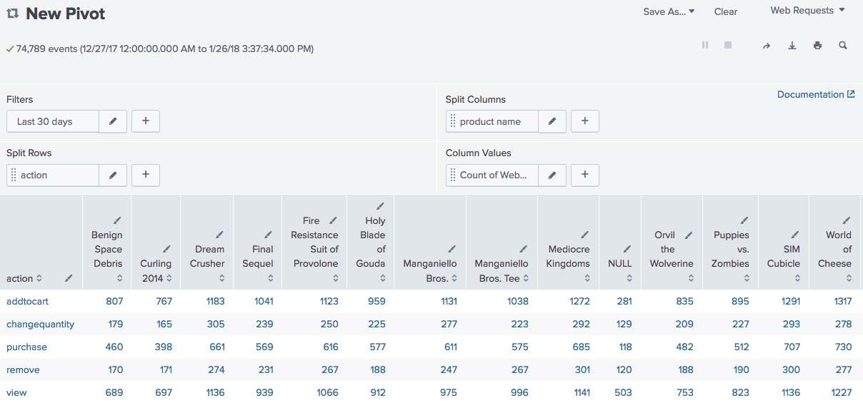

* + Hierarchically structured datasets that generate searches and drive Pivot

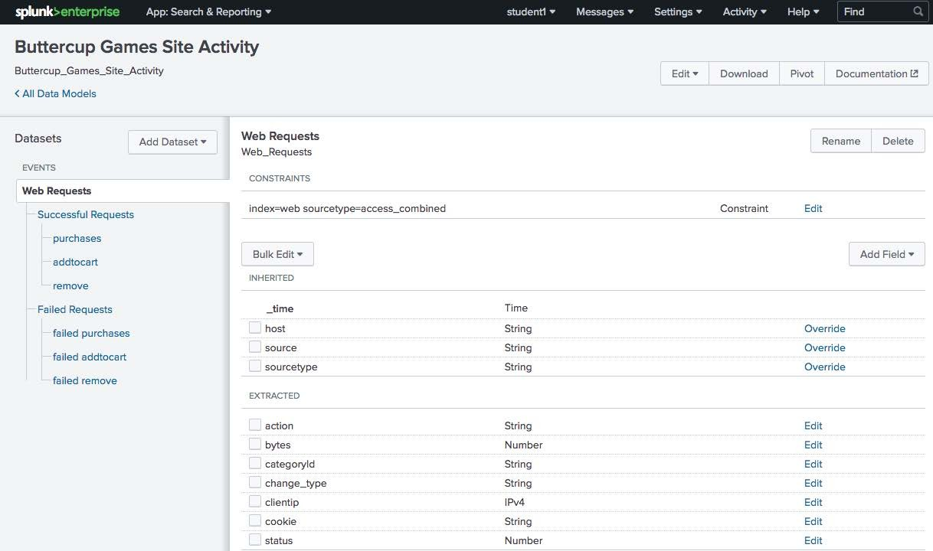

* + Pivot reports are created based on datasets
  + Each event, search or transaction is saved as a separate dataset

A data model can consist of 3 types of datasets

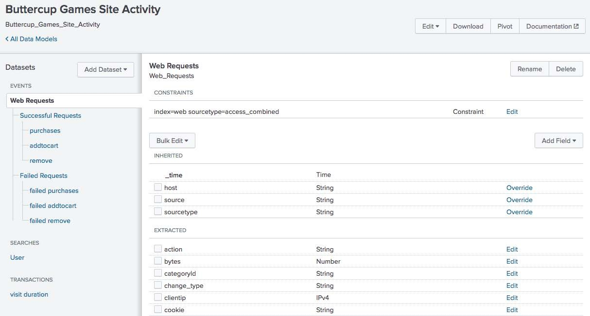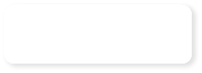

* + Events
  + Searches
  + Transactions

Events

Searches

Transactions

* + **Event datasets** contain constraints and fields
  + **Constraints** are essentially the search broken down into a hierarchy

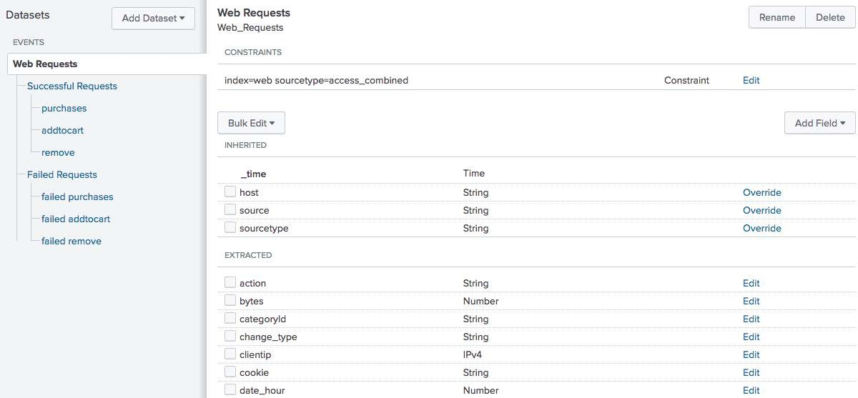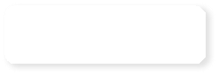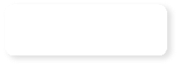

base search

fields

* + **Fields** are properties associated with the events

# Event Object Hierarchy and Constraints

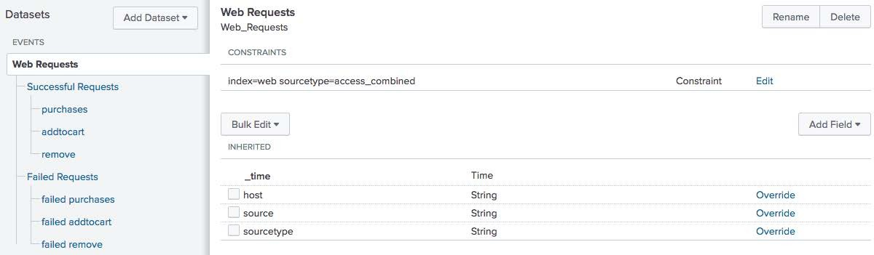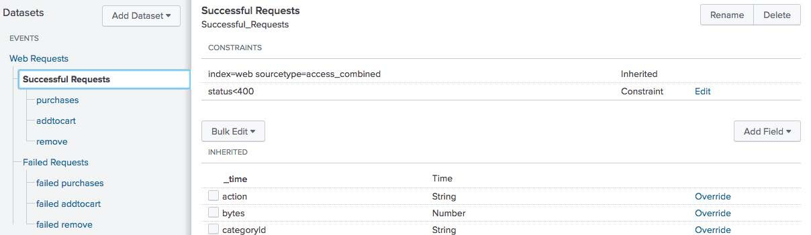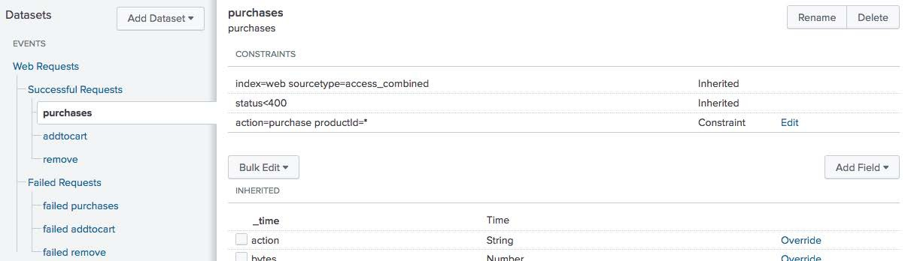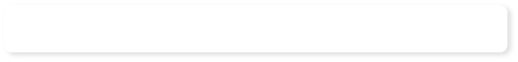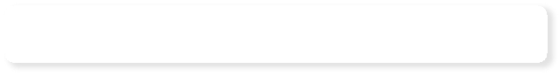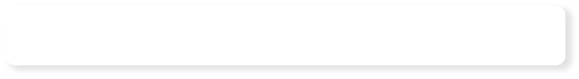

base search – all access_combined events

Each constraint inherits the parent search string

1

2

successful requests

3 successful requests for purchases

* + Select the fields you want to include in the dataset



Dataset Fields

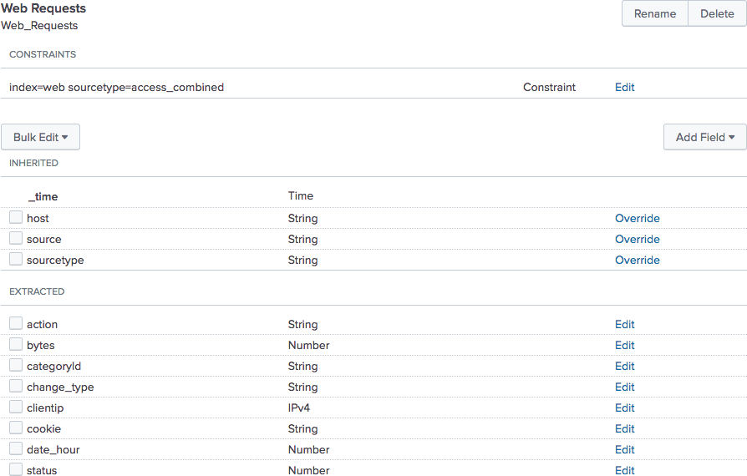

* + Like constraints, fields are inherited from parent objects

**Settings > Data Models**



Creating a Data Model

ID is automatically populated from Title, but can be overridden

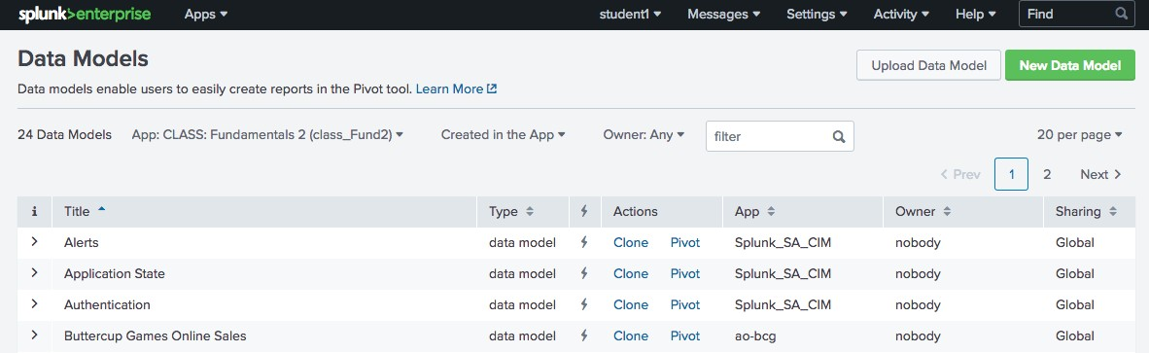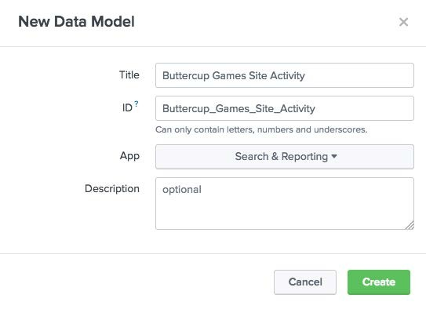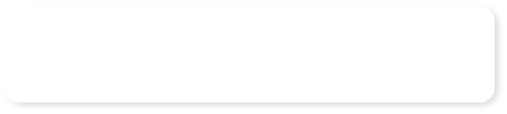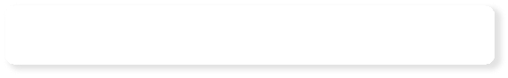

Choose app context

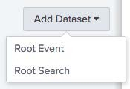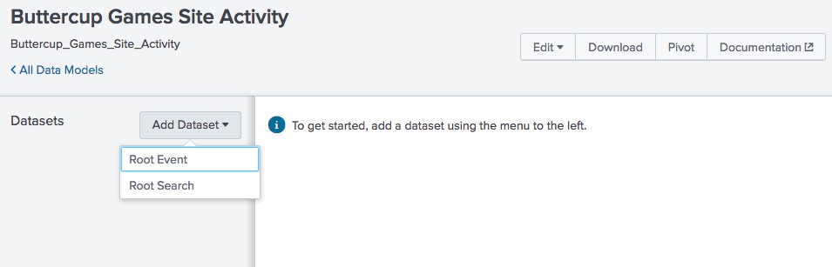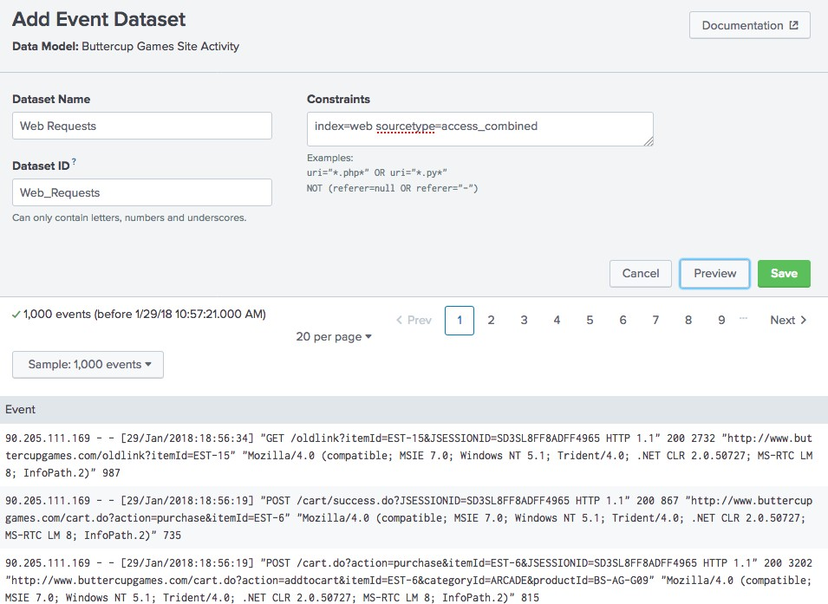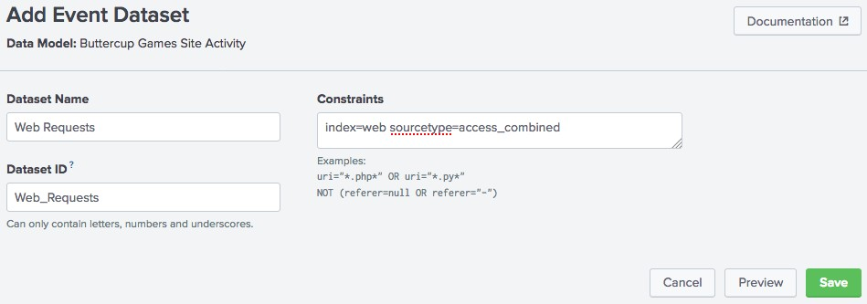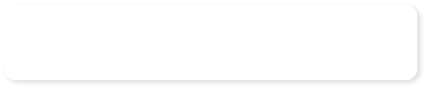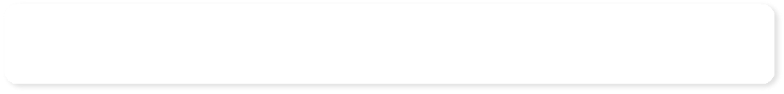

Constraints are essentially search terms – add child events (discussed later in this section) to further "narrow" your search

Click Preview to view the events that the constraint returns

* + In this example, the root event of this data model represents all web requests
  + The Inherited attributes are default fields
  + Use **Add Field > Auto-Extracted** to add more fields

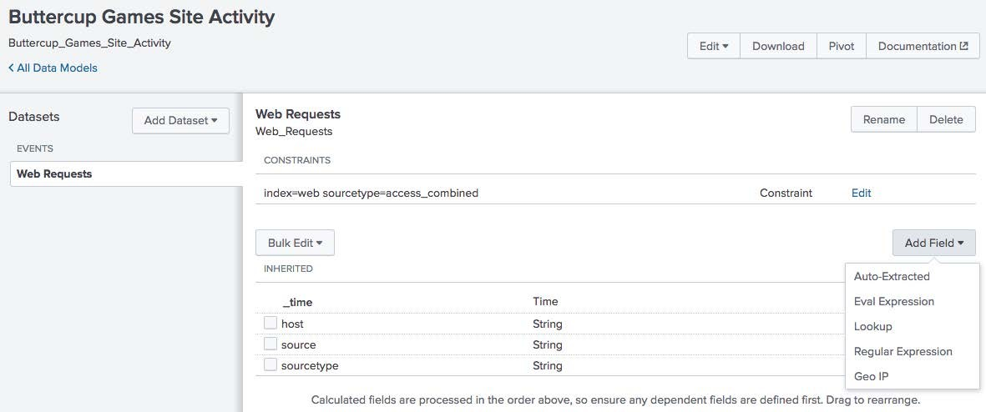

* + **Auto-Extracted** – can be default fields or manually extracted fields



Adding Fields

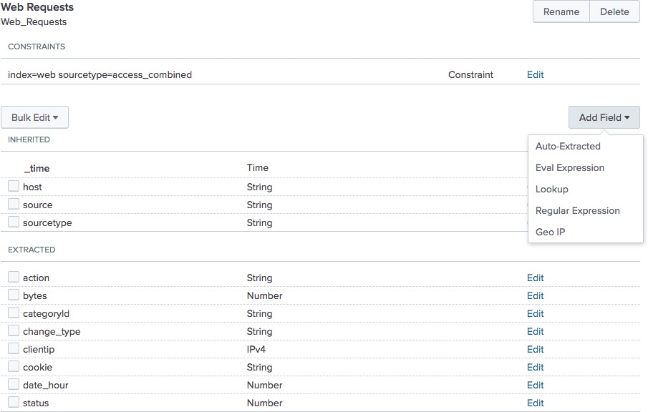

* + **Eval Expression** – a new field based on an expression that you define
  + **Lookup** – leverage an existing lookup table
  + **Regular Expression** – extract a new field based on regex
  + **Geo IP** – add geographical fields such as latitude/longitude, country, etc.

Fields that already exist for the constraint can be added as attributes to the data model

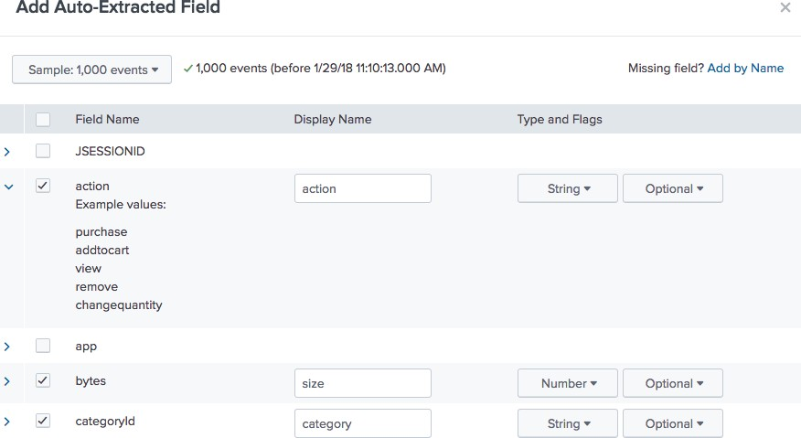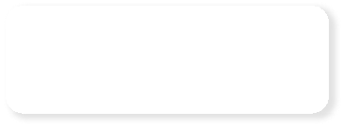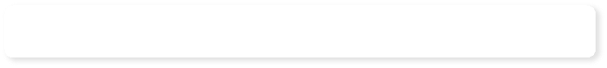

View a field's example values

Give the field a friendly name for use in Pivot

* + String: Field values are recognized as alpha-numeric

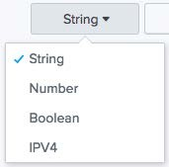

* + Number: Field values are recognized as numeric
  + Boolean: Field values are recognized as true/false or 1/0
  + IPV4: Field values are recognized as IP addresses
    - This is an important field type, as at least one IPV4 attribute type must be present in the data model in order to add a Geo IP attribute
  + Optional: This field doesn't have to appear in every event

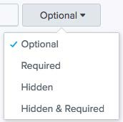

* + Required: Only events that contain this field are returned in Pivot
  + Hidden: This field is not displayed to Pivot users when they select the dataset in Pivot
    - Use for fields that are only being used to define another field, such as an eval expression
  + Hidden & Required: Only events that contain this field are returned, and the fields are hidden from use in Pivot
  + You can define a new field using an eval expression



Adding Fields – Eval Expressions

* + - In this example, you create a field named Error Reason that evaluates the value of the status field

Click Preview to verify your eval expression returns events

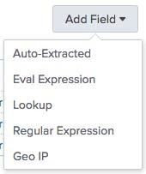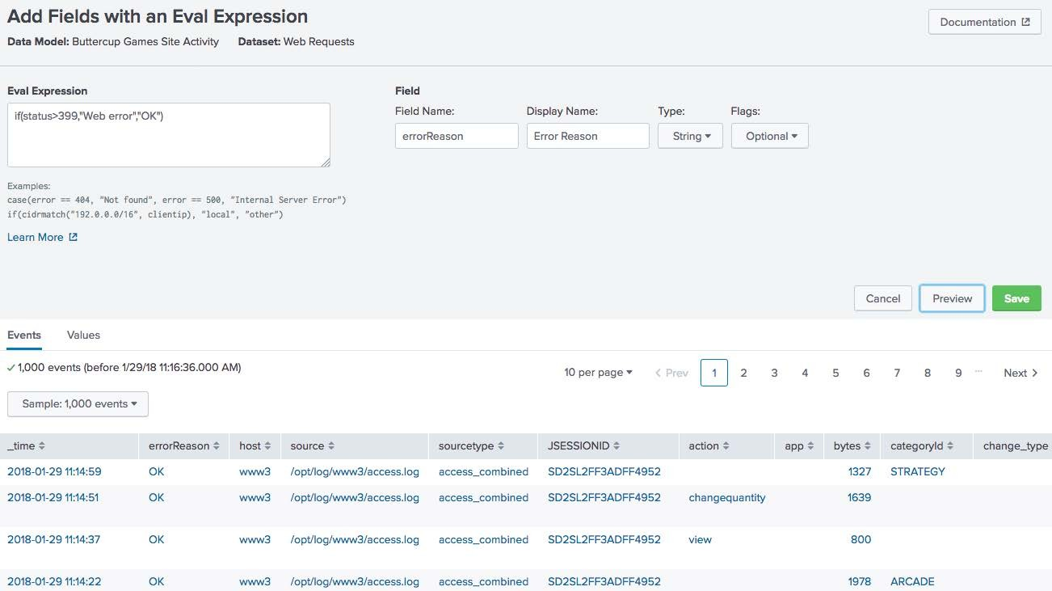

* + Leverage an existing lookup definition to add fields to your event object



Adding Fields – Lookups

* + Configure the lookup attribute in the same way as an automatic lookup

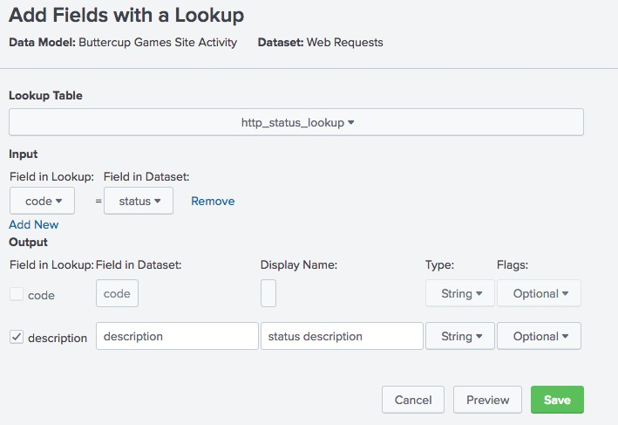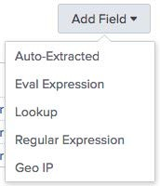

* + Use Preview to test your lookup settings



Adding Fields – Lookups (cont.)

* + Use the Events and Values tab to verify your results

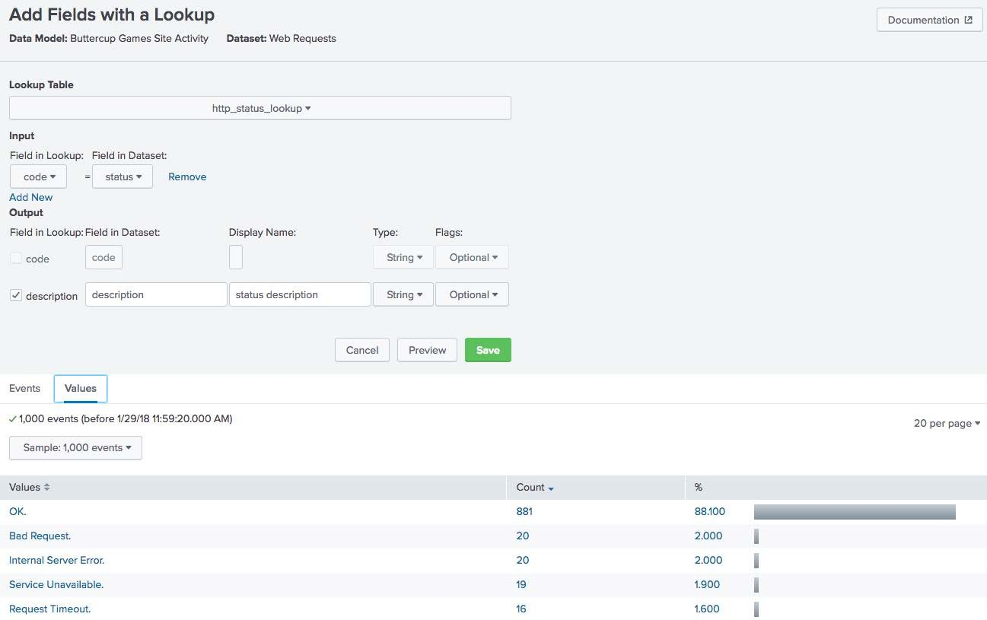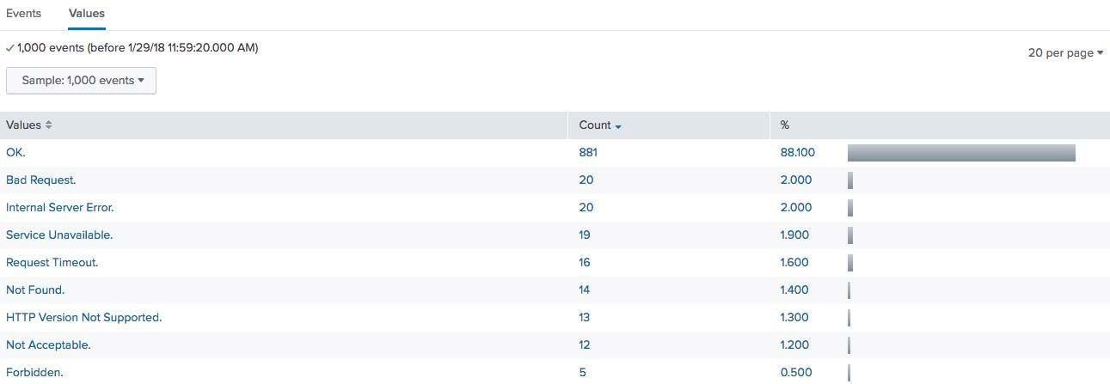

# Adding Fields – Regular Expression

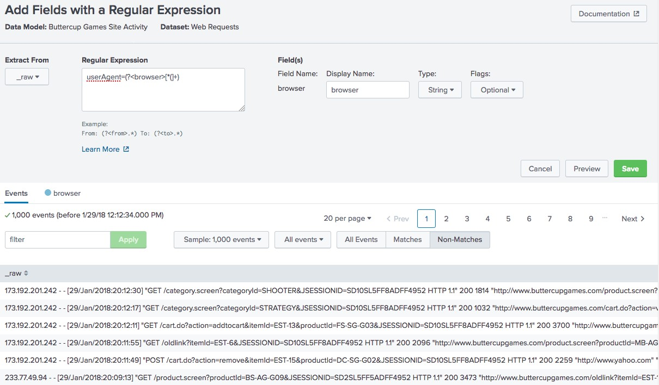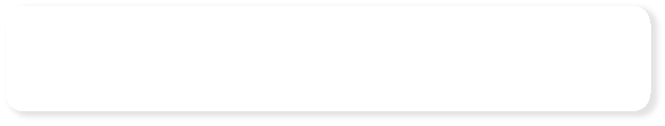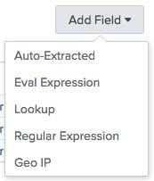

You can define a new field using a regular expression

Click Preview to view the events that Match

~~or Don’t Match the regular expression~~

* Map visualizations require latitude/longitude fields



Adding Fields - GeoIP

* To use Geo IP Lookup, at least one IP field must be configured as an IPv4 type
* While the map function isn't available in Pivot, the data model can be called using the

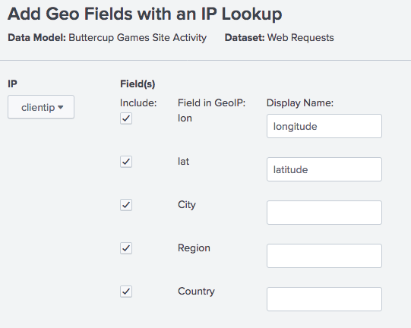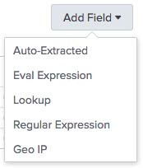

**| pivot** command and <map>

element in a dashboard population search

* + Select the field that contains the mapping to lat/lon
  + Identify the lat/lon and geo fields in the data

When you create a new child dataset, you give it one or more additional constraints

All events that have a status less than 400 (successful http request)

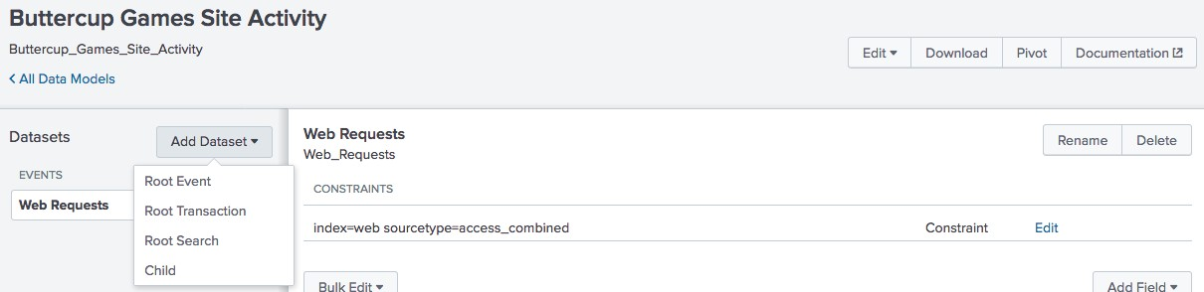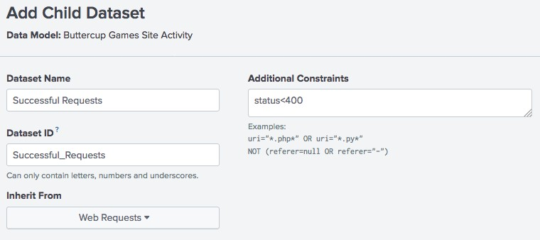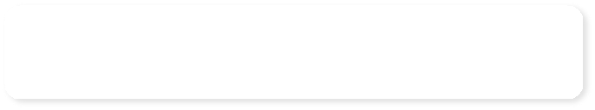

* Child datasets inherit all fields from the parent events
* You can add more fields to child datasets

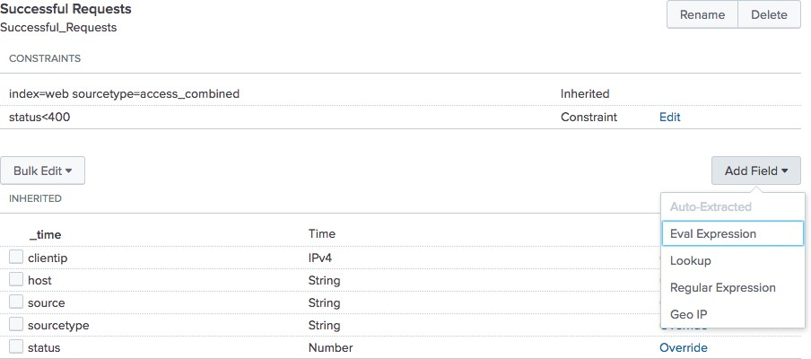

* Click Pivot to access the Select a Dataset window



Testing the Data Model

* Choose an object from the selected data model to begin building the report

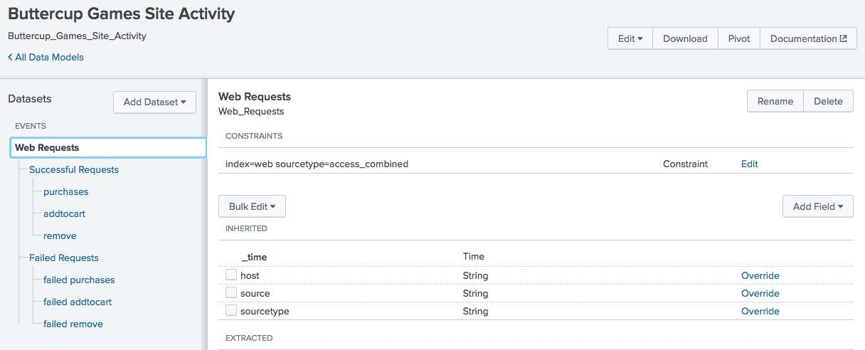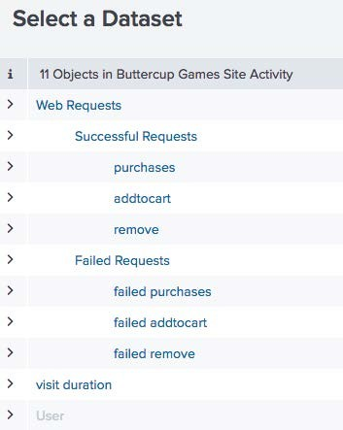

The New Pivot window automatically populates with a count of events for the selected dataset



Using the Data Model in Pivot

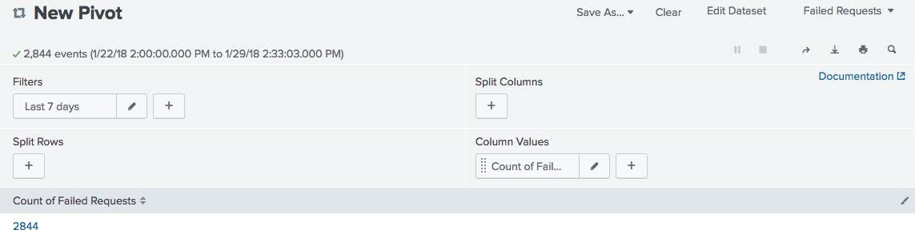

* The fields associated with each dataset are available as splits for rows or columns
* In this example, the Pivot report will show a count of failed request actions by status

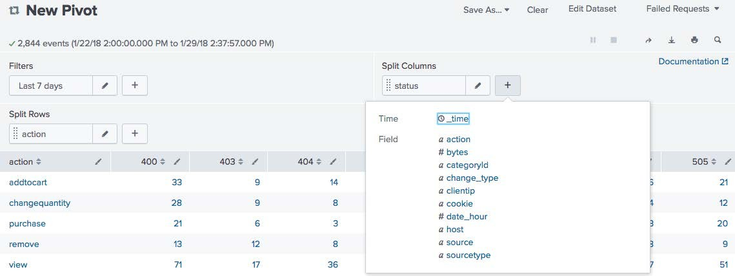

* Fields can also be used to filter events in the Pivot interface

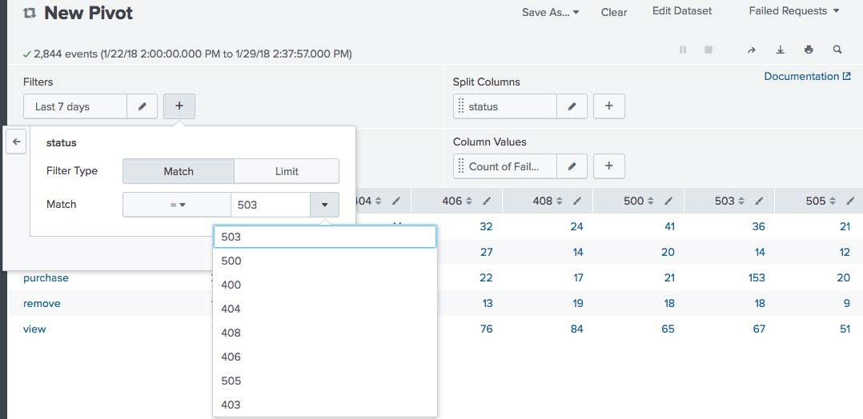

* In this example, the Pivot report is filtered to only return results where status=503

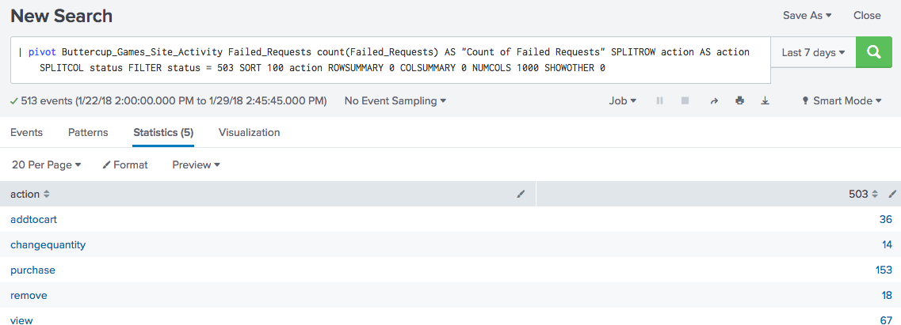

Data model name

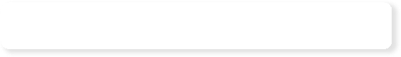

Object name

| pivot Buttercup_Games_Site_Activity failed_request

count(failed_request) AS "Count of Failed requests"

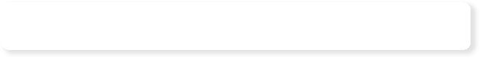

Split row field (or attribute)

SPLITROW action AS action TOP 100 count(failed_request)

SPLITCOL status FILTER status = 503



Split column field (or attribute) and filter field/value pair

* Arbitrary searches that include transforming commands to define the dataset that they represent

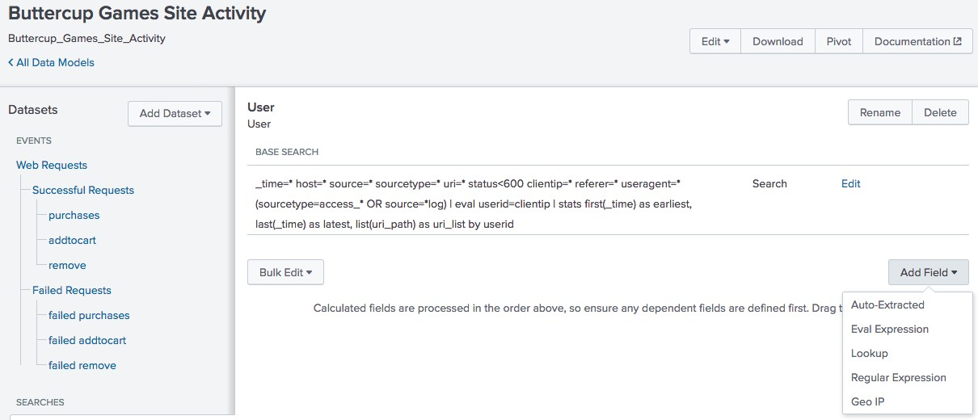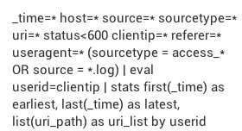

* Search datasets can also have fields, which are added via the **Add Field** button
* Enable the creation of datasets that represent transactions

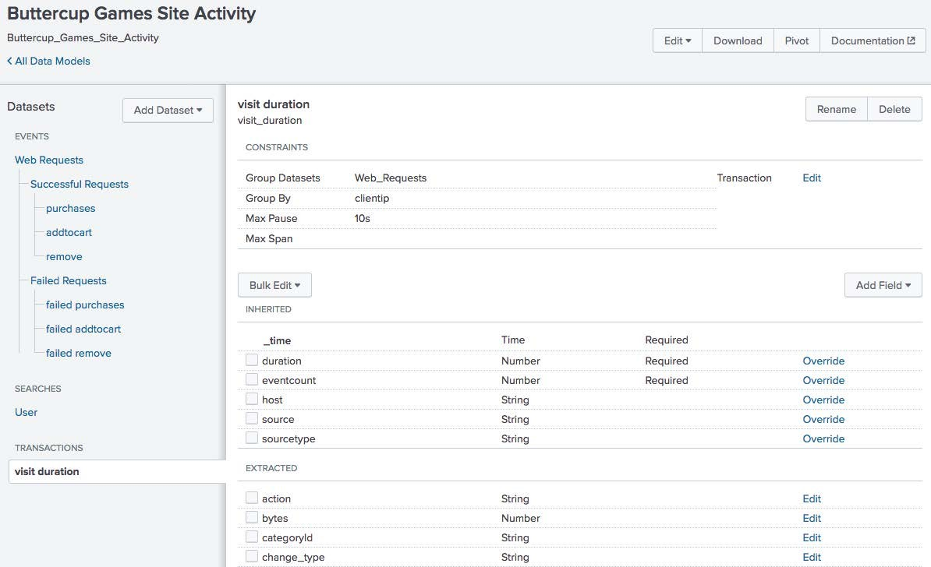

* Use fields that have already been added to the model using event or search datasets
* You can add a transaction to the data model
* The transaction dataset below would equate to the search:

**sourcetype=access_* | transaction clientip maxpause=10s**

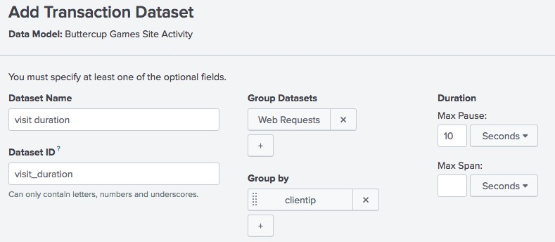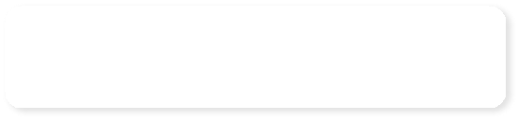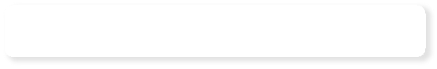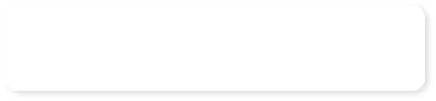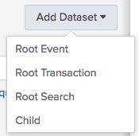

Select a dataset from the data model to base the transaction on

Optionally select max pause and max span

Select a group by field

* You can then add an eval expression or any other field to your transaction to further define the results



Adding a Transaction (cont.)

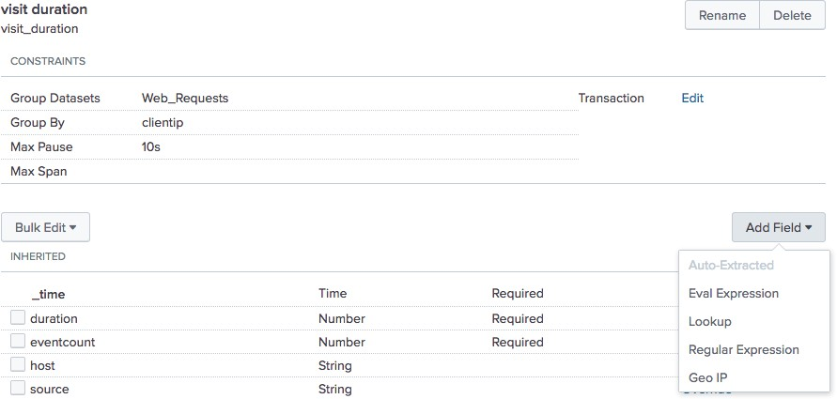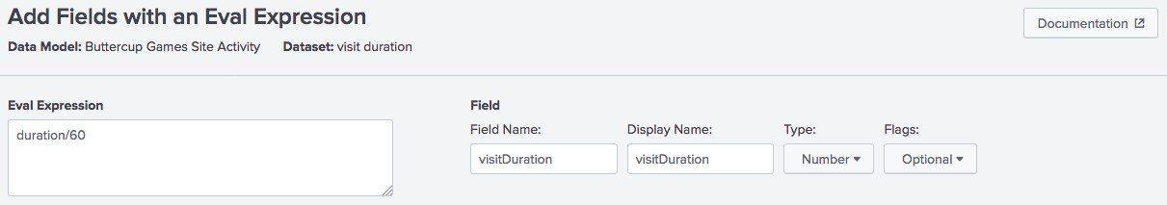

* This example shows dividing the duration field value by 60 to convert the duration field to minutes
* There must be at least one event or search dataset before adding a transaction dataset



Search and Transaction Dataset Considerations

* Search and transaction datasets cannot benefit from persistent data model acceleration
* As you learn to create data models, consider the types of reports your users will run
  + Can the same report be achieved with event datasets?
  + Will users need raw events or transactional data?



Note

Data model acceleration is discussed later in this module.

* When a data model is created, the owner can determine access based on the following permissions:

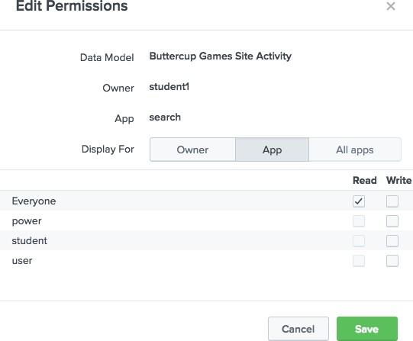

* + Who can see the data models

⬇ Owner, App, or All Apps

* + Which users can perform which actions (Read/Write)

⬇ Everyone

⬇ Power

⬇ User

⬇ Admin-defined roles, if applicable

* Use the Splunk Web interface to download or upload data models:
  + Back up important data models
  + Collaborate with other Splunk users to create/modify/test data models
  + Move data models from a test environment to production instance



Note

An HTML 5 supported browser must be used to download data models.

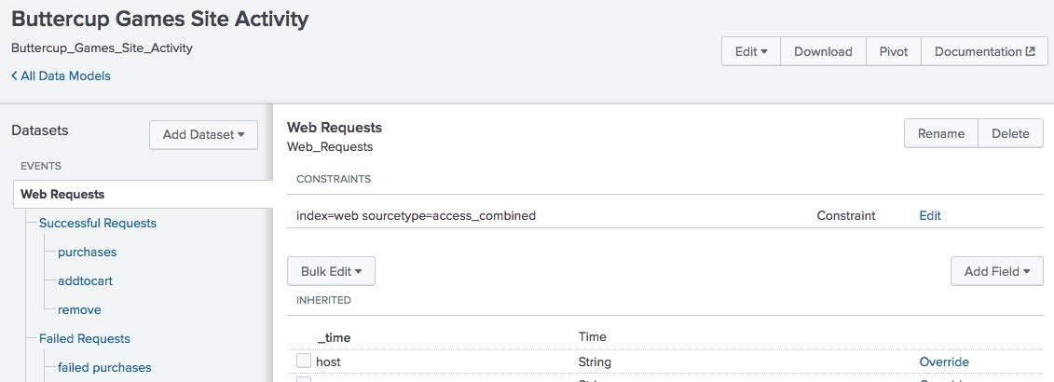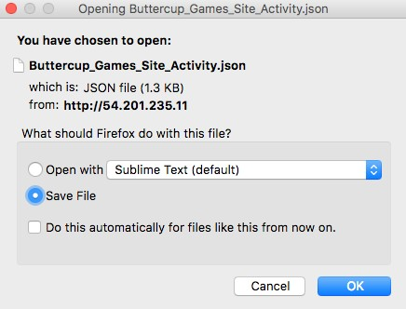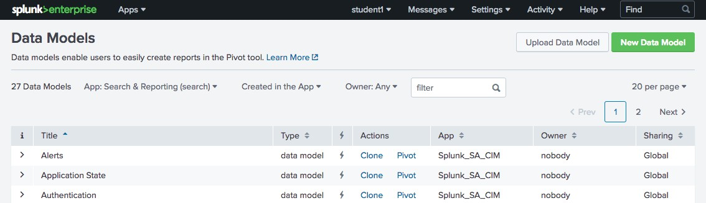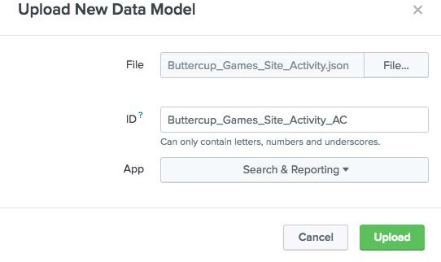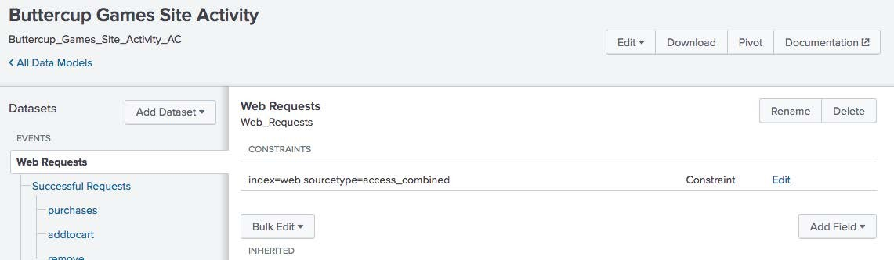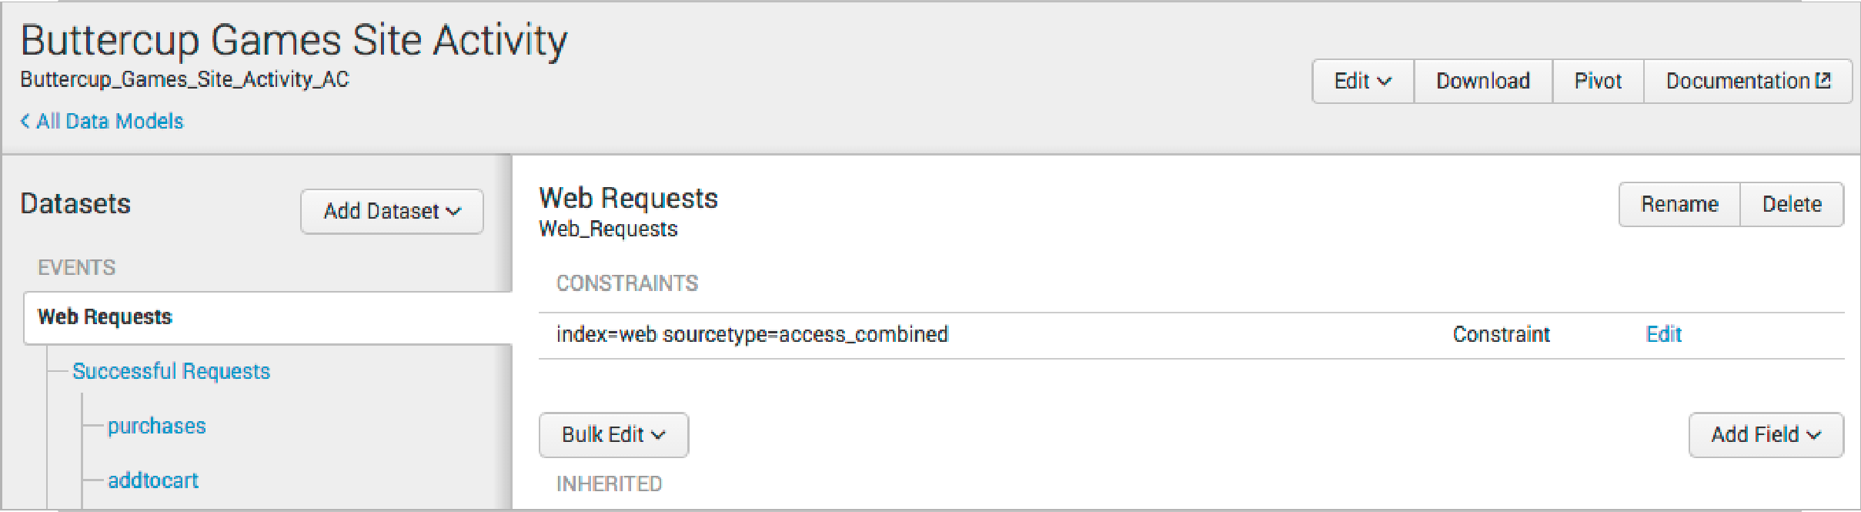

### Uses automatically created summaries to speed completion times for pivots



Data Model Acceleration

* Takes the form of inverted time-series index files (tsidx) that have been optimized for speed
* Discussed in more detail in *Advanced Searching and Reporting*
* With persistent data model acceleration, all fields in the model become "indexed" fields



Accelerating a Data Model



Note

Only root events can be accelerated. If there are multiple root events, only the first root event is accelerated.

* You must have administrative permissions or the

**accelerate_datamodel** capability to accelerate a data model

* Private data models cannot be accelerated

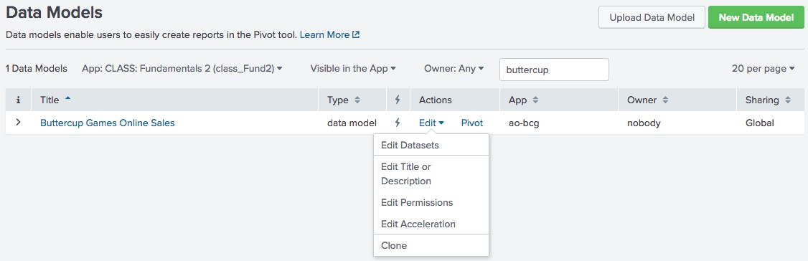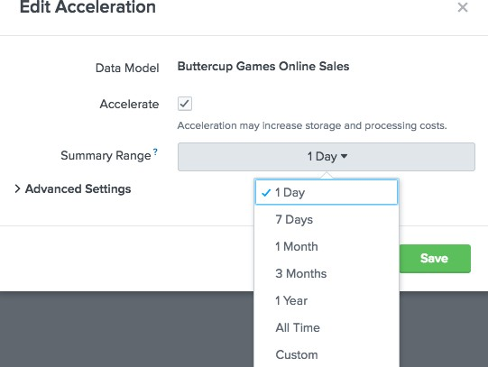

* Accelerated data models cannot be edited

Module 14:

Using the Common Information Model (CIM) Add-On

* Describe the Splunk Common Information Model



Objectives

* List the knowledge objects included with the Splunk CIM Add-On
* Use the CIM Add-On to normalize data
* The Splunk Common Information Model provides a methodology to normalize data



What is the Common Information Model (CIM)?

* Leverage the CIM when creating field extractions, field aliases, event types, and tags to ensure:
  + Multiple apps can co-exist on a single Splunk deployment
  + Object permissions can be set to global for the use of multiple apps
  + Easier and more efficient correlation of data from different sources and source types

**Search Head**



TA Checkpoint

Web

Unix

Network

CIM

Search

**General users**



**Network team**



**Server admins**



**Web admins**



**Search Time apps**

**Indexer Index**

TA3

TA2

TA Checkpoint

TA1

**Logs and Data**

**Time apps**

|  |  |  |  |
| --- | --- | --- | --- |
| **Field name** | **Data type** | **Description** | **Possible values** |
| action | string | Action taken by the reporting device. | delivered, blocked, quarantined, deleted, unknown |
| duration | number | The amount of time for the completion of the messaging event, in seconds. | Email |
| src | string | The system that sent the message. May be **aliased** from more specific fields such as src_host, src_ip, or src_name. |  |

|  |  |  |  |
| --- | --- | --- | --- |
| **Field name** | **Data type** | **Description** | **Possible values** |
| action | string | The action taken by the network device. | allowed, blocked, dropped, unknown |
| bytes | number | Total count of bytes handled by this device/interface (bytes_in + bytes_out). |  |
| bytes_in | number | How many bytes this device/interface received. |  |
| bytes_out | number | How many bytes this device/interface transmitted. |  |
| src | string | The source of the network traffic (the client requesting the connection). May be **aliased** from more specific fields such as src_host, src_ip, or src_name. |  |

|  |  |  |  |
| --- | --- | --- | --- |
| **Field name** | **Data type** | **Description** | **Possible values** |
| action | string | The action taken by the server or proxy. |  |
| duration | number | The time taken by the proxy event, in milliseconds. |  |
| http_method | string | The HTTP method used in the request. | GET, PUT, POST, DELETE, etc. |
| src | string | The source of the network traffic (the client requesting the connection). |  |
| status | string | The HTTP response code indicating the status of the proxy request. | 404, 302, 500, and so on. |

* Set of 22 pre-configured data models



Splunk CIM Add-on

|  |  |
| --- | --- |
| **Splunk CIM Add-On Data Models** | |
| [Alerts](http://docs.splunk.com/Documentation/CIM/4.2.0/User/Alerts) | [Java Virtual Machines (JVM)](http://docs.splunk.com/Documentation/CIM/4.2.0/User/JVM) |
| [Application State](http://docs.splunk.com/Documentation/CIM/4.2.0/User/ApplicationState) | [Malware](http://docs.splunk.com/Documentation/CIM/4.2.0/User/Malware) |
| [Authentication](http://docs.splunk.com/Documentation/CIM/4.2.0/User/Authentication) | [Network Resolution (DNS)](http://docs.splunk.com/Documentation/CIM/4.2.0/User/NetworkResolutionDNS) |
| [Certificates](http://docs.splunk.com/Documentation/CIM/4.2.0/User/Certificates) | [Network Sessions](http://docs.splunk.com/Documentation/CIM/4.2.0/User/NetworkSessions) |
| [Change Analysis](http://docs.splunk.com/Documentation/CIM/4.2.0/User/ChangeAnalysis) | [Network Traffic](http://docs.splunk.com/Documentation/CIM/4.2.0/User/NetworkTraffic) |
| [CIM Validation (S.o.S)](http://docs.splunk.com/Documentation/CIM/4.2.0/User/UsetheCIMtovalidateyourdata#Use_the_CIM_Validation_.28S.o.S..29_datamodel) | [Performance](http://docs.splunk.com/Documentation/CIM/4.2.0/User/Performance) |
| [Databases](http://docs.splunk.com/Documentation/CIM/4.2.0/User/Datastore) | [Splunk Audit Logs](http://docs.splunk.com/Documentation/CIM/4.2.0/User/SplunkAuditLogs) |
| [Email](http://docs.splunk.com/Documentation/CIM/4.2.0/User/Email) | [Ticket Management](http://docs.splunk.com/Documentation/CIM/4.2.0/User/TicketManagement) |
| [Interprocess Messaging](http://docs.splunk.com/Documentation/CIM/4.2.0/User/InterprocessMessaging) | [Updates](http://docs.splunk.com/Documentation/CIM/4.2.0/User/Updates) |
| [Intrusion Detection](http://docs.splunk.com/Documentation/CIM/4.2.0/User/IntrusionDetection) | [Vulnerabilities](http://docs.splunk.com/Documentation/CIM/4.2.0/User/Vulnerabilities) |
| [Inventory](http://docs.splunk.com/Documentation/CIM/4.2.0/User/ComputeInventory) | [Web](http://docs.splunk.com/Documentation/CIM/4.2.0/User/Web) |

* + Fields and event category tags
  + Least common denominator of a domain of interest
* Leverage the CIM so that knowledge objects in multiple apps can co-exist on a single Splunk deployment
* Available on splunkbase:
  + <https://splunkbase.splunk.com/app/1621/>
* Use the CIM Reference Tables



Note

The data models included in the CIM add-on are configured with data model acceleration turned off.

* + [https://docs.splunk.com/Documentation/CIM/4.9.0](https://docs.splunk.com/Documentation/CIM/4.5.0/User/Howtousethesereferencetables)

[/User/Howtousethesereferencetables](https://docs.splunk.com/Documentation/CIM/4.5.0/User/Howtousethesereferencetables)

1. Examine your data

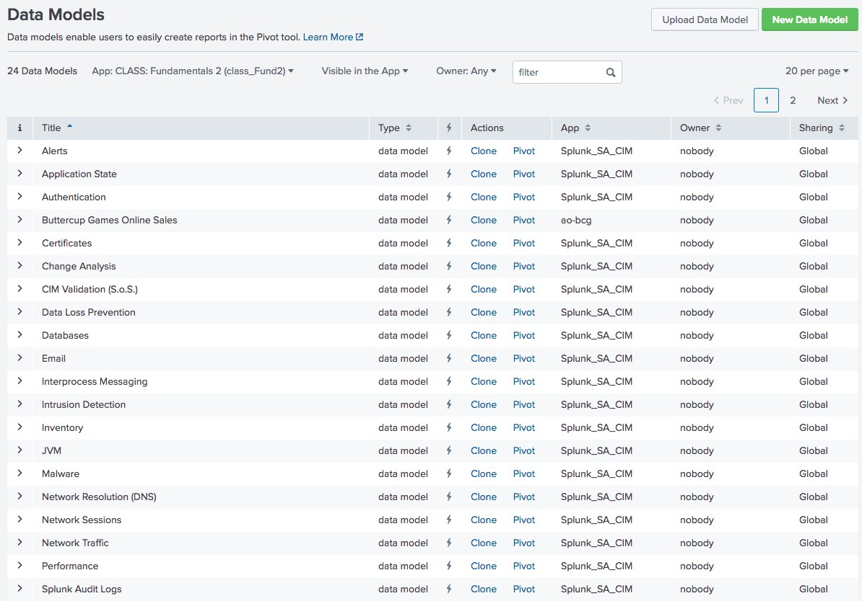

* + Go to **Settings > Data Models**
  + Identify a data model relevant to your dataset



Best Practice

Keep the CIM Reference Tables in Splunk Docs page open in a separate tab.

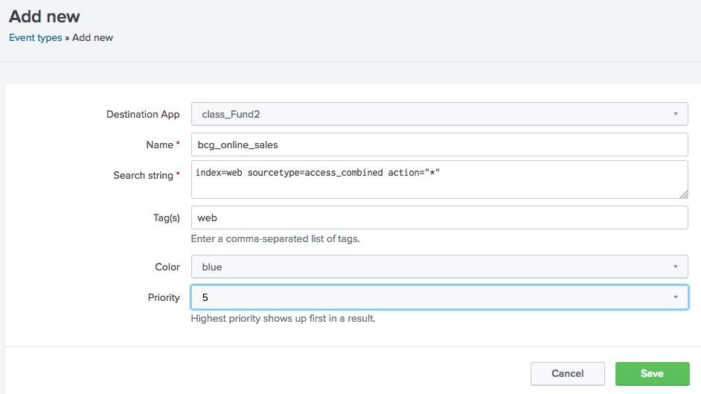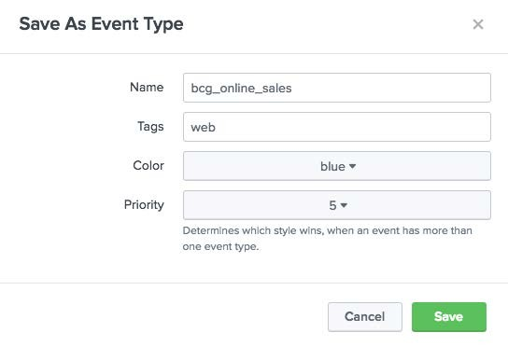

1. Create event types & tags
   * Identify the CIM datasets relevant to your events
   * Observe which tags are required for that dataset or any parent datasets
   * Apply those tags to your events using event types
2. Create field aliases

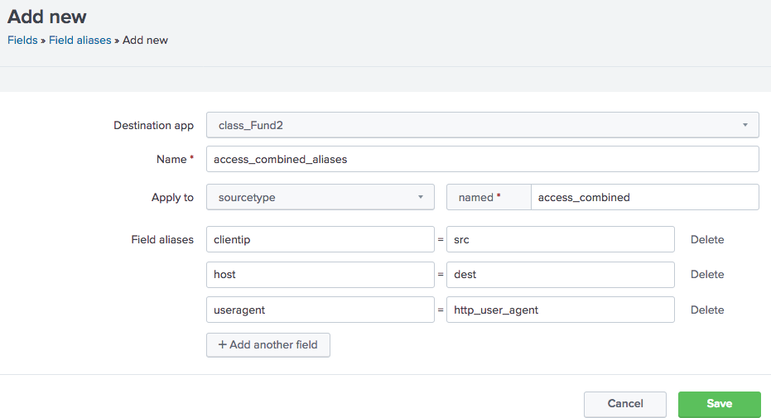

Field name in CIM object

Field name in your data

* + Determine whether any existing fields in your data have different names than the names expected by the data models
  + Define field aliases to capture the field with a different name in your original data and map it to the field name that the CIM expects

1. Add missing fields

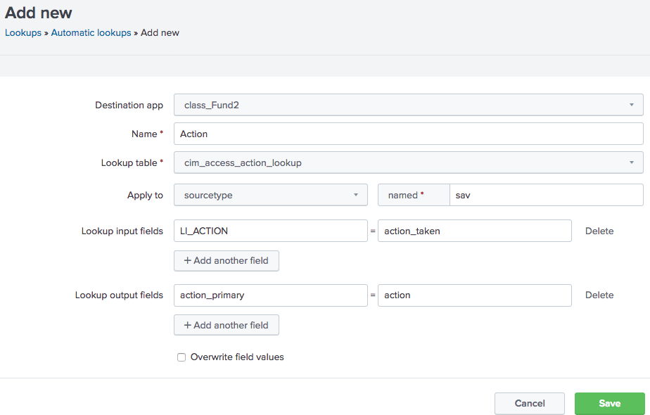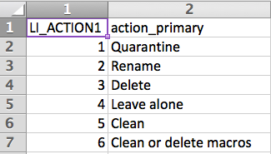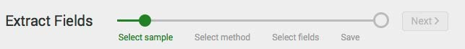

* + Create field extractions
  + Write lookups to add fields and normalize field values

1. Validate against data model
   * Use the datamodel command
   * Use Pivot in Splunk Web



Note

For more information, see the *Common Information Model Add-on Manual*: [http://docs.splunk.com/Documentation/CIM/latest/ User/Overview](http://docs.splunk.com/Documentation/CIM/4.6.0/User/Overview)

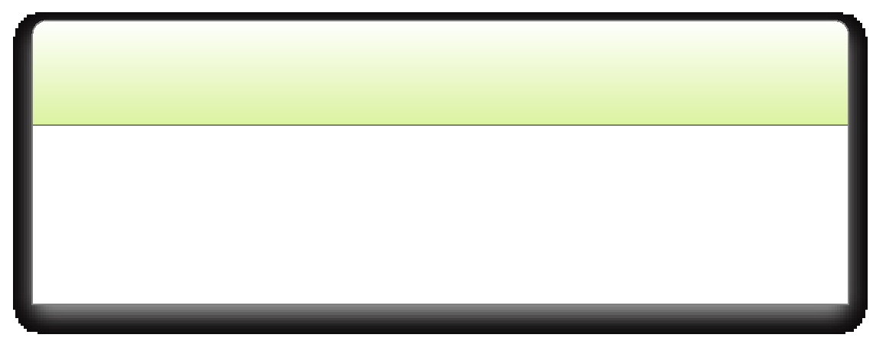

Important

The object name and search keyword aren't valid unless preceded by the data model name. The command search cannot be substituted with a search string or name.

**Generated for mastinder singh (mastinder.singh@jpmchase.com) (C) Splunk Inc, not for distribution**

Splunk Fundamentals 2

278

Copyright © 2018 Splunk, Inc. All rights reserved | 14 June 2018

* Search against a specified data model object

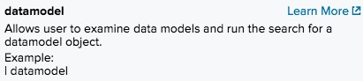

* Return a description of all or a specified data model and its objects
* Is a generating command and should be the first command in the pipeline

| datamodel Web Web search | fields Web*



Note

When using the datamodel command, the data model name and dataset name are case- sensitive.

**Generated for mastinder singh (mastinder.singh@jpmchase.com) (C) Splunk Inc, not for distribution**

Splunk Fundamentals 2

279

Copyright © 2018 Splunk, Inc. All rights reserved | 14 June 2018

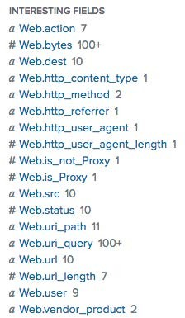

A B C D E

Command

A•

Data model name

B•

Data model dataset name Command

C•

D•

Find field names with Web prefix

E•

Dataset name prepended to field names in your data

* Retrieves data from a data model or named dataset
* Must be the first command in a search
* Different than just using datamodel
  + datamodel returns **all** fields prepended with data model name
  + from datamodel returns specified fields only

| from datamodel:"internal_server.splunkdaccess"

* from can also retrieve data from saved searches, reports, or lookup files

| from savedsearch:mysecurityquery

* Understand and use the CIM Add-on



Additional CIM Resources

<http://docs.splunk.com/Documentation/Splunk/latest/Knowledge/UnderstandandusetheCommonInformationModel>

* Overview of the Splunk CIM

<http://docs.splunk.com/Documentation/CIM/latest/User/Overview>

* Use the CIM to normalize data at search time

<http://docs.splunk.com/Documentation/CIM/latest/User/UsetheCIMtonormalizedataatsearchtime>